Applying Bulleted and Numbered Lists
Lists are useful for organizing items or drawing attention to important information. Using Word's and Sakai's Bullets and Numbering list options will structure your lists so that they appear uniform and tidy. Additionally, screen reading software will announce when it has arrived at a properly formatted list, informing the user to expect a series of items. Utilizing the built-in list options will also make your lists easy to format.

To Structure a List in Word:
- Place the cursor in the location where you wish to begin the list.
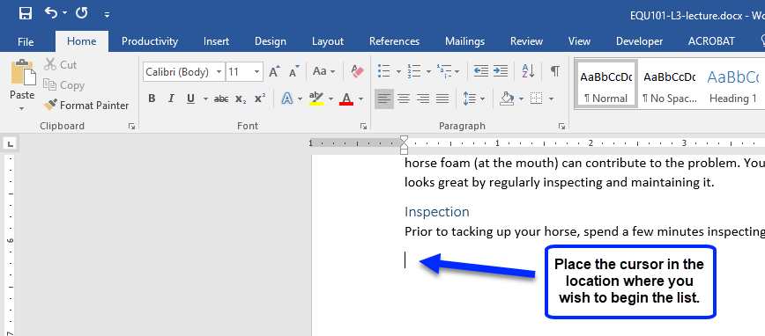
- On the Home tab, locate the Paragraph group. Taking into consideration the type of list you would like to create, click the Bullets option or the Numbering option.
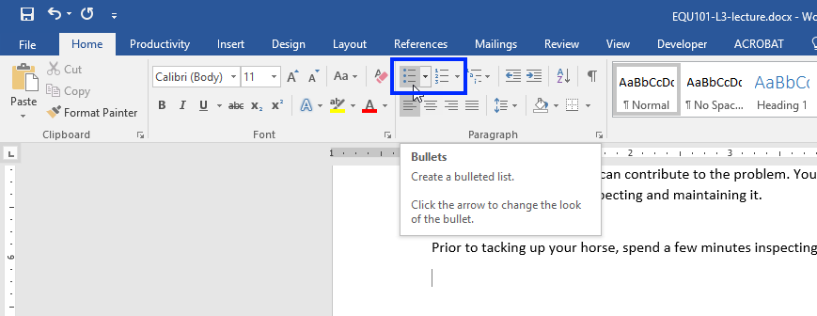
- Depending on your selection, a bullet or a number will appear. Type the first list item.
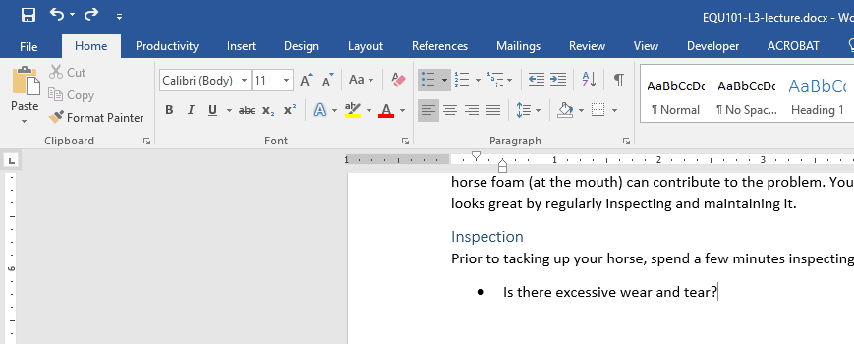
- To create the next list item, press Enter.
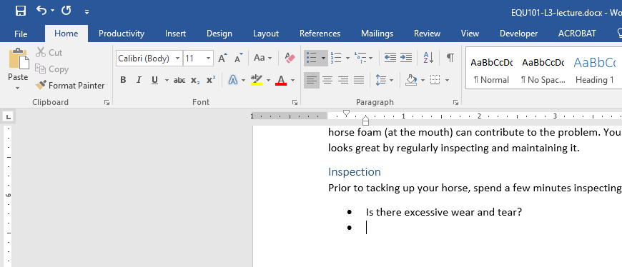
- To leave the list, press Enter twice.
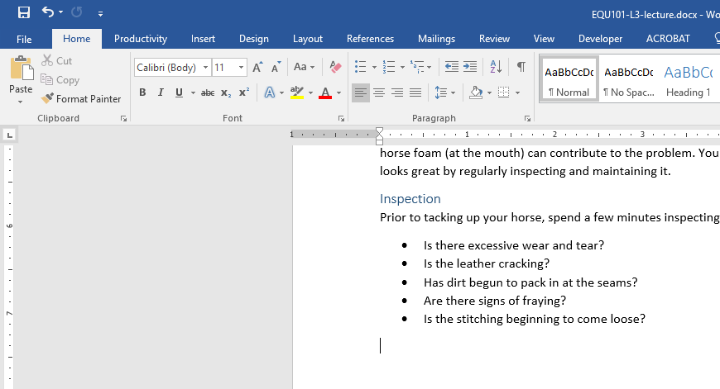

Other Bullet and Numbering Options
For more bullet or numbering options in Word, click the drop-down arrow next to a list option.
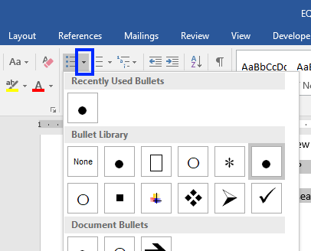

To Structure a List in Sakai:
In Sakai, you can create structured lists in almost every area that has a text editor, including content items, discussion board posts, and assignments.
- In the text editor, place the cursor in the location where you wish to begin the list.
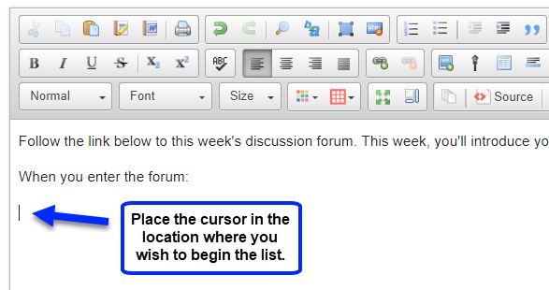
- From the text editor’s menu options, click the Bullet option or the Number option.
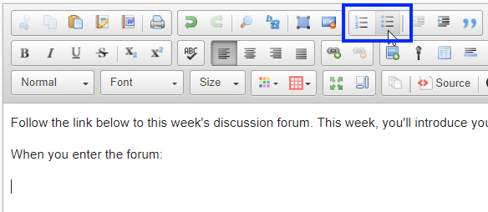
- Depending on your selection, a bullet or a number will appear. Type the first list item.
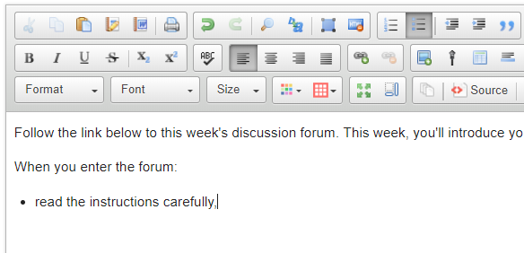
- To create the next list item, press Enter.
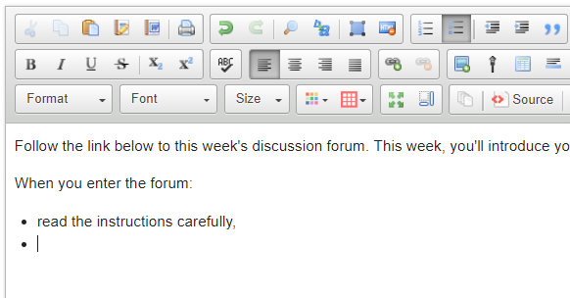
- To leave the list, press Enter twice.
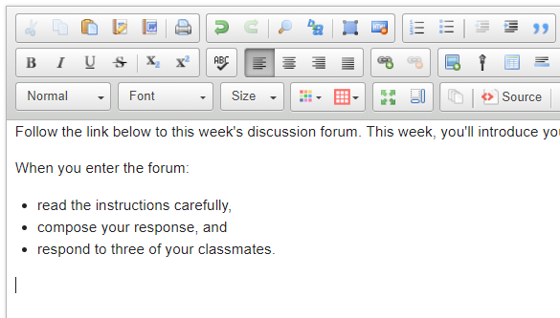

An Alternative Method for Formatting or Structuring a List
In Word or Sakai, highlight the complete list of items, and then click either the Bullets or Numbering option.
