Creating Accessible Tables in Microsoft Word
An accessible table generally contains simple data or structured information that is logical from left to right, top to bottom. It will have a title and one header row.
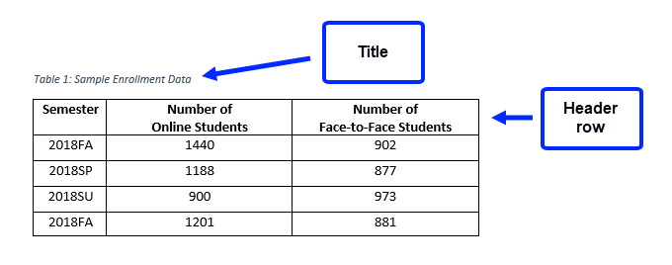

To Create a New Table:
- Select the Insert tab on the Ribbon.
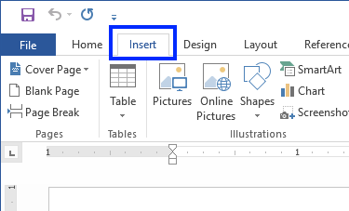
- Click the Table command. A drop-down menu containing a grid of squares will appear. Hover the mouse over the grid to select the number of columns and rows in the table.
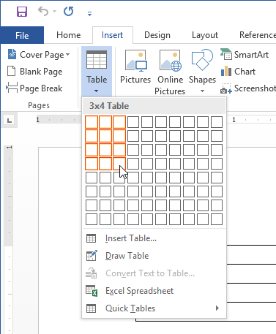
- Click the mouse, and the table appears in the document.

Formatting a Table for Accessibility
Adding a title and denoting the header row help make a table more accessible.

To Add a Title
Providing a title introduces the table to someone using assistive technologies, and it will also help identify the table’s content for everyone. Word identifies a title as a caption.
- Hover the mouse over the table. A plus sign appears in the upper-left corner.
- Right-click the plus sign and select Insert Caption.
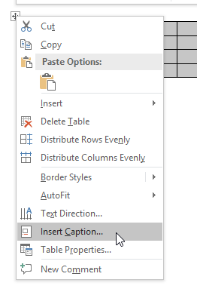
- A dialog box appears. In the Caption: field, type a title for the table and click OK.
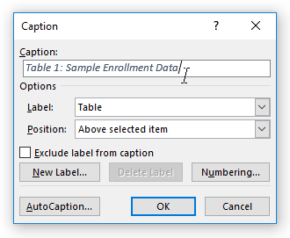
- The caption/title appears above the table.

To Identify the Header Row
- Highlight the top row and right-click. Select Table Properties from the menu that appears.
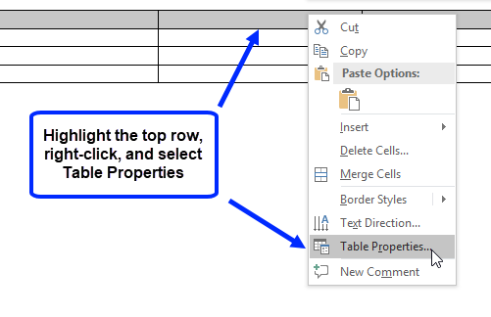
- A dialog box appears. Select the Row tab, and place a check the box next to Repeat as hear row at the top of each page.
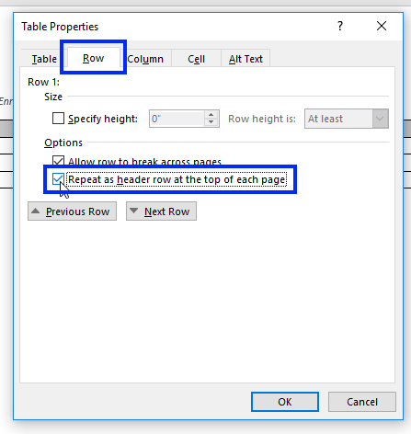

Accessibility Pitfalls
- Avoid creating your table with the Draw Table tool. It does not produce the structured table that the Table Command creates.
- Avoid blank cells. Instead, type blank cell or data not available. Change the font color to blend the text in with the background.
- Avoid creating page layouts with tables. Tables should be used to present data or structured information.
- Avoid merging or splitting cells or
- Avoid controlling the spacing in your table with blank rows or columns. Adjust line spacing instead.

Other Accessibility Considerations

Restricting Rows from Breaking across Pages:
When a table becomes large enough that it needs an additional page to display all of the content, restricting the table’s rows from breaking across pages can help keep all of the information in the last row intact.
- Select the entire table, right-click, and choose Table Properties from the menu that appears.
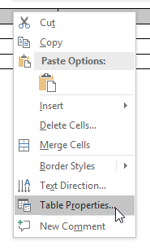
- Select the Row tab, and uncheck the box next to Allow row to break across pages.
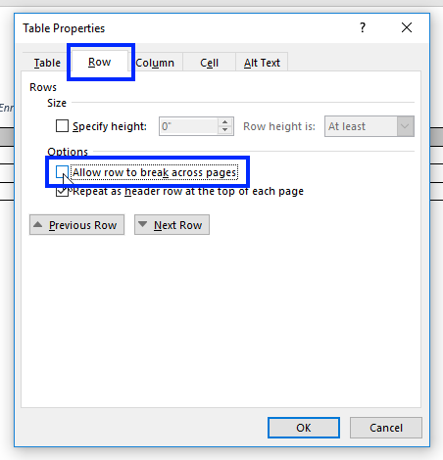

Adding Alternative Text
Alternative text provides information about the content of the table and is helpful to screen reader users. The title of the table can be used as the alternative text. If the table contains abbreviations or other information that needs to be explained with a longer description, this information can be provided in the Alternative text and should also be provided within the text of the document.
To add alternative text, open the Table Properties dialog box and select the Alt Text tab. Type the alternative text in the Description field.
