Composing Descriptive Hyperlinks
When creating a hyperlink, use descriptive language that specifies the purpose of the link. This is usually a few words, or a succinct description, stating where the link leads.

Creating Hyperlinks
If creating a hyperlink to a website, first visit the website and copy its address (URL).
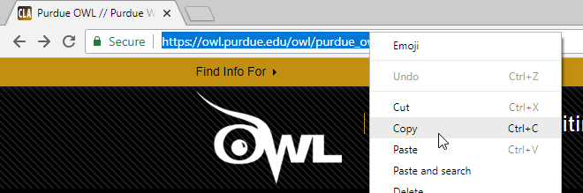

To Create a Hyperlink in Word and PowerPoint:
- Type the descriptive hyperlink text, and highlight it.
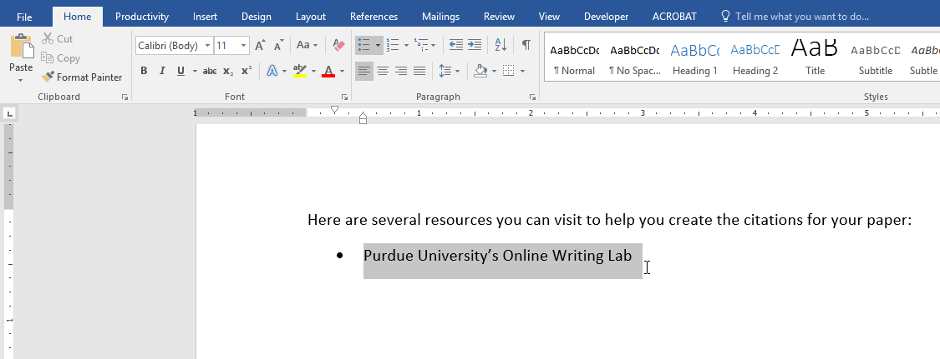
- Right-click the hyperlink text and select Hyperlink from the menu that appears.
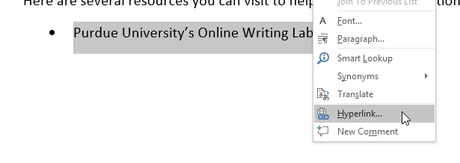
- A dialog box appears. In the Address field, paste the address (URL). Click OK.
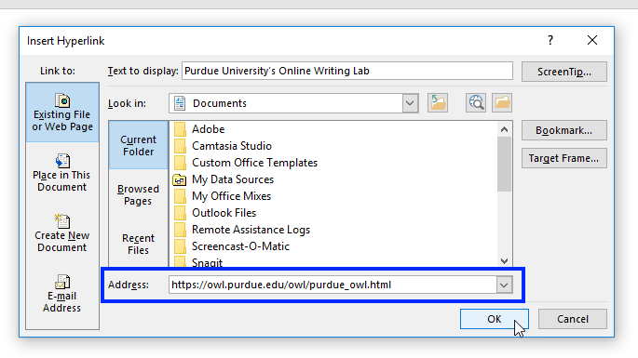
- The hyperlink is active (clickable).
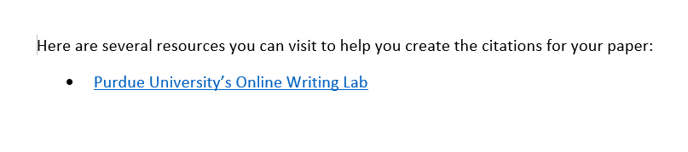
- If you think the document or presentation will likely be printed, as a courtesy you can paste the address (URL) near the active hyperlink. (Pasting the address is not necessary for accessibility compliance; however, it is useful when the content is printed, and if the URL is longer, you can shorten it using Bitly.com.)
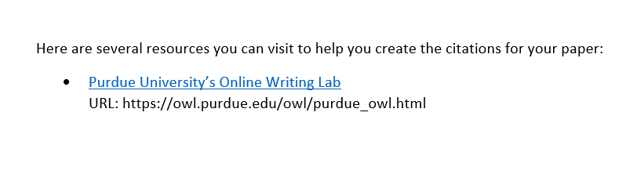

Please Make a Note!
- If you’re creating a link to a downloadable file, indicate the type of file in the active hyperlink (e.g., DOC, PPT, PDF). This helps make students aware that they will be downloading a file.
- Hyperlinks in PowerPoint can be tricky for an assistive technology user to navigate. To help ensure the student is alerted to the presence of a hyperlink, always include: (link) as part of the active hyperlink text. For example, Durham Tech Library (link).

To Create an Accessible Hyperlink Anywhere in Sakai:
- In the text editor, type the descriptive hyperlink text, and highlight it.
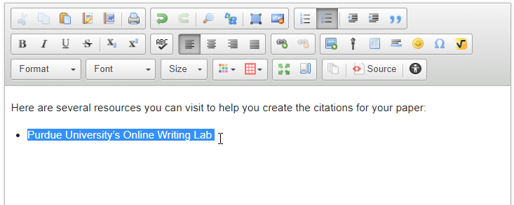
- From the text editor’s toolbar, click the Link icon.
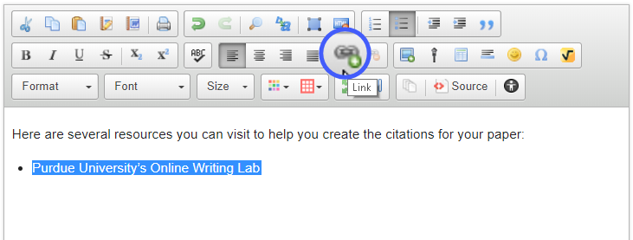
- A dialog box appears. In the URL field, paste the address (URL), and then click OK.
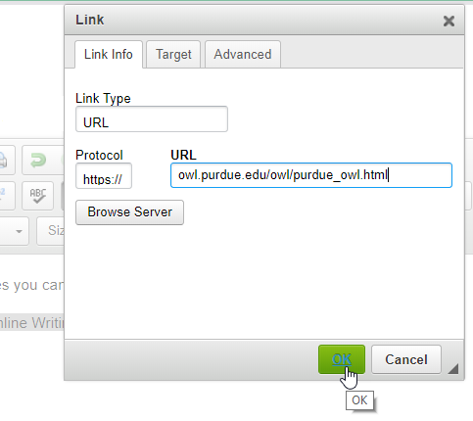
- The hyperlink is active. Click Save.
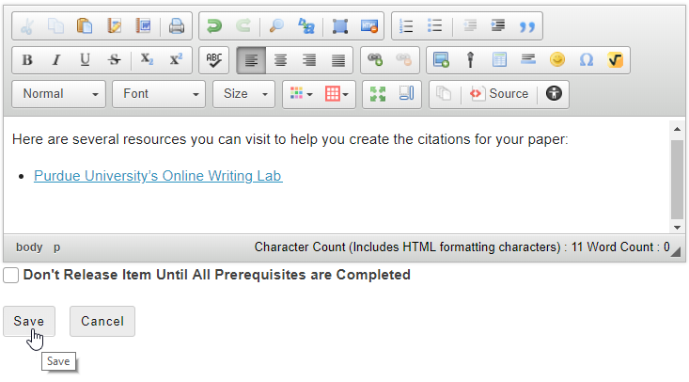

An Alternative Method for Creating a Hyperlink in the Lessons Tool
Within the Lessons tool in Sakai, there’s a second way to add hyperlinks.
- Click Add Content (or the icon) and select Add Content Links.
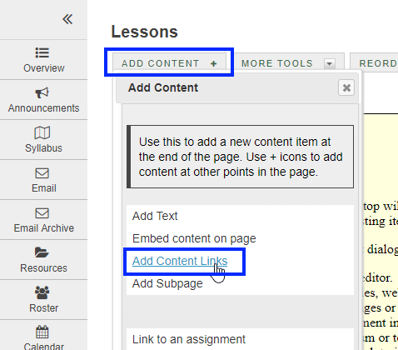

- A dialog box appears. In the Item Name field, type the descriptive hyperlink text. In the Or add a URL field, paste the address (URL), and then click Save.
