Applying Heading Styles
As you create content in Word or Sakai, consider the structure of your document or text. It is good design practice to divide longer content into sections, and then label each section with a heading or subheading. Applying heading styles to the title and headings creates accessible content structure allowing all users to scan the document or content for meaning.

Nesting Headings Appropriately
As you apply heading styles to your content, make sure to apply them appropriately so that proper hierarchy is established. Heading levels create an outline, and so it is important to apply them in numeric order rather than skipping levels.
- Heading 1
This heading style is applied to the title of a page (or content). It is the main heading and denotes the overall topic; therefore, it is usually used only once.
- Heading 2
Most of the subheadings that come after Heading 1 will receive a Heading 2 style. Heading 2 can be used as many times as needed.
- Heading 3, 4, and beyond
Your text may require additional subsections; these additional heading styles are available, if needed.

To Apply a Heading Style in Word:
- Highlight the heading (or subheading).
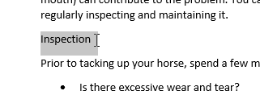
- On the Home tab, click the appropriate style.
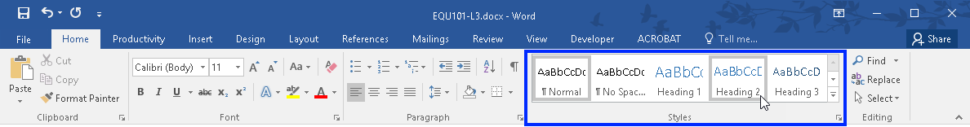
- The heading style is applied.
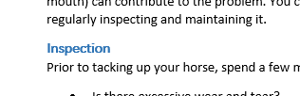

Word’s Navigation Pane
Microsoft Word's Navigation Pane displays text that's been formatted with a Heading Style. Whether you're working on a new document, or editing an existing one, the Navigation Pane can be a useful tool for taking a quick look at your document's structure or for verifying that heading styles have been applied.

To Open the Navigation Pane:
- Click the View tab on the Ribbon. Locate the Show group and place a check in the box next to Navigation Pane.
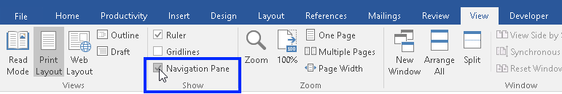
- The Navigation Pane appears on the left side of the screen. If heading styles are used in the document, they will appear here.
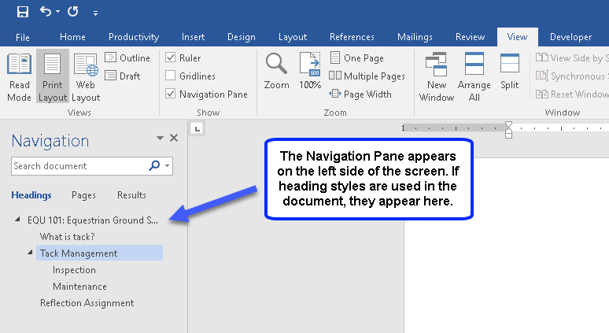
- To jump to a new location in the document, click a heading.
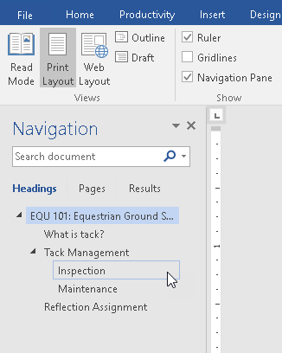

To Apply a Heading Style in Sakai:
- Highlight the heading (or subheading).
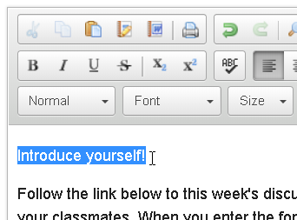
- Click the Format drop-down menu and select the appropriate style.
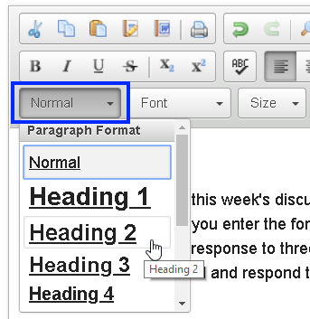
- The heading style is applied to the text.
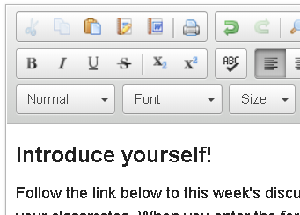
- Click Save.

