COMMUNICATIONS MANAGEMENT:

How to Create and Print Letters and Labels
Using COLLEAGUE

Durham Technical Community College Training Manual

Created by
Penny Augustine
08/12/08

TABLE OF CONTENTS

Page

Getting started…………………………………..……….………..……….………..……. 1

DOC: How to create a LETTER document…………….………..……….………..……. 3

GTA: How to create a track to assign a document to one or more students.….…….…... 19

PCB: How to print a document…..…………....………..………………………………. 27

Important processing information………………………………………….... 46

DOC: How to create, assign and print LABELS (document)……………………...…… 47

Mnemonics required for the processes shown in this manual………………..…..………. 69

Other mnemonics associated with communications management………………………. 70

Getting Started

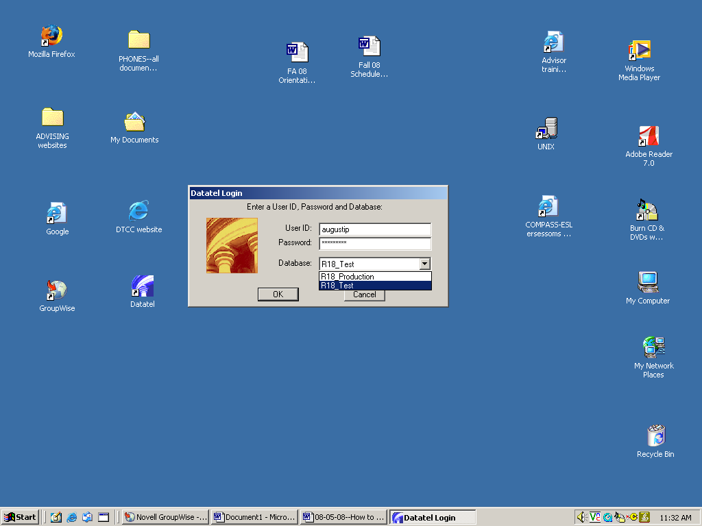
Remember to log into your R18 TEST account for this training session.

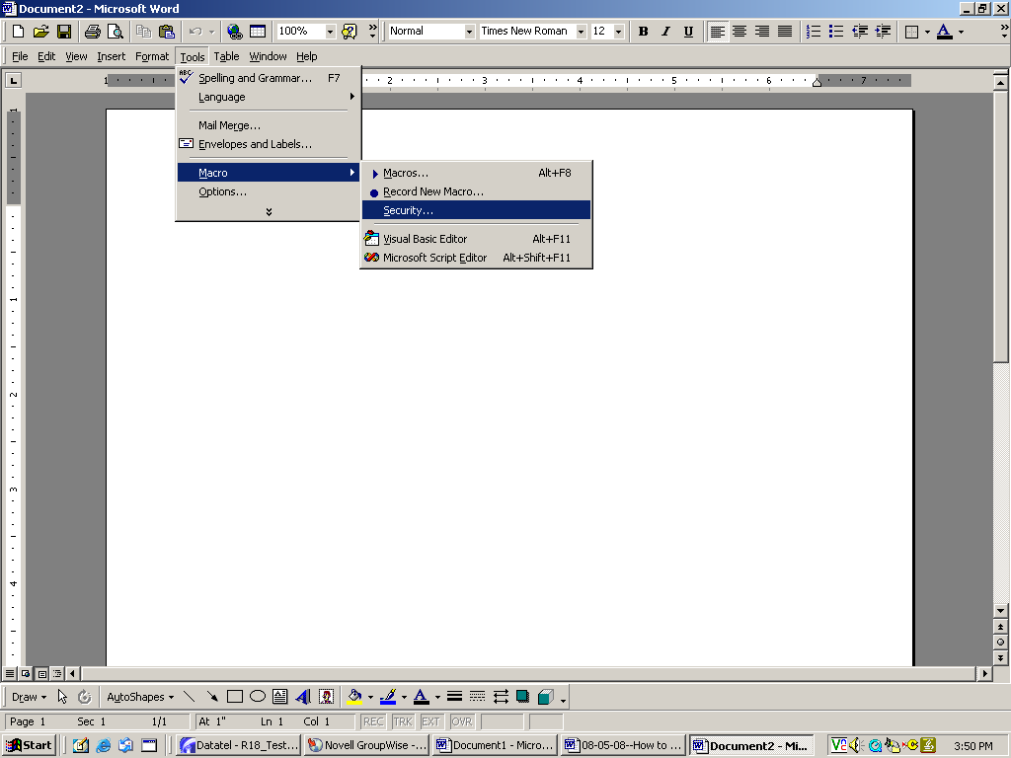

Setting your Security Level

Before you create your first document in Colleague, open Word and set your Security Level to “Medium.” Click on Tools, Macro and Security.

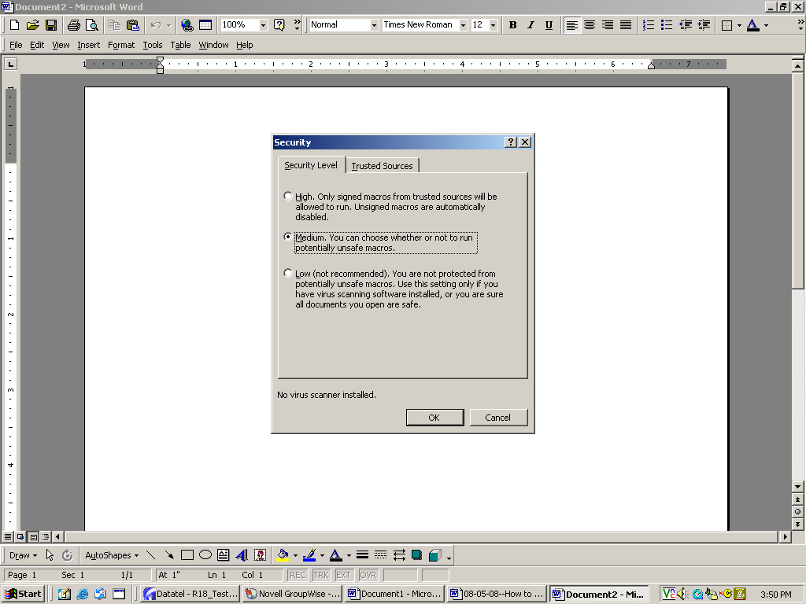
Click on Medium for your Security Level, then click OK to close Word.

Note: If you have difficulty creating a document in Colleague, you may need to close Colleague, return to Word and set your security to Low.

Very Important: You must close ALL Word or Excel documents on your desktop BEFORE you can create a document in Colleague.

DOC: How to create a LETTER document

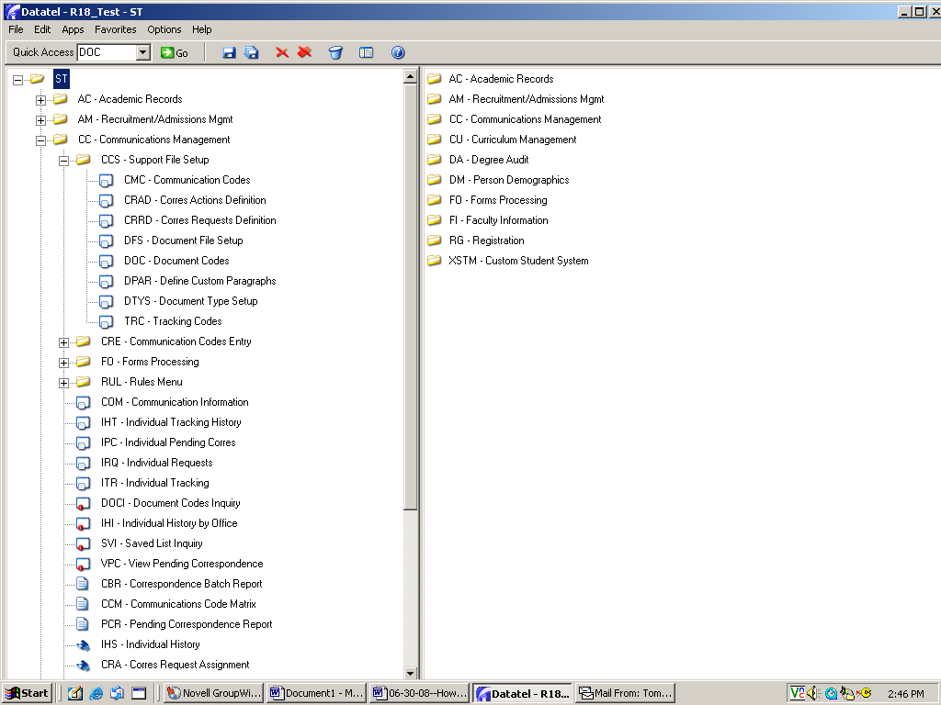
To create a Colleague document, begin by double clicking on DOC in your access tree

OR
type DOC in the quick access box, the click GO.

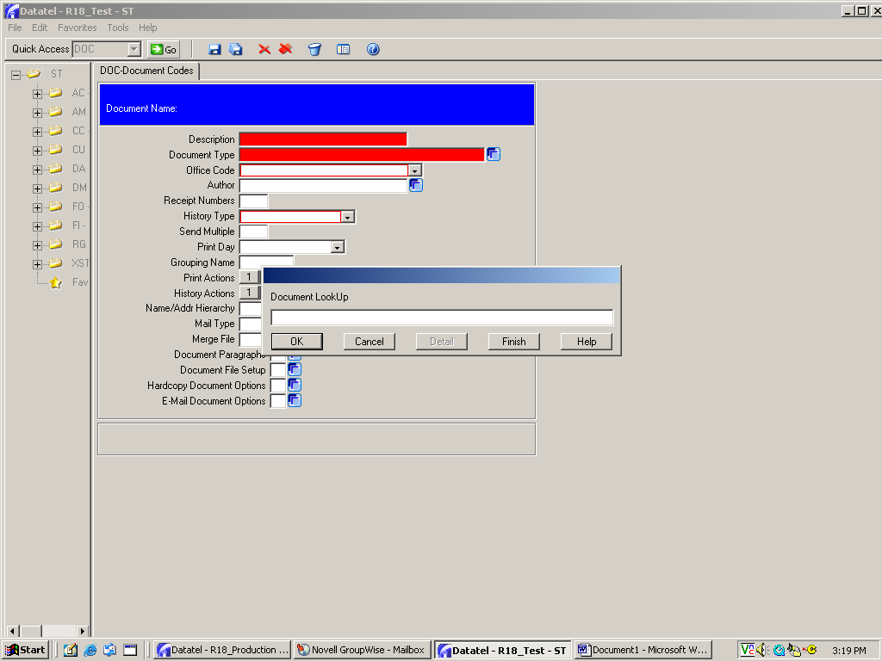
The Document LookUp box will appear. This will allow you to find and edit a document you’ve already created or create a new document.

For this training session, you will create a NEW document.

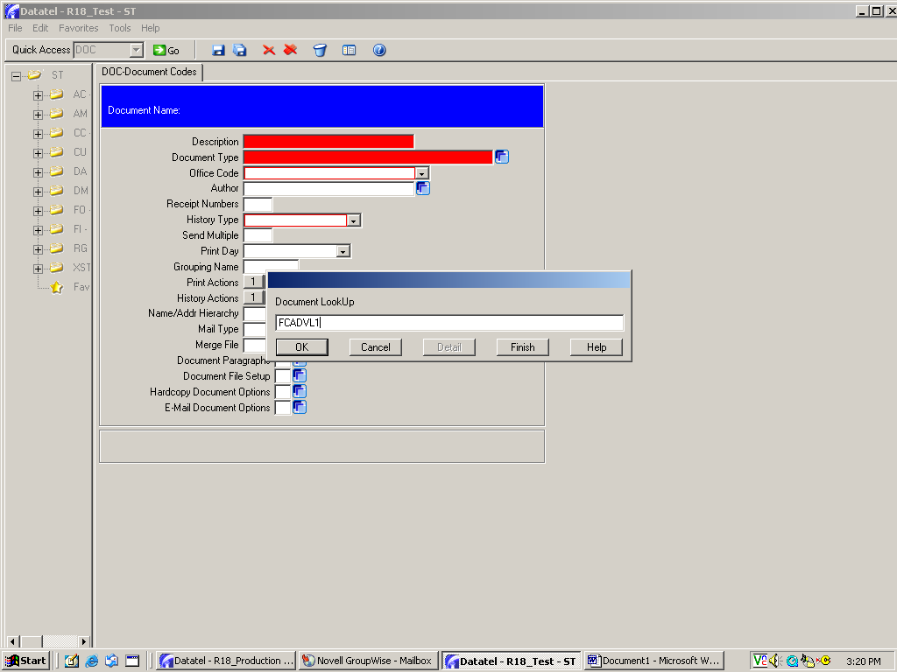
To create a new document, you’ll need to give it a document code name that will allow you to easily identify it the next time you use it. The naming convention for documents is:

Start with a 2-letter office code (ex. FC = Faculty Advisement; CU = Curriculum), then add 5 letters or numbers to identify the document.

This document was given the code FCADVL1 which means Faculty Advisement--Advising Letter 1.

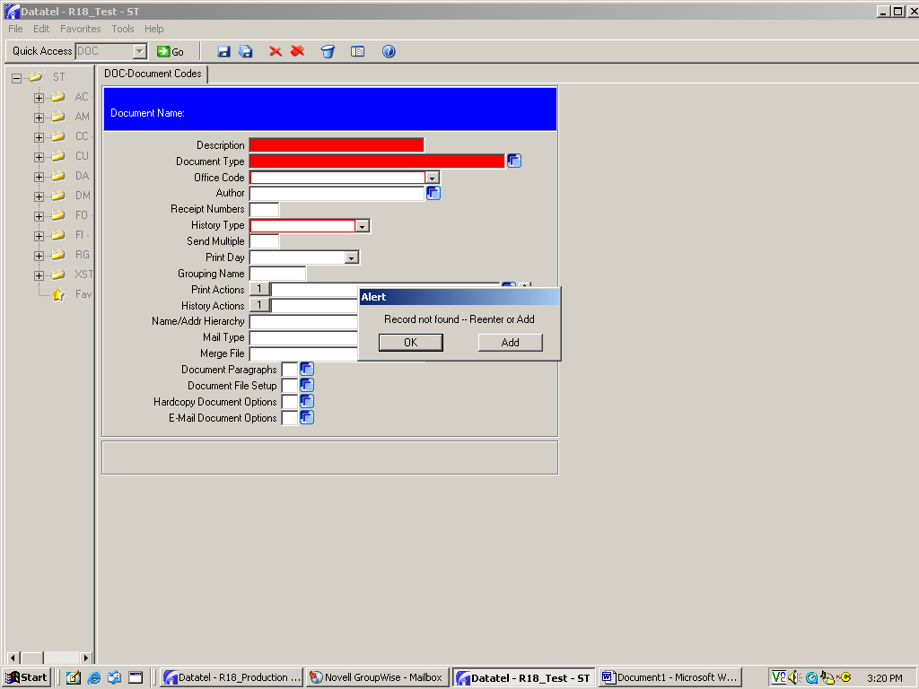
When you create a new document, you’ll always get this ALERT box.

Click on ADD to have the new document “added” to the list of Colleague documents.

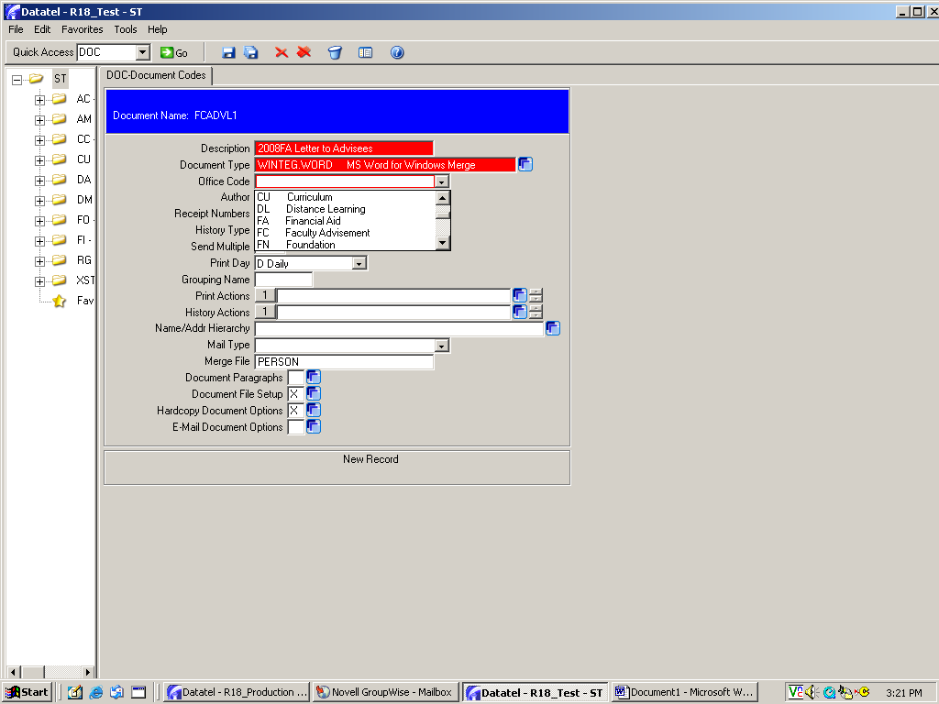
Description: Begin entering the identifying information for your document. Write a short description that will help you recognize the document again.

Document Type: This is always WINTEG.WORD. You can type it in or click on the blue box to find it in the menu…then select it.

Office Code: Choose the office code appropriate for your department. The dropdown box will display a list of department codes. (This office code will be used as the first two letters of your document’s code.)

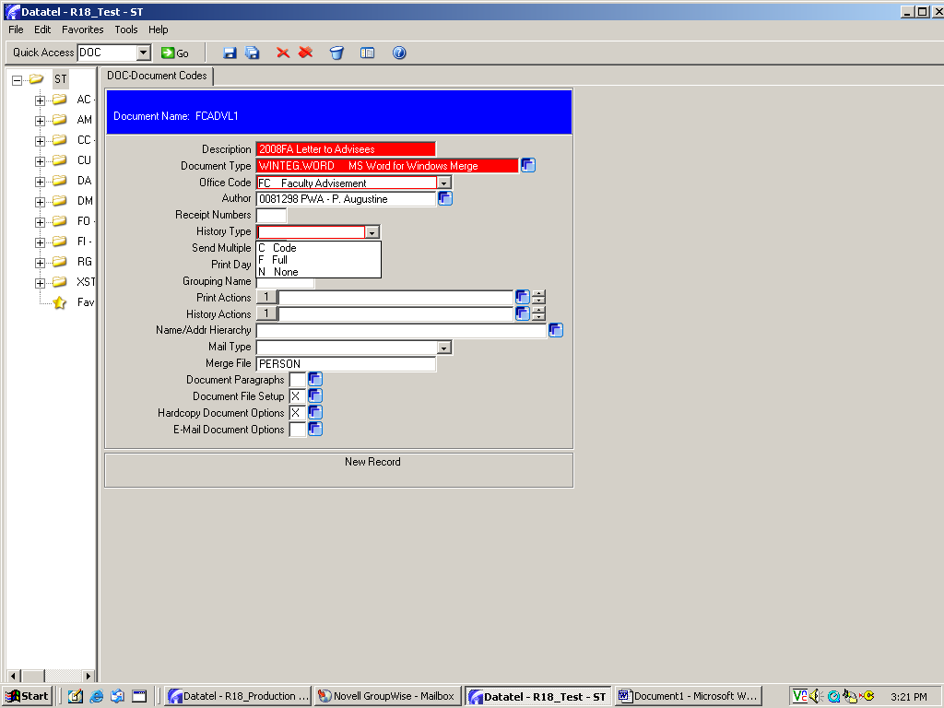
Author: If you enter your name, you will be the only person who can edit the document at a later date. If you leave this field blank, others can edit the document. You’ll need to decide which option is appropriate for your document.

History Type: Always choose C for Code.

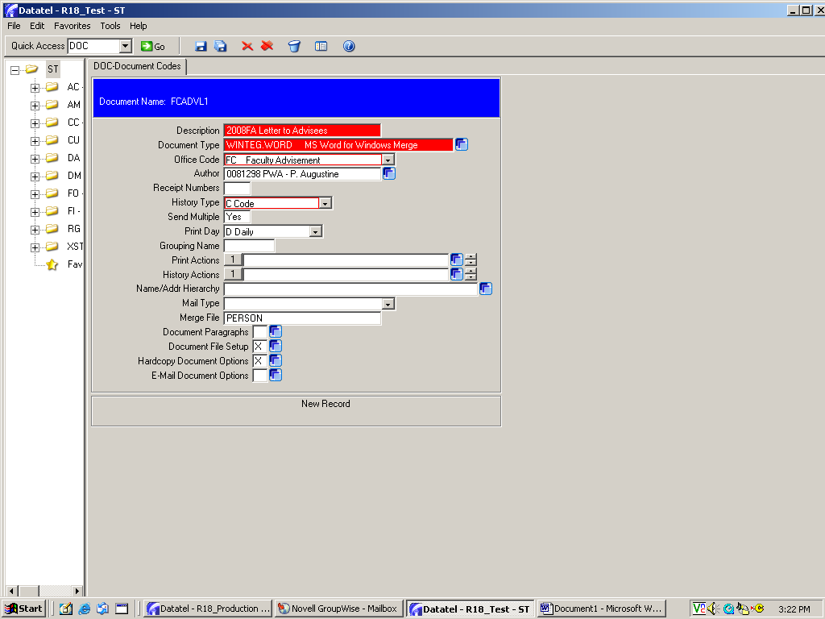
Send multiple: Always set this at YES so that you can send the document more than once.

Print Day: Always choose D for Daily to print the document at other times.

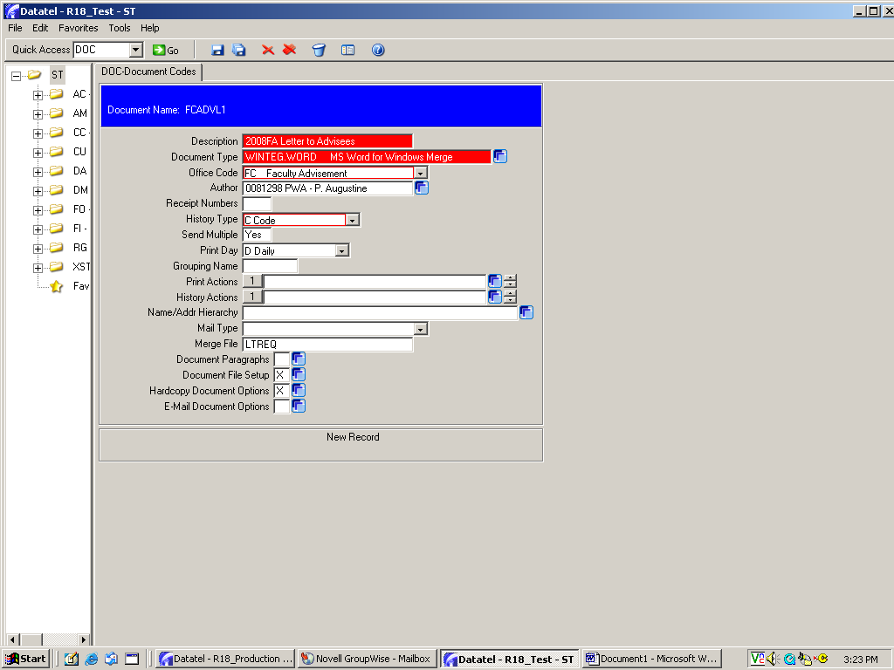
Merge File: The default is “Person.” Change this to LTREQ by typing in those letters.
Document File Setup: Click on the blue box to go to the DFS mnemonic screen. This screen will allow you to choose the Colleague data that will be incorporated into your document.

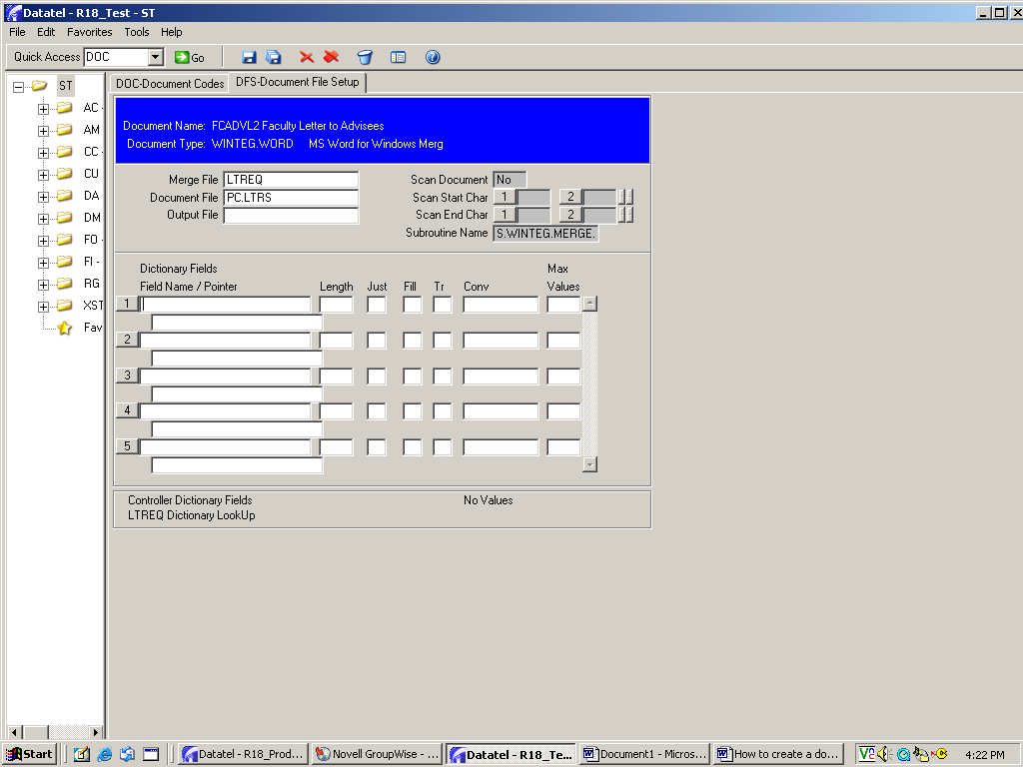
In DFS, the Merge File, Document File, Scan Document, and Subroutine Name fields will already be populated. Don’t change anything.

In the blank fields in the middle of the page, you will begin entering the field names for your data.

When you enter a Field Name, the Length and Justification fields (and sometimes the “pointer” field) will automatically populate. Don’t change anything.

If you are creating a document and would like to include the person’s name in the greeting (ex. Dear Martha Johnson), enter the following:

FIRST.NAME = first name
LAST.NAME = last name
Although not included here, MIDDLE.NAME = middle name. Note that LTREQ.PERSON automatically populates in the “pointer” fields for first and last names since that data exists in a different merge file.

If you want to include the mailing address in your letter, always enter ALL of these field names:

LTREQ.ADDRESS1
LTREQ.ADDRESS2
LTREQ.ADDRESS3
LTREQ.ADDRESS4
LTREQ.ADDRESS5

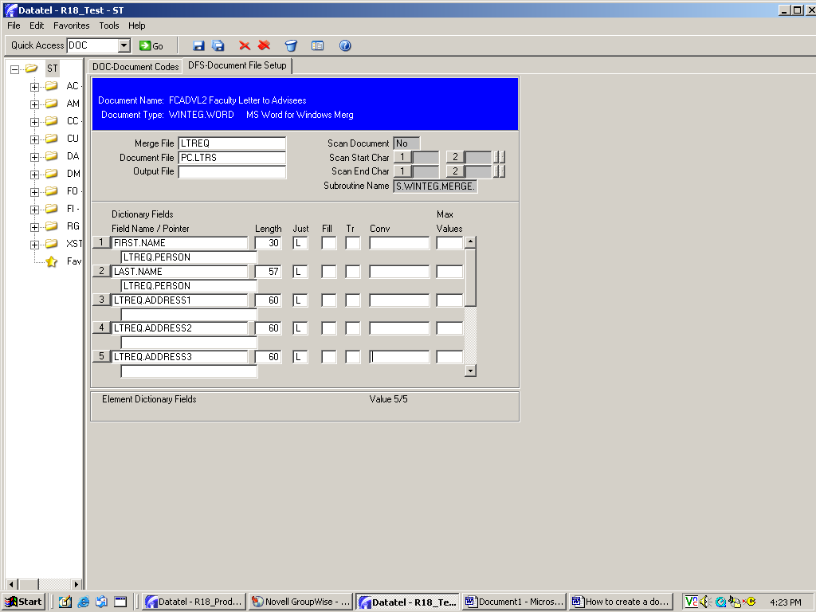
Lines 6 & 7 will appear after you enter LTREQ.ADDRESS3.

See next page for entry of the final two field names.

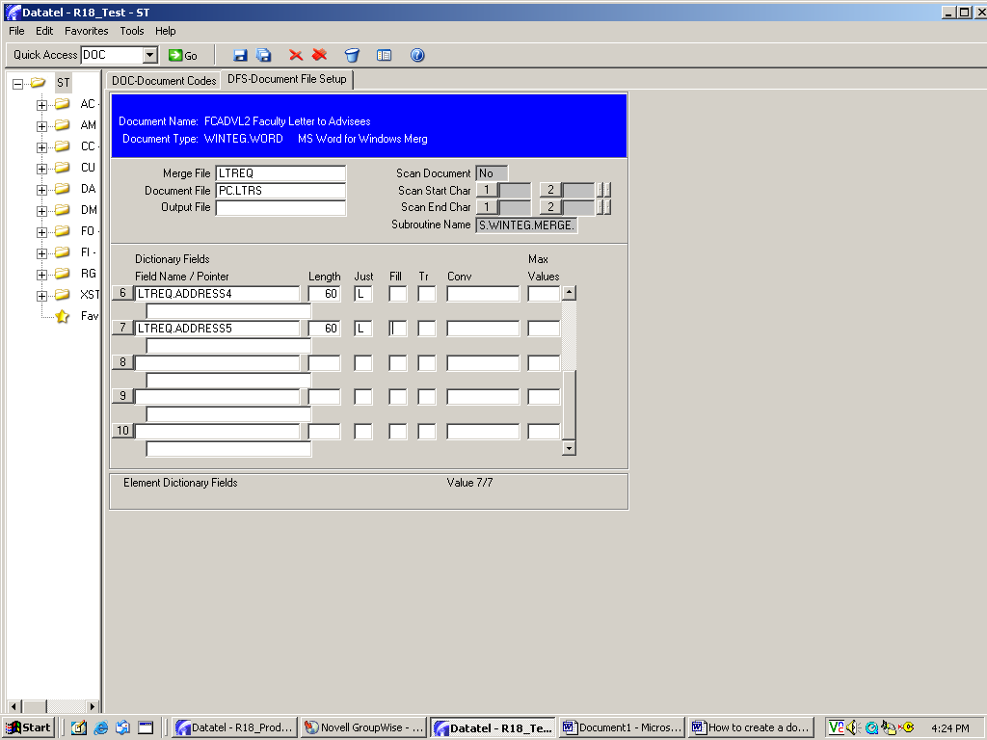
These are the final two field names needed for the mailing address.
FYI: If you want to include a student’s ID number in your document, the field name is just ID.

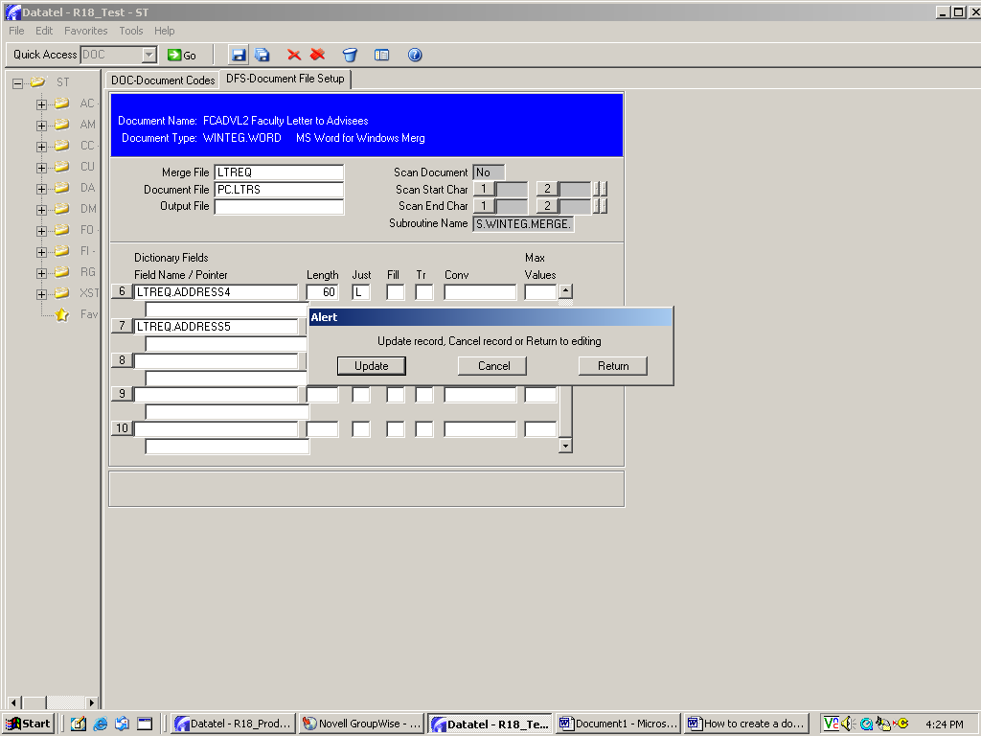
When you finish entering field names, click on Save, then Update to return to the DOC screen.

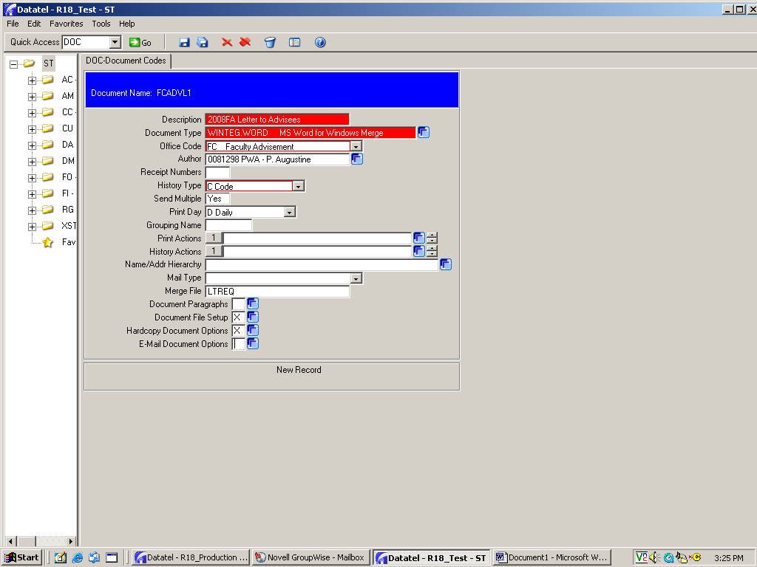
Now you’re ready to create your document.

Begin by clicking on the blue box for Hardcopy Document Options.

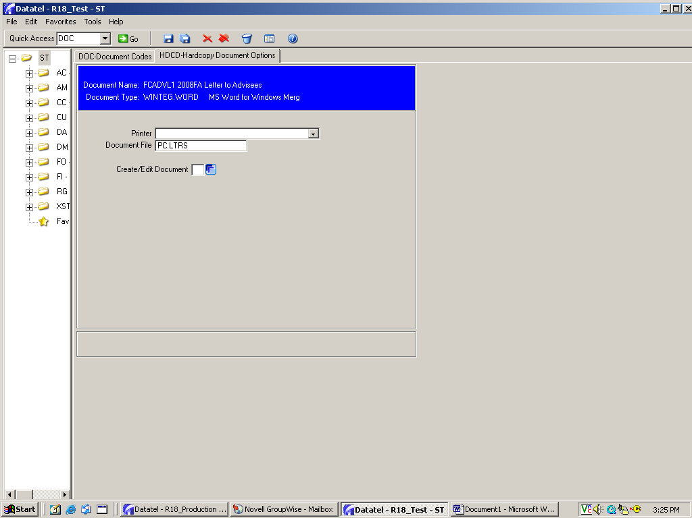
Next, click on the blue box for Create/Edit Document.

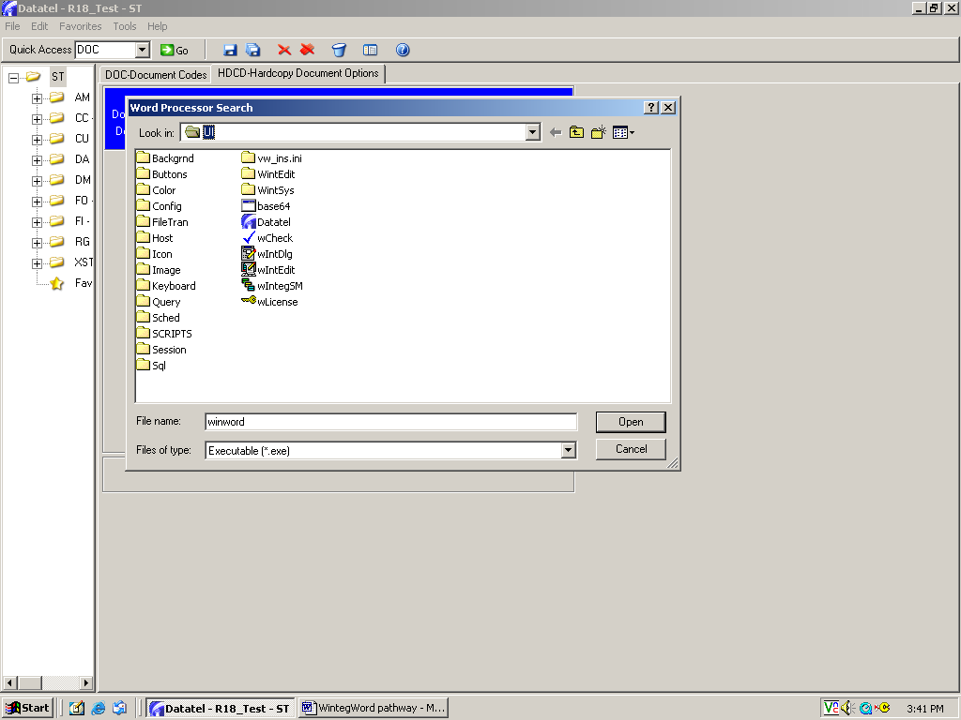
The first time that you create a document in Colleague, you MAY get this alert box. If that happens, follow the directions on pages 10-13 to set the pathway to WinWord. If you do NOT get this alert box, then go directly to page 13 to continue.

******
If this box appears,
notice that the Lookin field is set to UI.

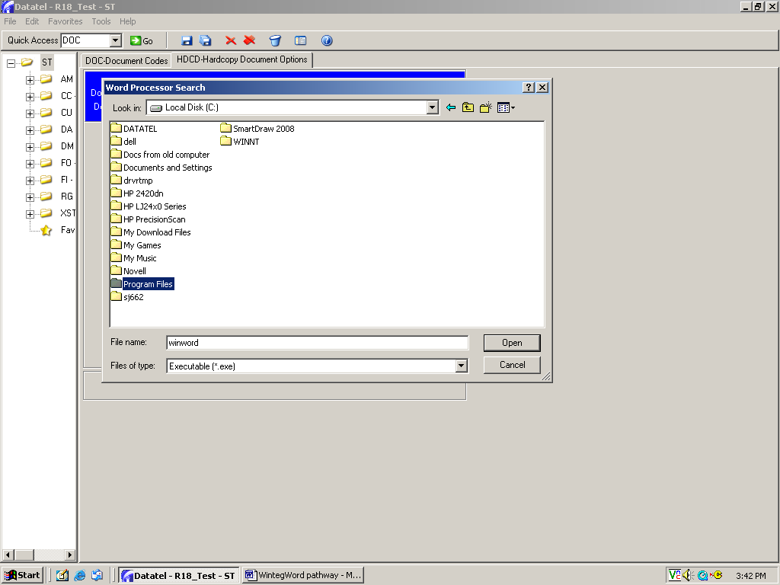
Click on the dropdown arrow and choose Local Disk C, then double click on Program Files.
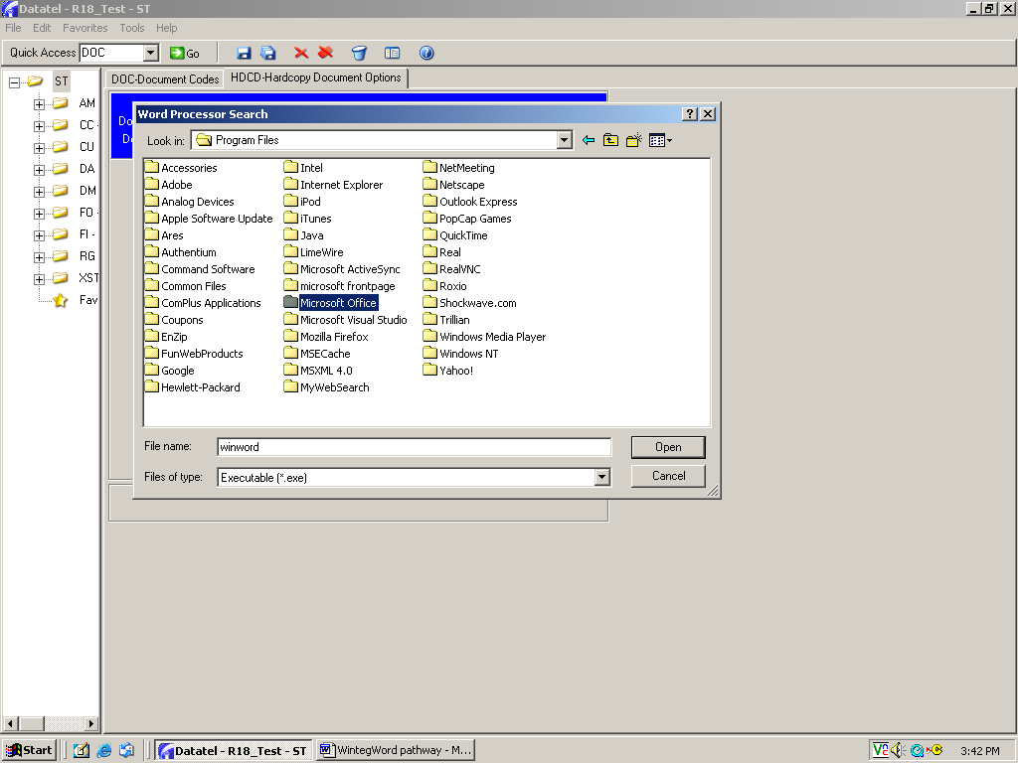
Double click on Microsoft Office.

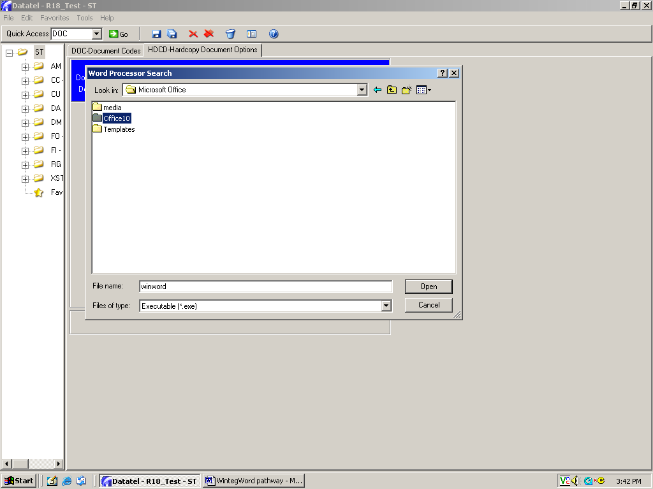
Double click on Office10.

(If you have a different version of Office (ex. Office11), double click on your version.)
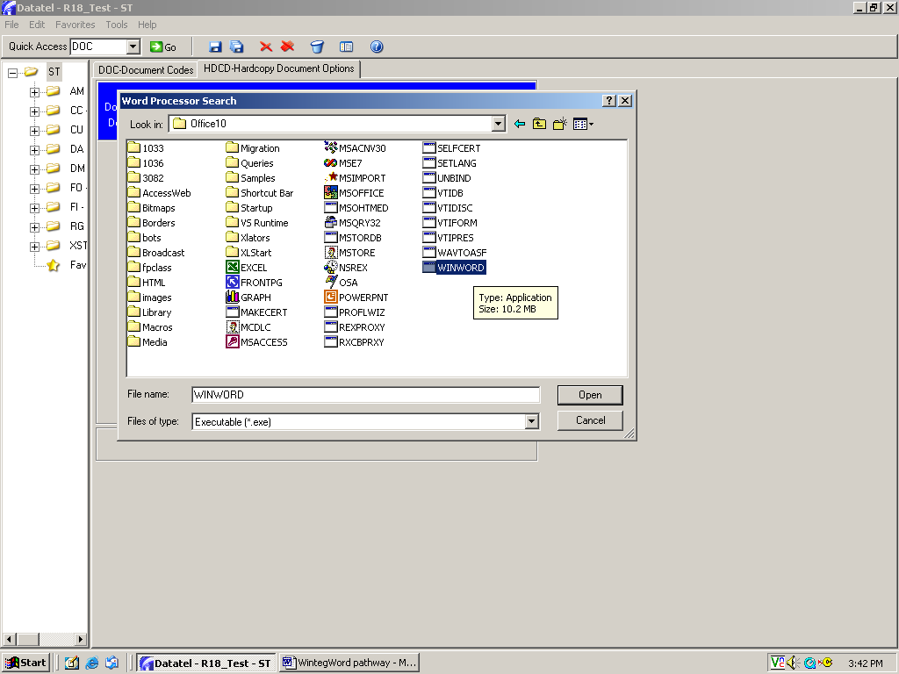
Double click on WinWord.

(You may need to scroll over to find it since it’s usually at the very end of the list.)

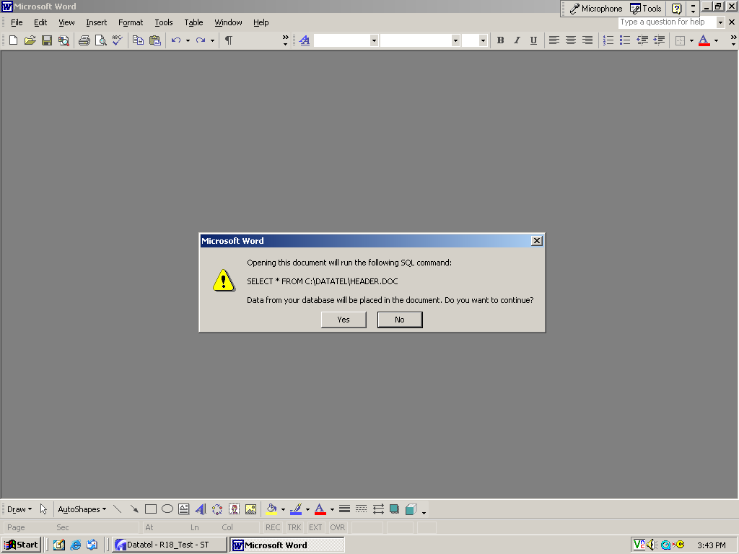
Click on Yes.
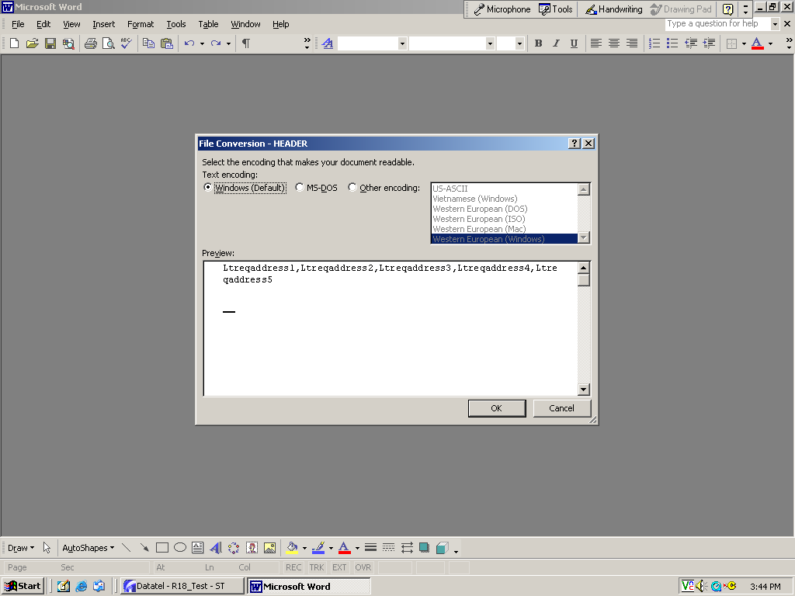
Click on OK to continue.

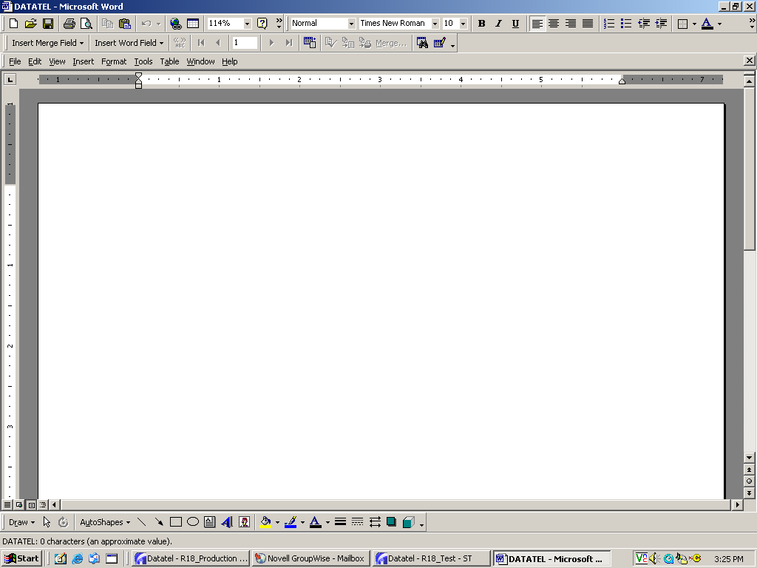
Once Colleague opens Word, a blank document will appear. You will create your document on this screen.

DON’T FORGET: Make sure there are no other Word or Excel documents open on your desktop when you create a document in Colleague.

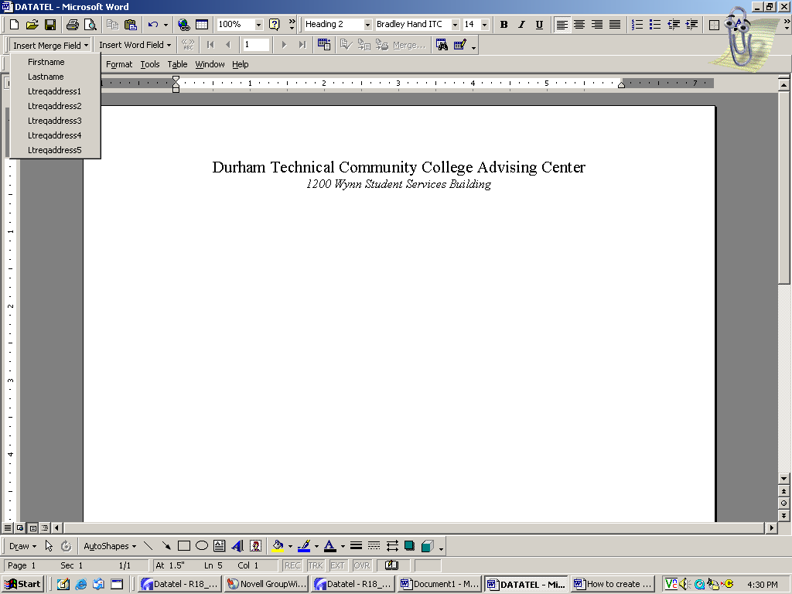
I created a minimal “letterhead” for this example.

If you are comfortable using the “insert” function of Word: If you have a blank DTCC letterhead set up on your computer in Word, you can insert it into your Colleague document…and then just type your letter. It won’t be fancy, but you can print on plain paper rather than having to use regular letterhead. To begin, click on the regular Insert tab on the task bar. On this screenshot, the Insert tab is hidden by the insert mail merge box that’s open. Click on Insert, then File. Find the appropriate file in the lookup box for “My Document” and then double click to insert it to the document you’re creating.
When you’re ready to incorporate your Colleague data into your document, click on the “Insert Merge Field” box to find the field names.

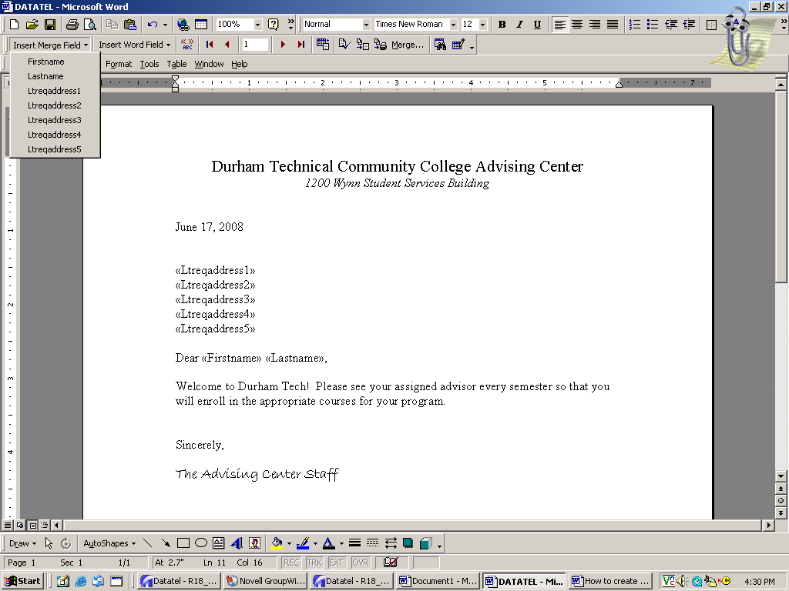
Now you can begin to insert the field names into your document. Place your cursor where you want the field to go, then double-click on the appropriate field name listed in the “Insert Merge Field” box on the toolbar.

Now start typing your document.

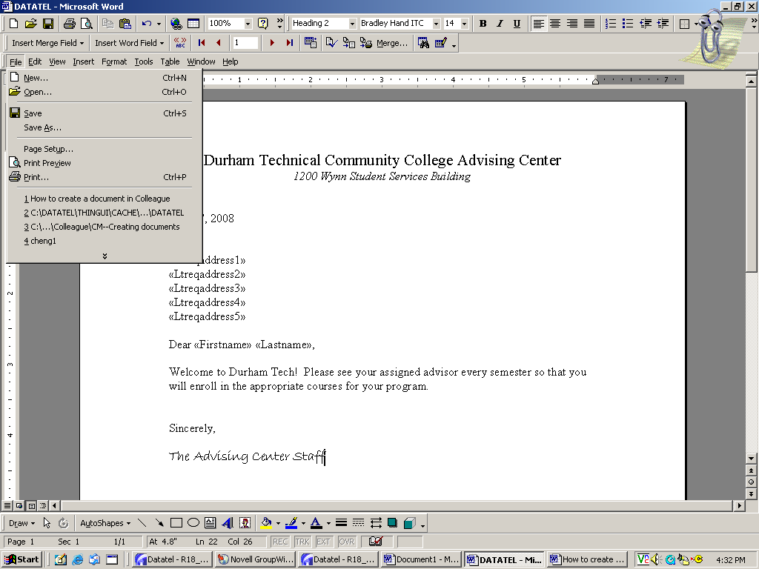
When your document setup is complete, click on Save.

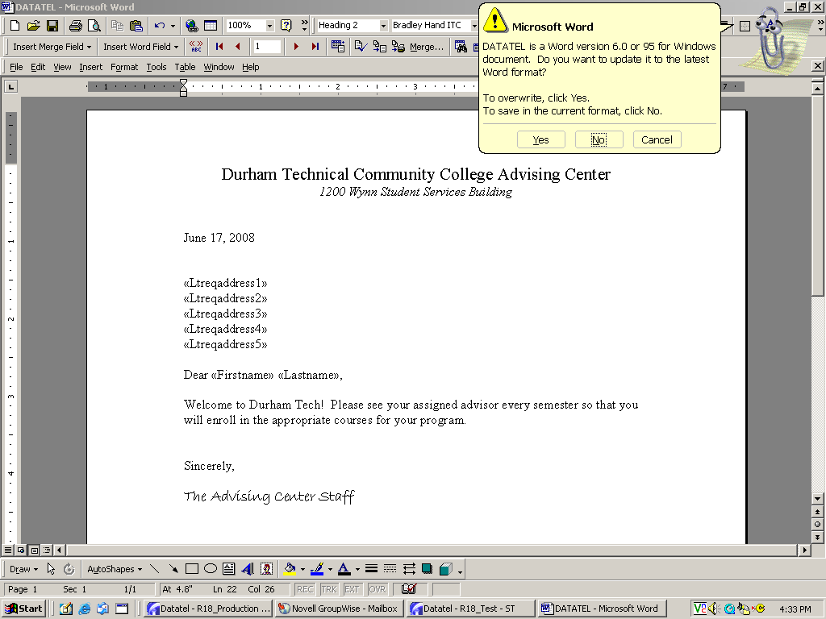
Depending on what version of Word you have, you may get this alert box.

If it appears, click on NO to be able to save the document.
Once your document is saved, click on the X in the top right corner to exit Word.

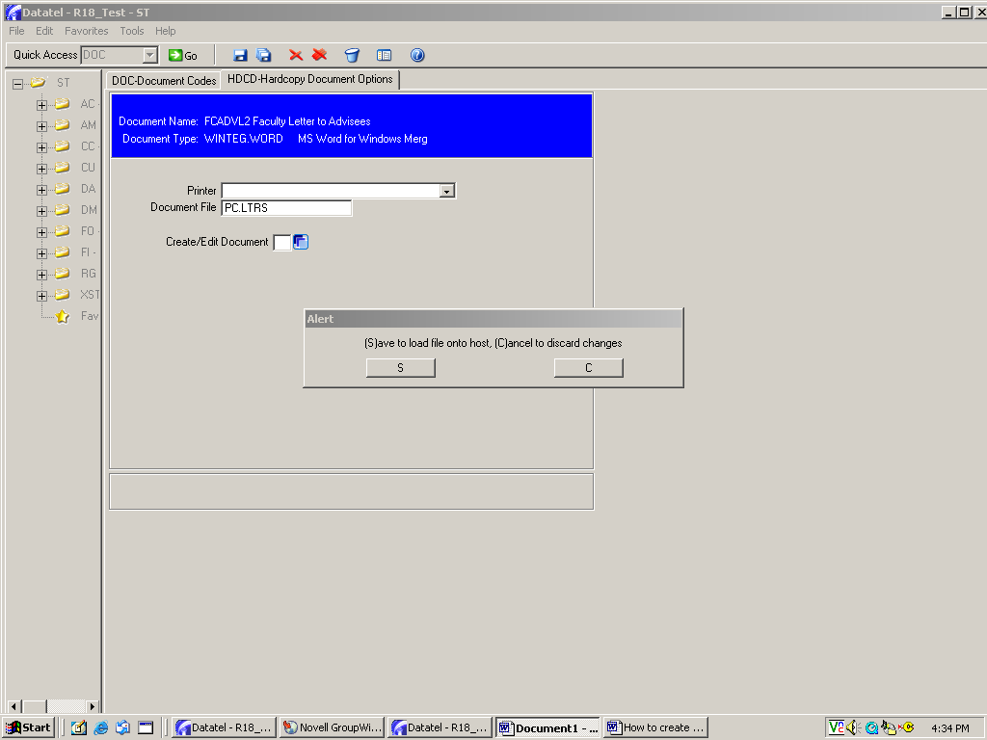
When the HDCD screen reappears, you MUST click S to Save your document.

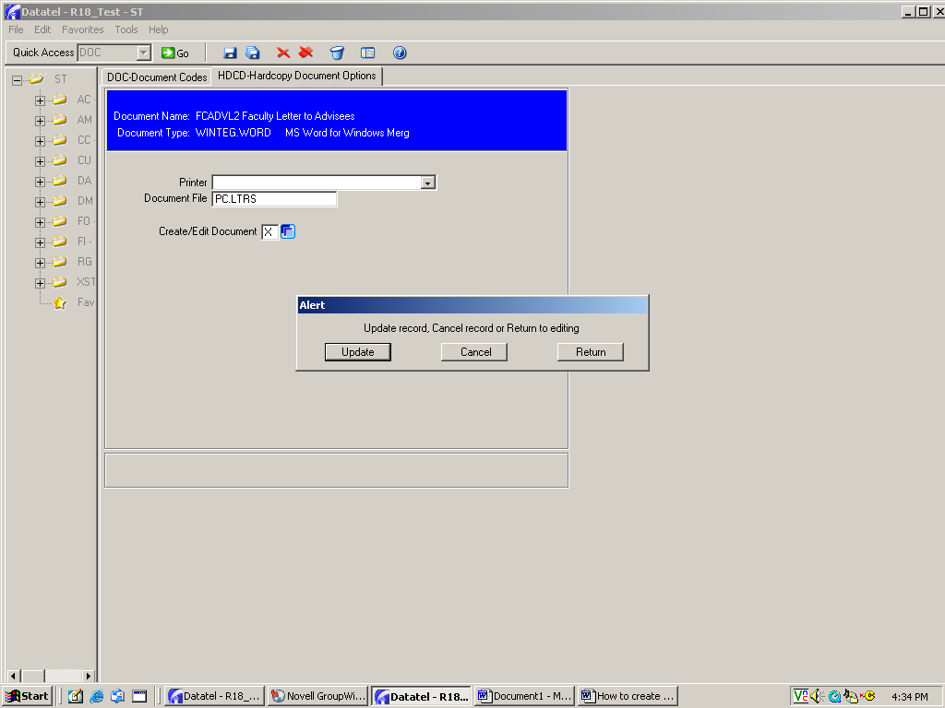
Click Update.

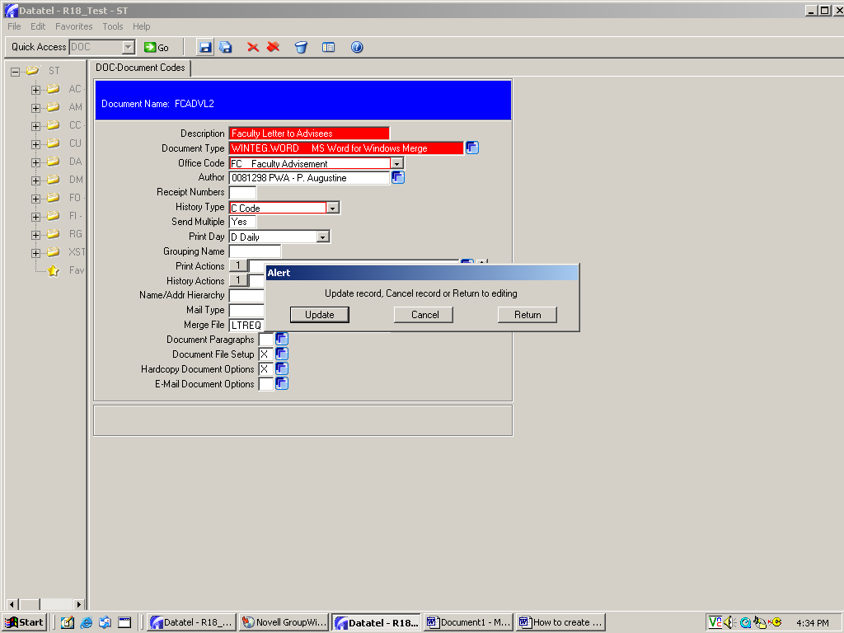
When the DOC screen appears, click Save All or Save and Update.

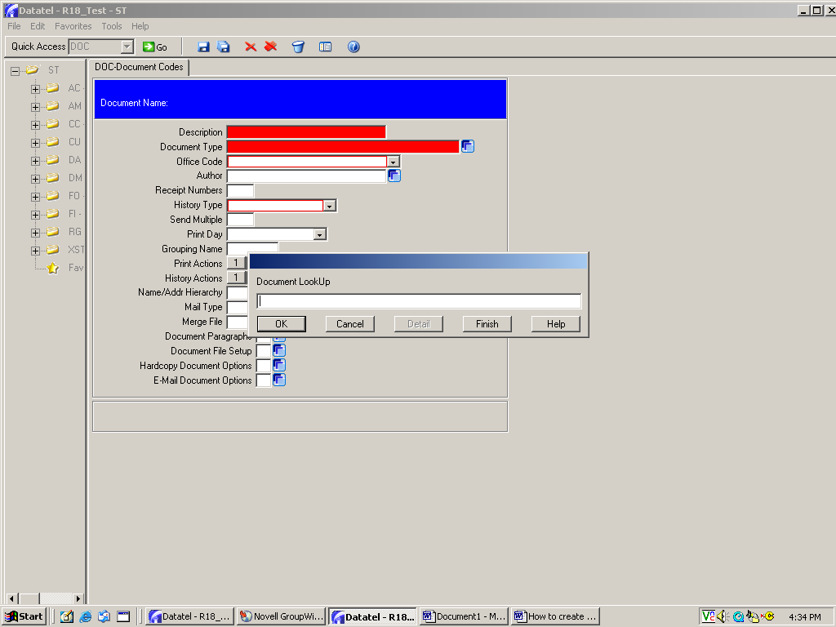
Your screen will return to the DOC mnemonic. At this point, you can click on Cancel to exit.

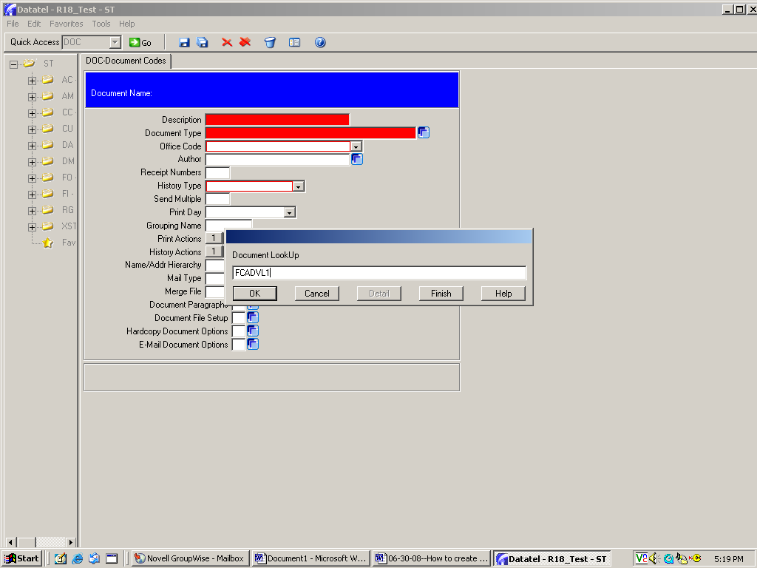
EDITING YOUR DOCUMENT

If you decide to make changes to your document after it’s created, go back to DOC and type the document code in the LookUp box and click OK.

Note: If you’ve forgotten the document code, type … in the LookUp box to pull up the list of all documents, then look for yours. The description will be displayed, so that’s why you always want to write a description that makes sense to you.

When the DOC screen populates with your document, click on Hardcopy Document Options to pull up the actual document.

Remember that you always have to go through the SAVE options again to keep any changes yo make to your document.

How to use

GTA: How to create a track to assign a document to one or more students

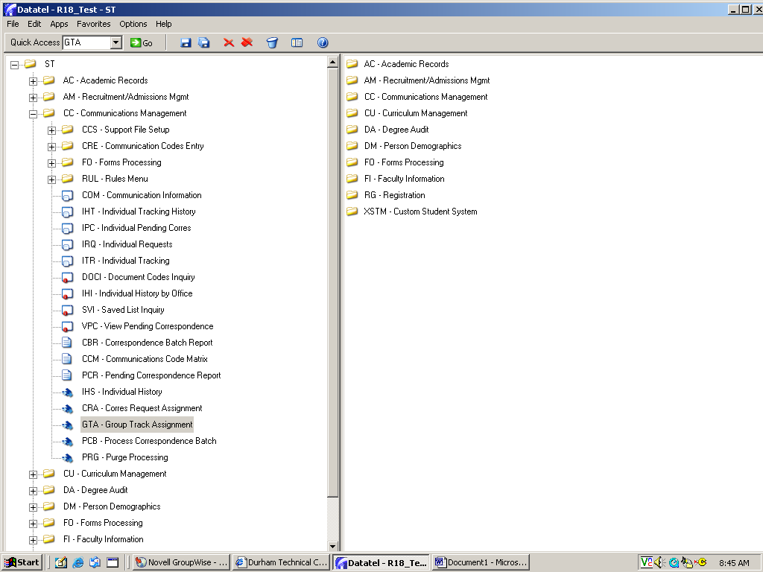
Access GTA (Group Tracking Assignment) through Quick Access or your mnemonics tree.

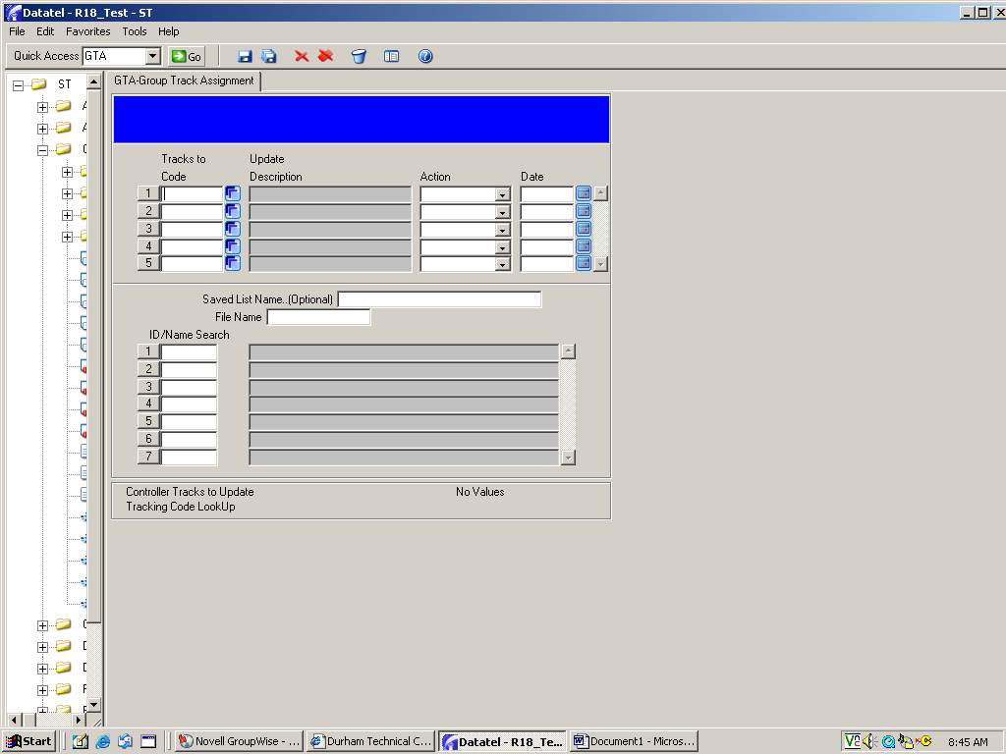
Drill down on the blue box on the first line to begin creating a document track.

NOTE: Once created, this track can be used any time you want to assign this particular document to one or more students.
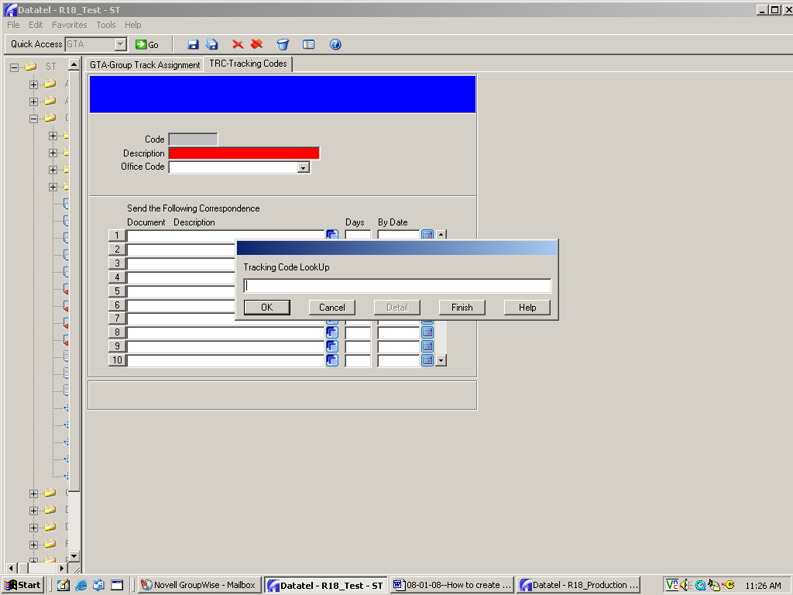
Your “track” will be created on the TRC screen.

Decide on track name that you will recognize, then type the name in the lookup box. Use the naming convention for your track title.

Example: FCADVL1
FC=Faculty Advisement
T=Track
AVL1=Advising Letter 1

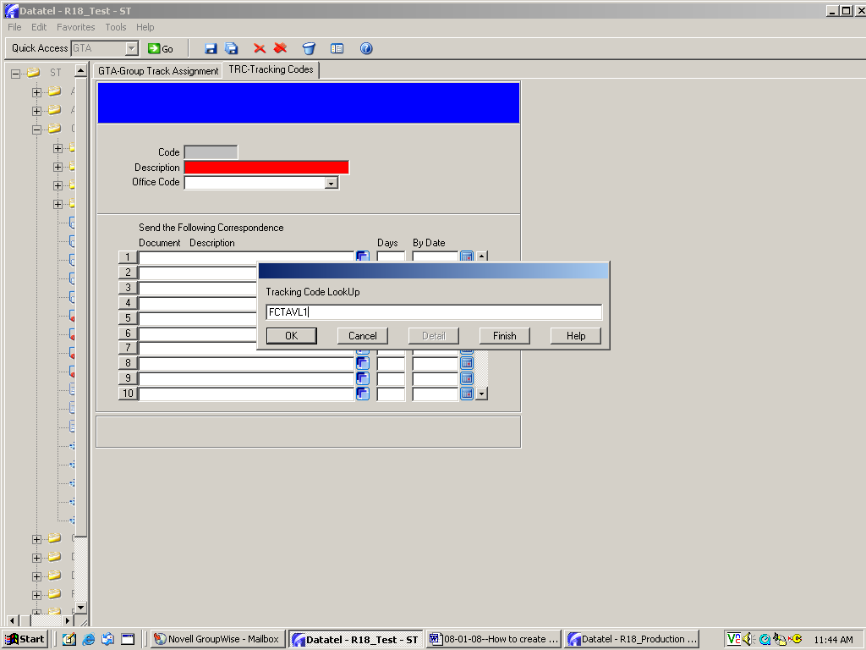

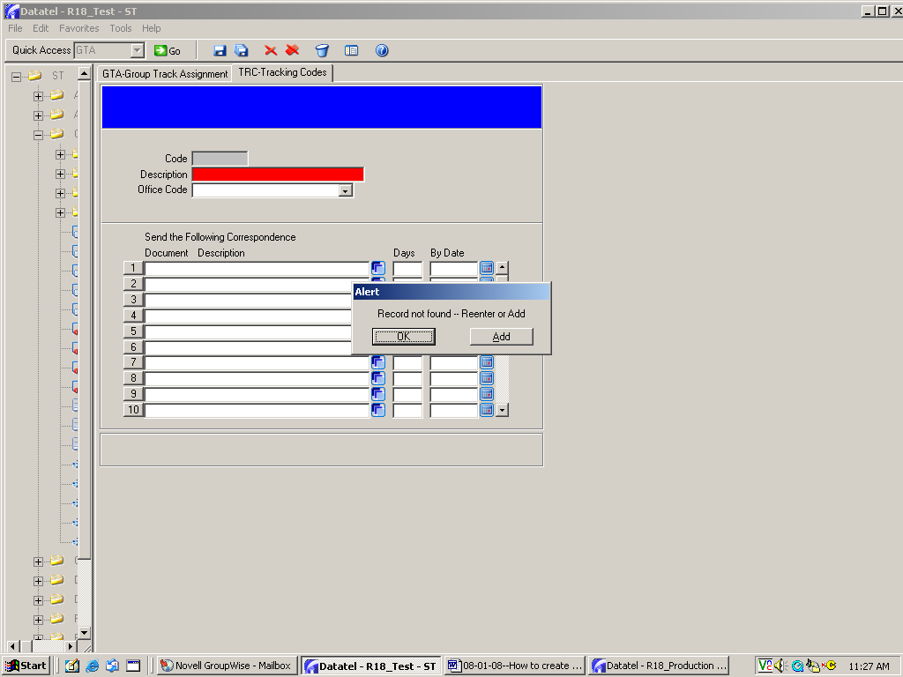
Since this is a new track, an ALERT box will appear. Click on Add to continue .

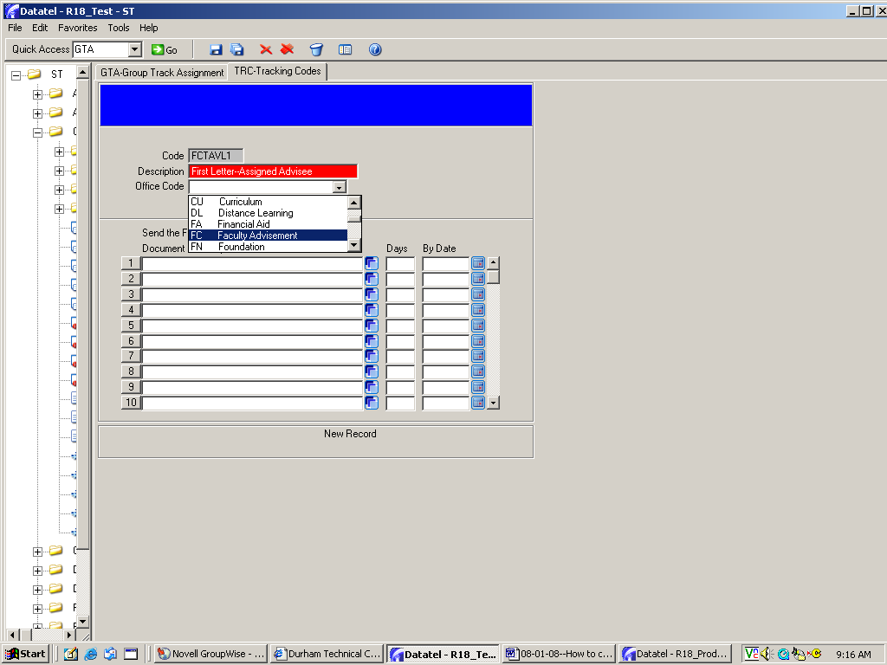
Write a brief, recognizable description for the track, then choose your appropriate office code.
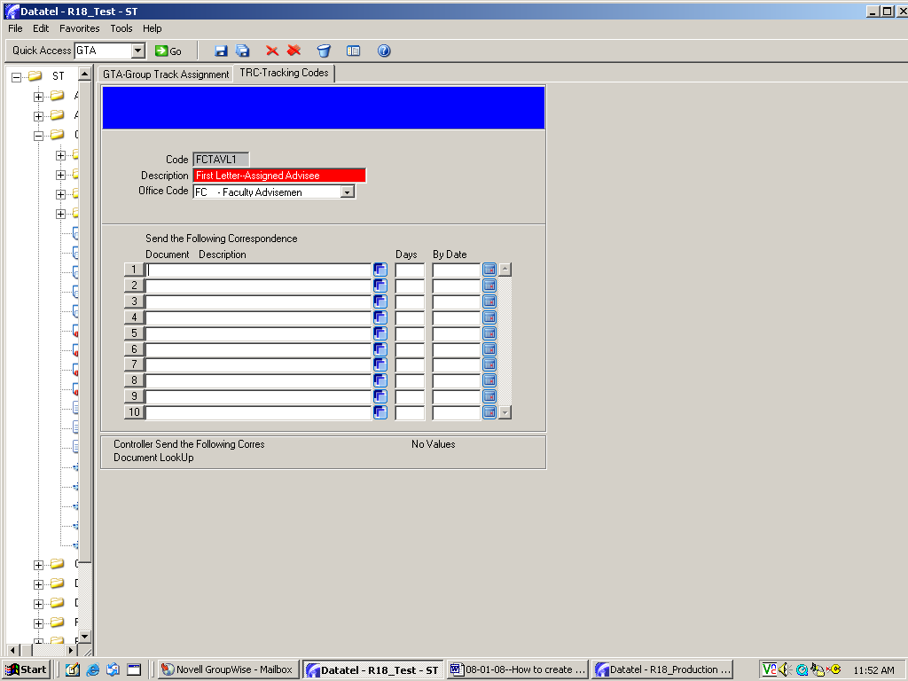
Click on the blue box on the first line to find the document you want to link to this track.

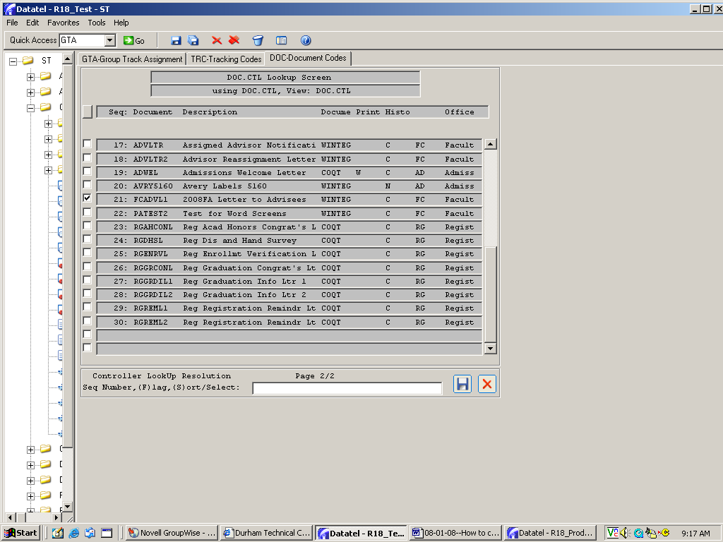
Click on the document, then save and update.

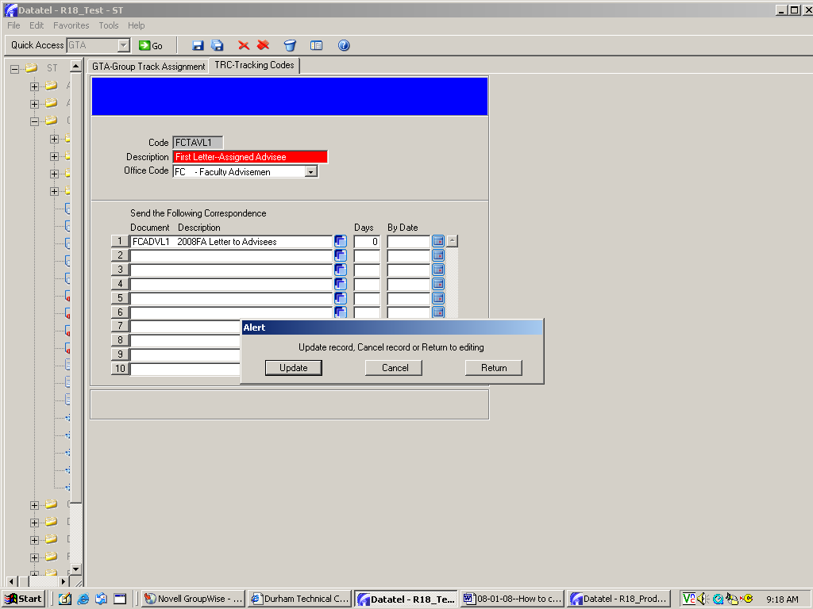
When the document appears on the TRC screen, type 0 in the “days” column, then save and update.

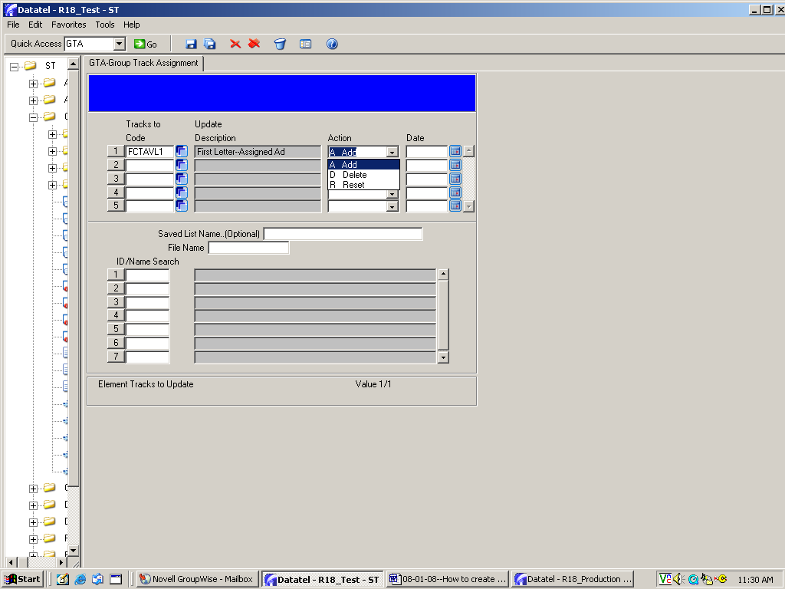
When the GTA screen appears again, click on the down arrow for “Action” and choose Add.

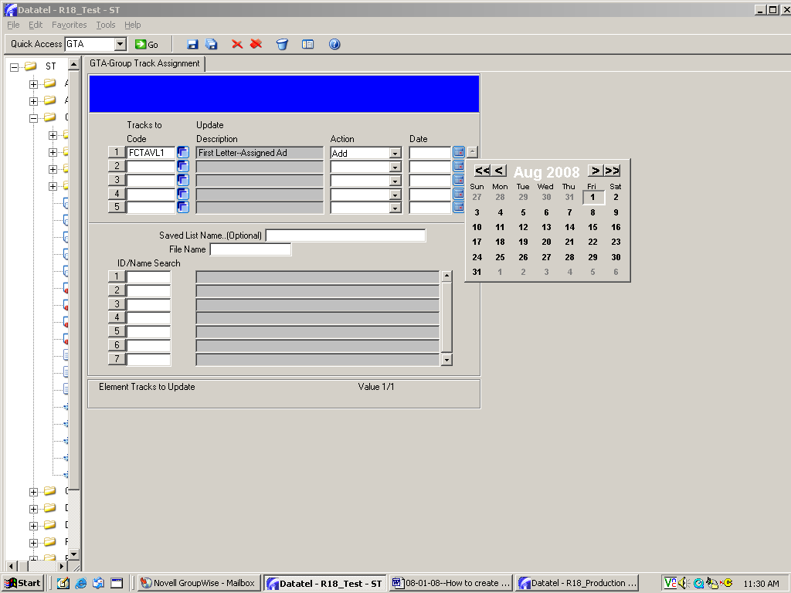
In the Date box, either use the calendar or type in the date that you created this track.

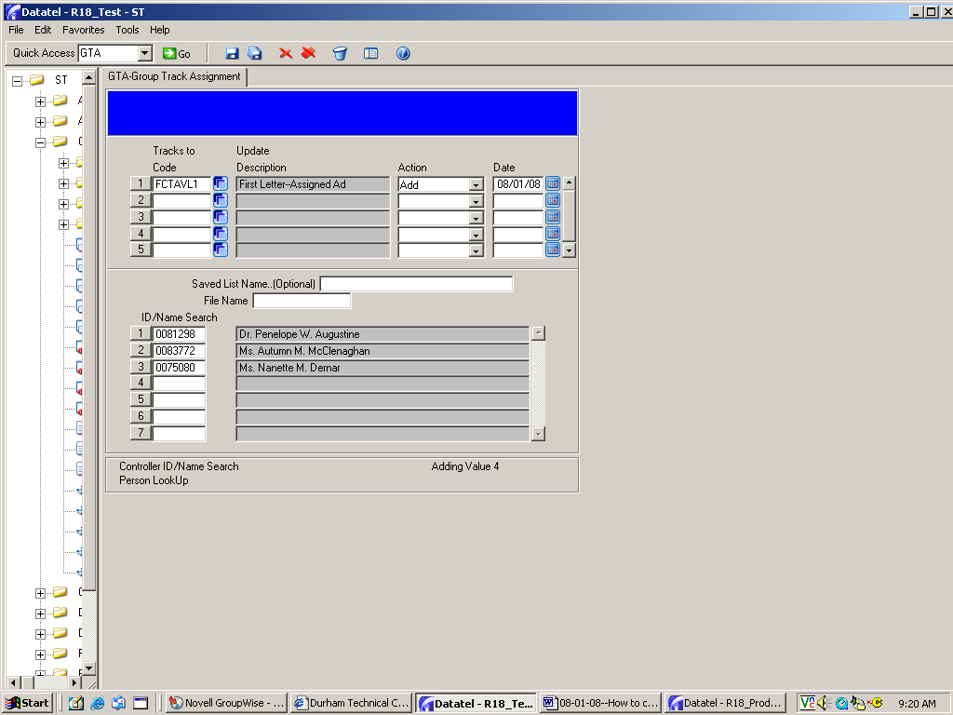
After you enter the date at the top, use the mouse to go to the “ID/Name Search” box and click on the first blank line. Do not tab down to get to the field.

“File Name” in the middle of the screen needs to be populated last. If you tab down, the file name will automatically populate…which may cause problems when you enter some student IDs.
Begin entering the ID numbers or names of students who will be assigned this “track” so that they will receive the document attached to the track.

IMPORTANT: Once created, this track can be used to assign this document to additional students at any time.

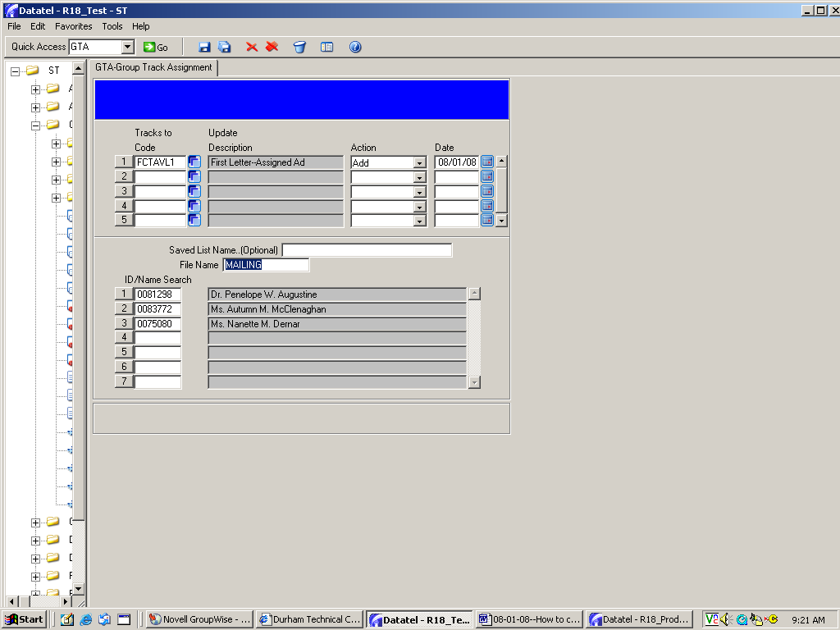
After you finishing entering the student IDs/names, then click in the “File Name” box and the word MAILING will automatically populate.

NOTE: If you accidentally click in the File Name box before entering IDs, the word MAILING will automatically populate…and you may encounter problems entering some IDs/names. If that occurs, go to the File Name box and delete (for now) the MAILING name, then enter the IDs/names…then go back and click the File Name box so that MAILING appears.

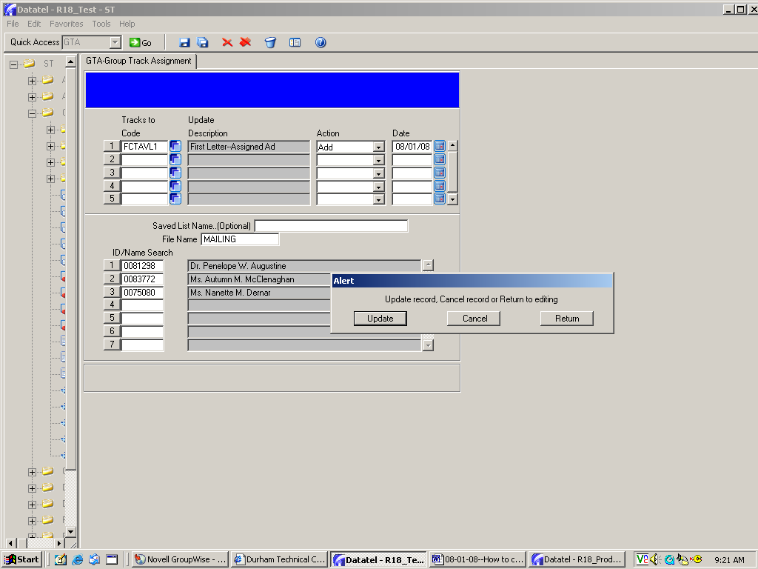
Save and Update to complete creation of this track.
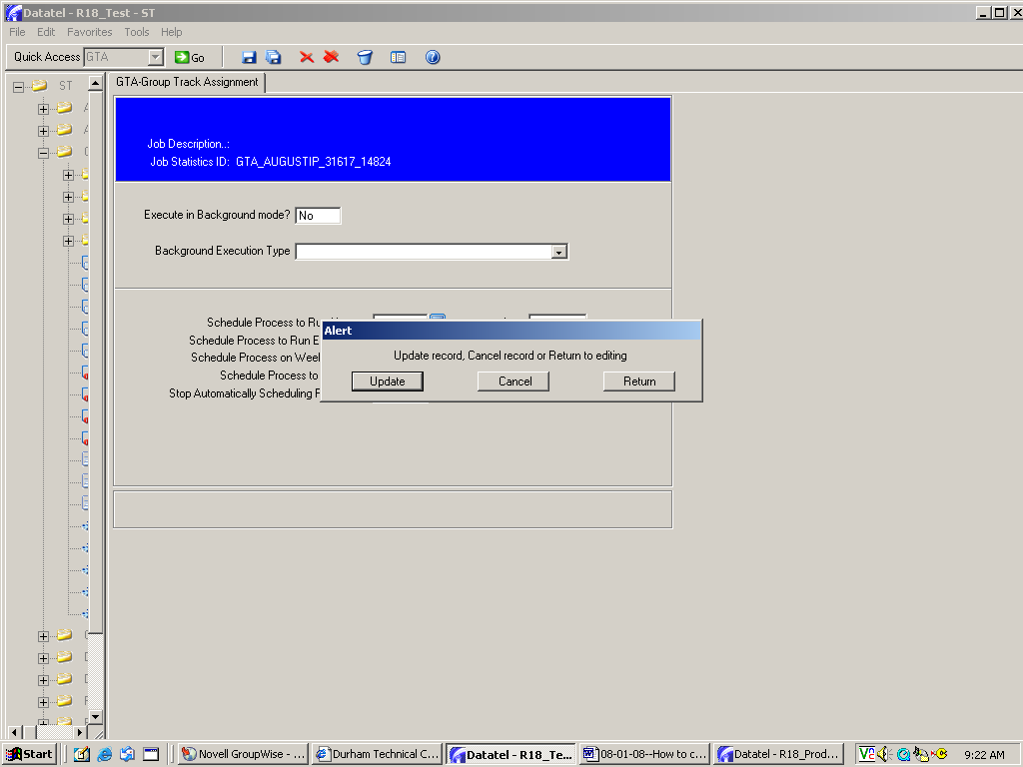
Click Update.

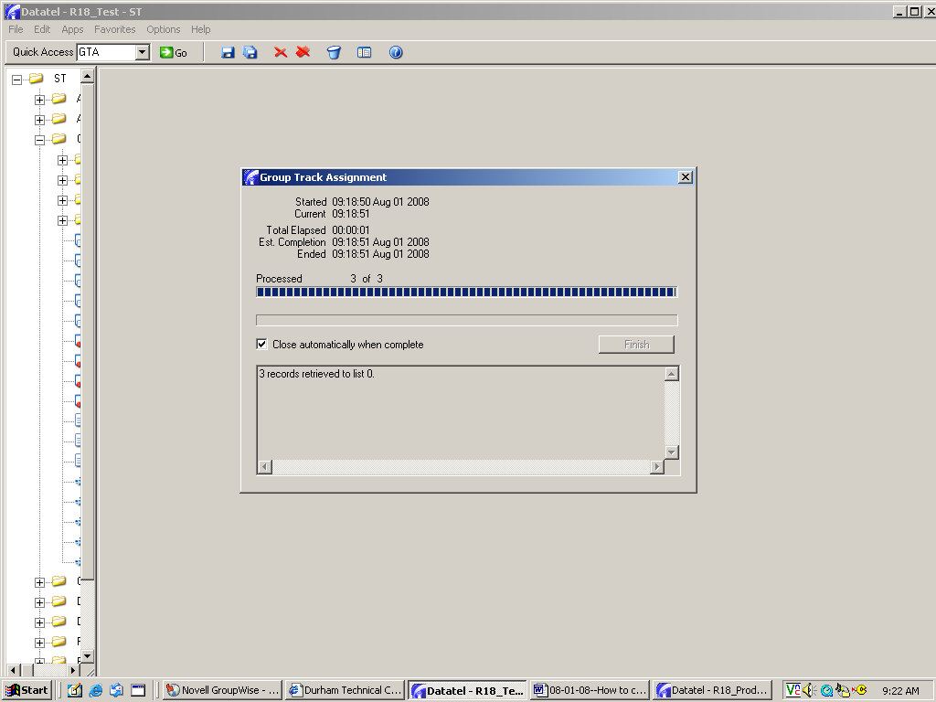
Click in this box so that this screen will automatically close when the processor has finished—or click on Finish to complete the process.

You have created a track that will allow you to assign and print the associated document for any student at any time. To do this, go to TRC and type the track name in the lookup box (see page 19), then follow the instructions beginning on page 22 to assign the track to the new group of students.

PCB: How to print a document

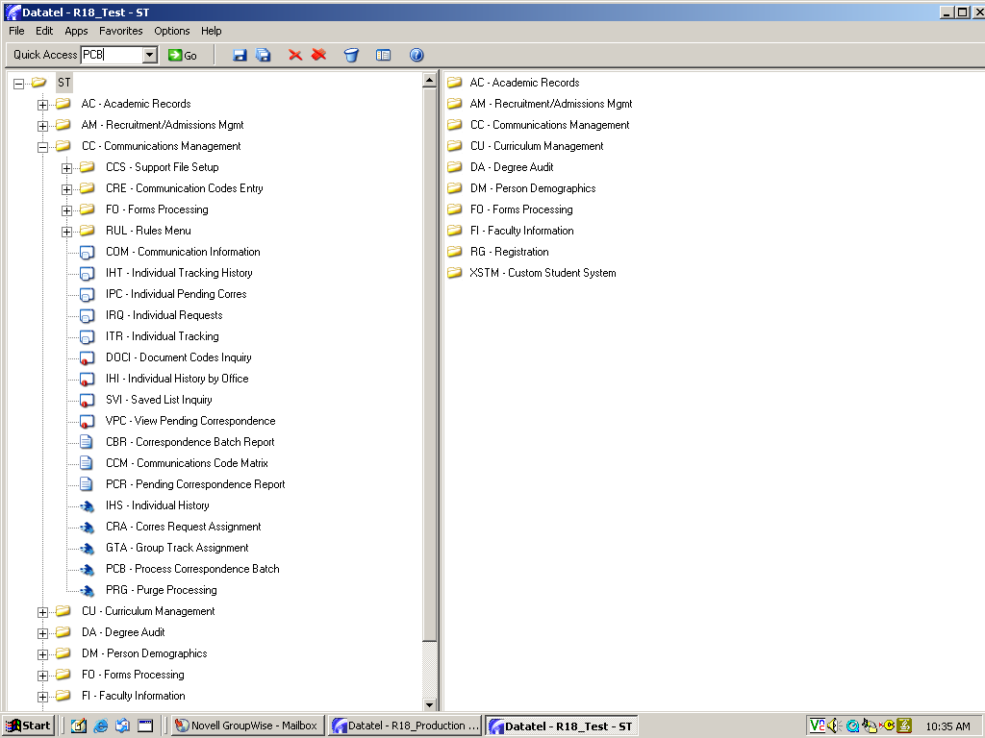
To begin the print process, double click on PCB in your access tree

OR
type PCB in the quick access box, the click GO.

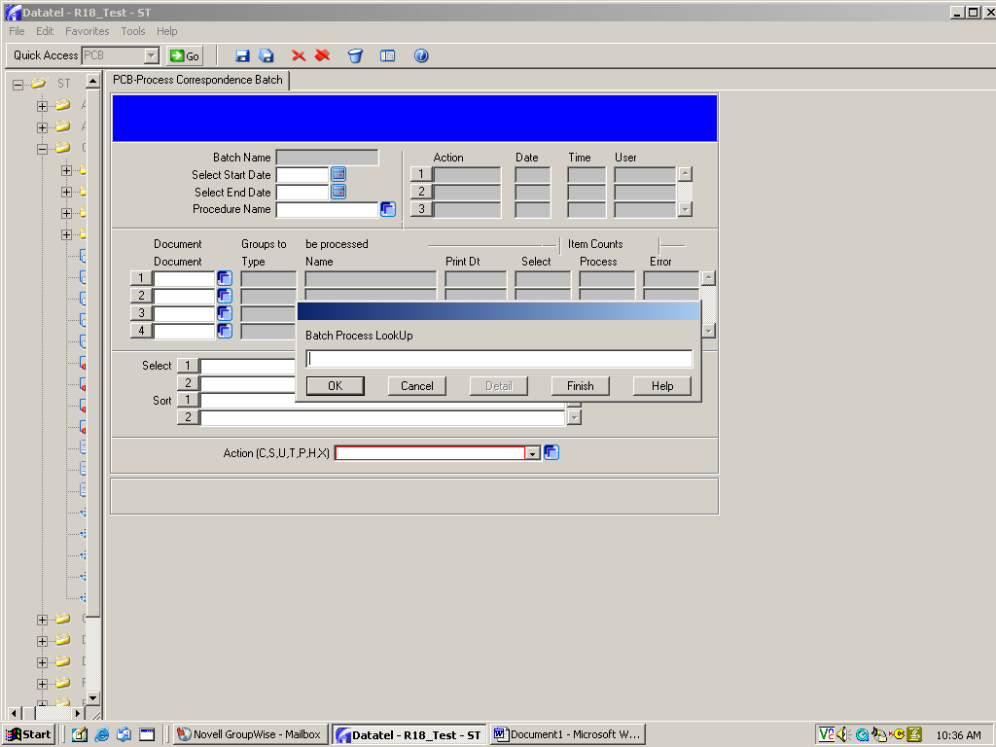
The Batch Process lookup box will appear next.
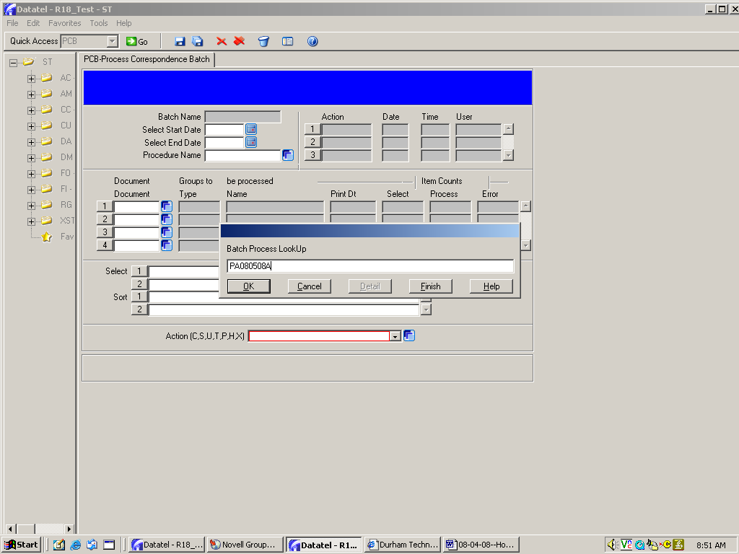
Since you are processing a new document batch, you’ll create a new batch name.

Naming convention: So that you can identify the batch as yours, use your first and last initials, followed by the date. If you think you might process more than one batch that day, add an “A” at the end of the title. (If you do process another batch, use a “B” at the end of the title for the next group.)

This batch is named PA080508A.

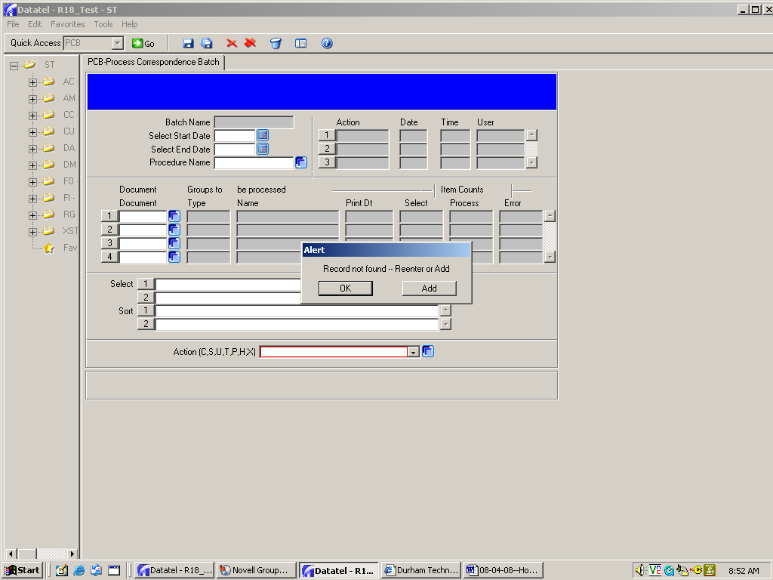
Since this is a new batch, click Add to start the processing.
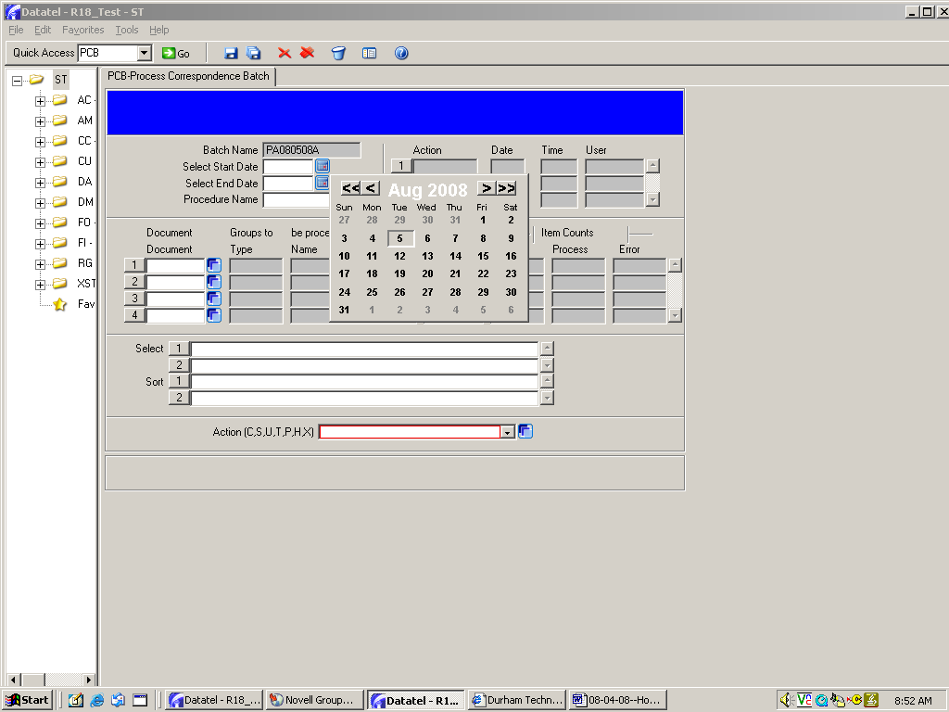
Use the day’s date as both the “Select Start Date” and “Select End Date.” You can type in the date or select it from the dropdown box.

Note: If you are unable to print the same day that you create a document track, the “start” date will be the date you created the track and the “end” date will be the date you’re actually processing the batch.

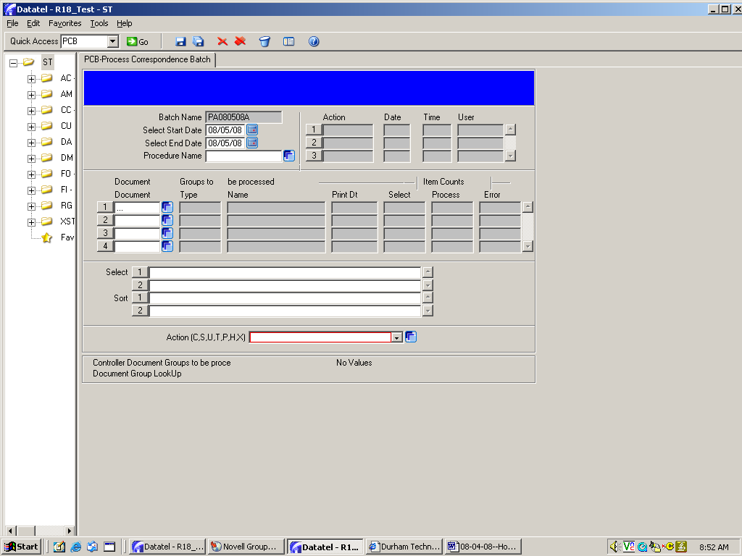
Now you’ll need to select the document you want to print.

Type … in the document box and press enter.
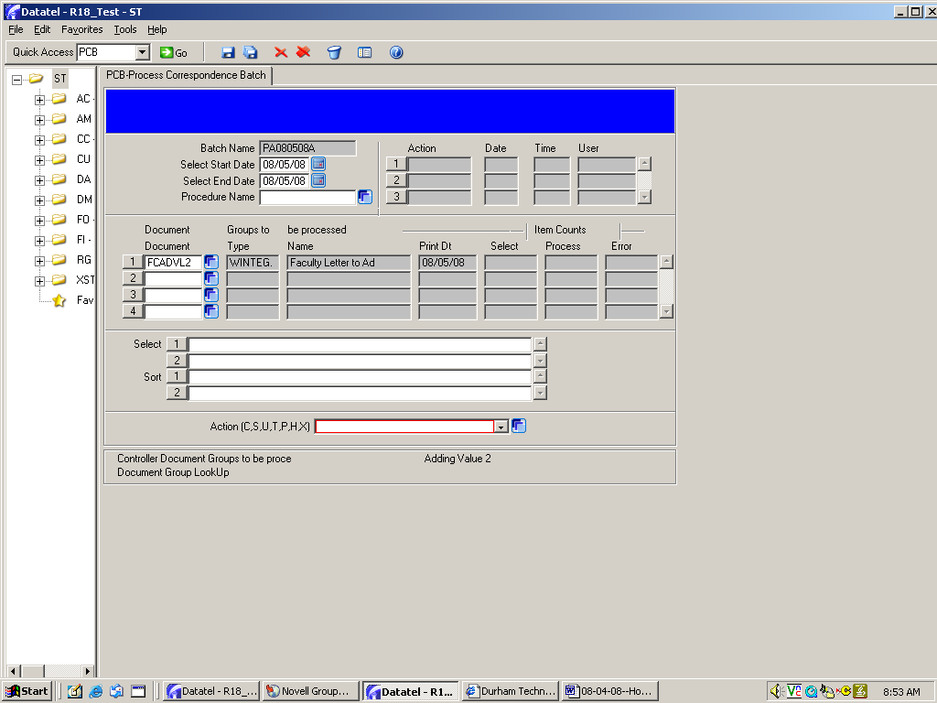
If no other documents are in the queue for processing, your document name will automatically populate.

If other documents are waiting to be processed, a selection screen will appear. Click in the box next to your document and click save at the bottom. Remember that you’re looking for the document name, not the track name!

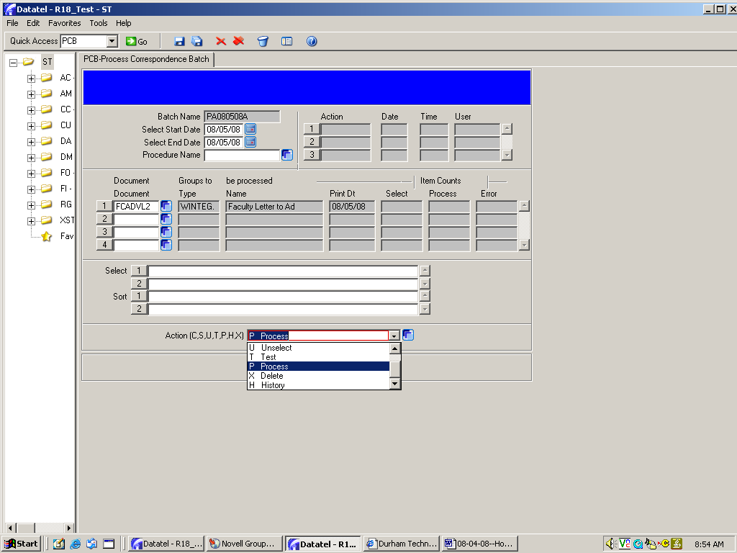
In the Action dropdown box at the bottom of the page, click on P to begin the batch process.

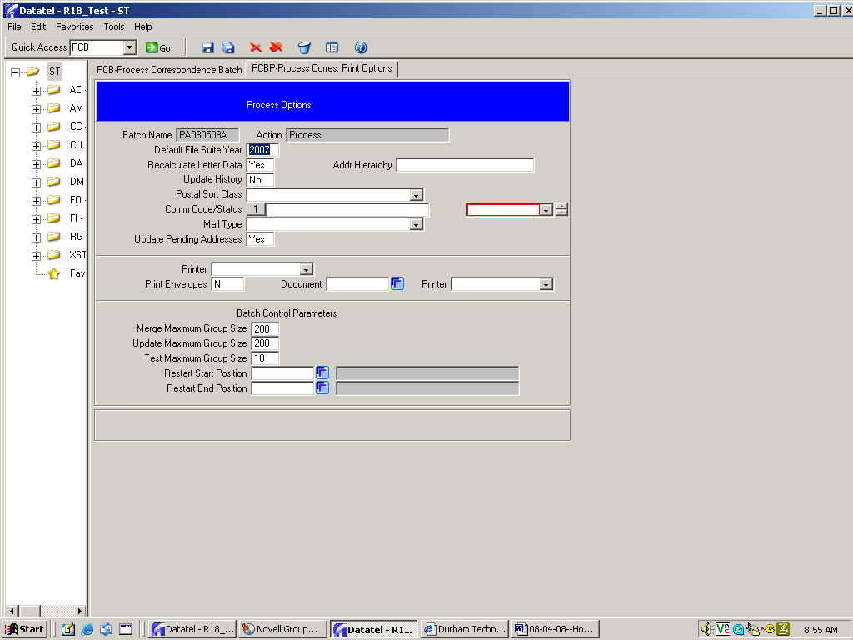
Click on the Save All icon.

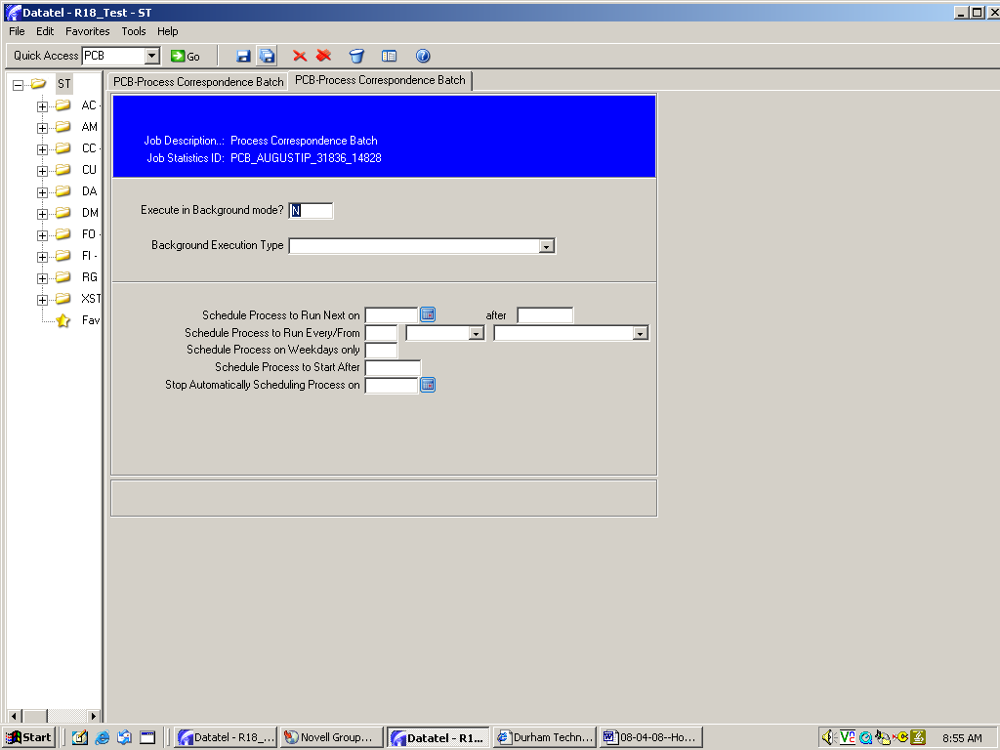
Click on the Save All icon.
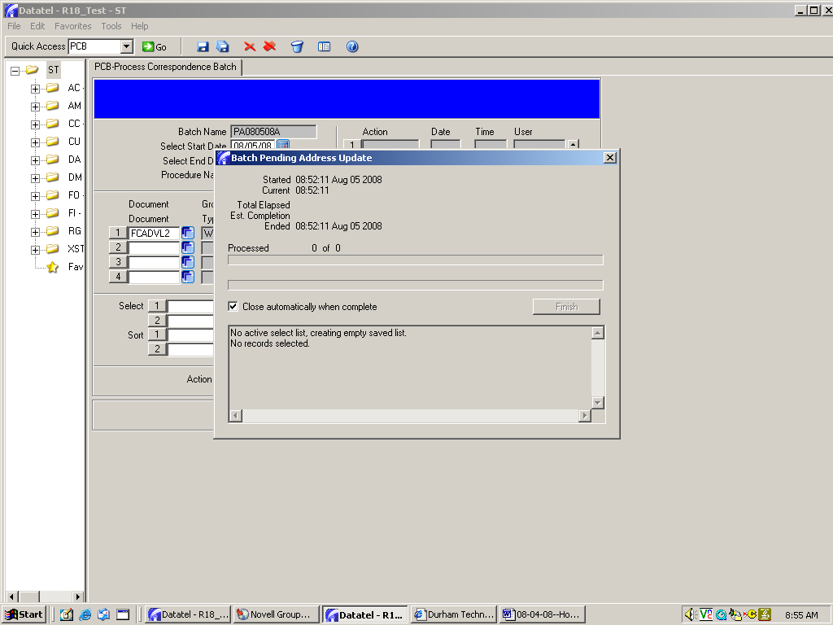
Click in this box so that this screen will automatically close once the records are selected.

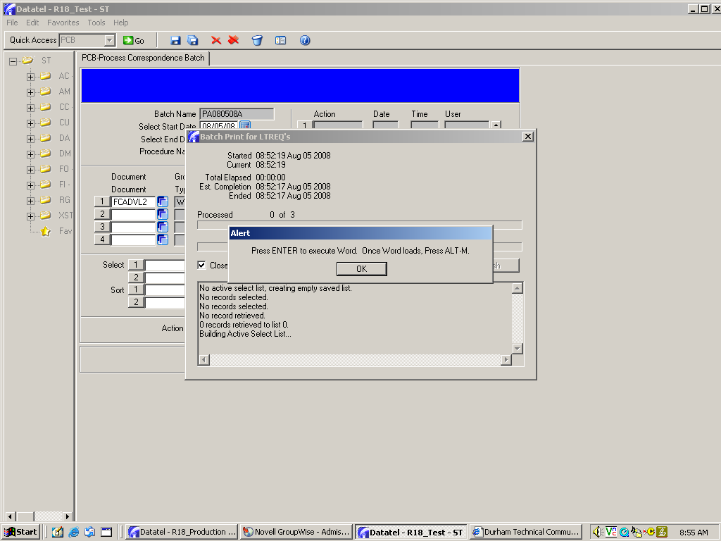
Click OK or press the “Enter” key on your keyboard to start Word.
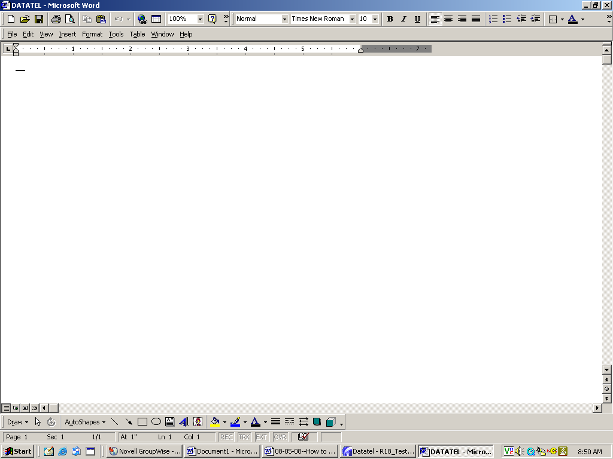

IMPORTANT

When this blank screen appears, press Alt and M at the same time on your keyboard to go to the next screen.

.

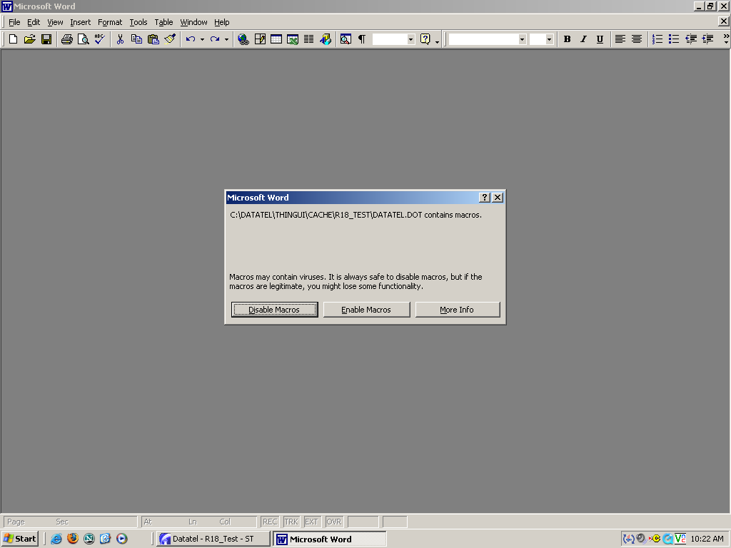
You may or may not get this next alert box. If you do, click Enable Macros to continue.

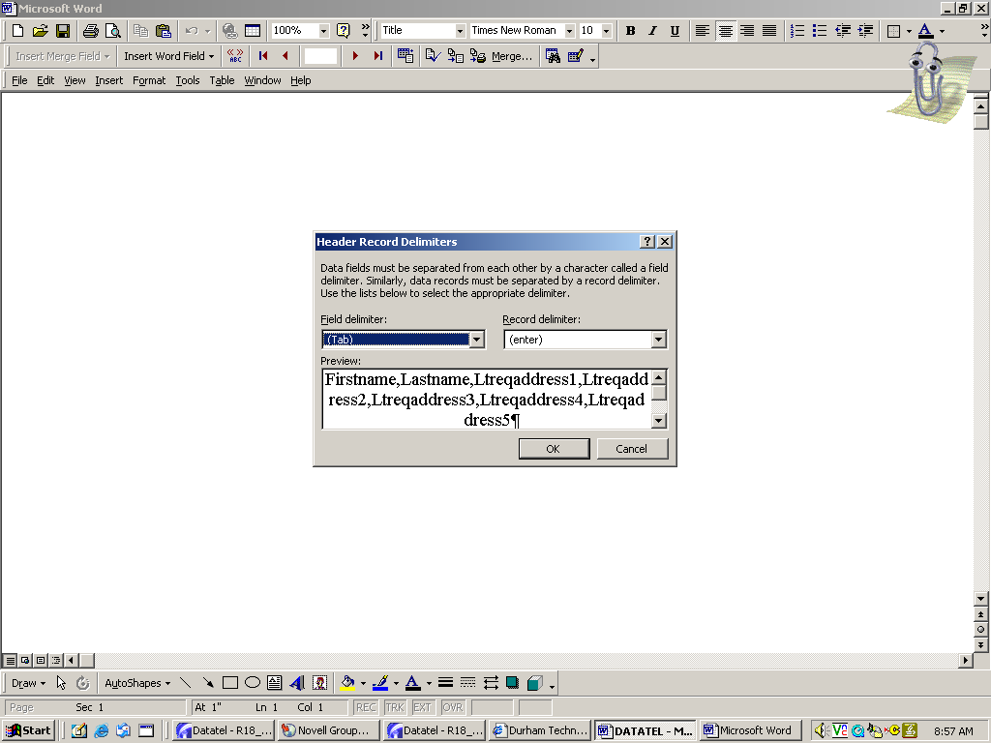
Depending on your Word setup, you may get another alert box. If this alert appears, click on OK to continue.

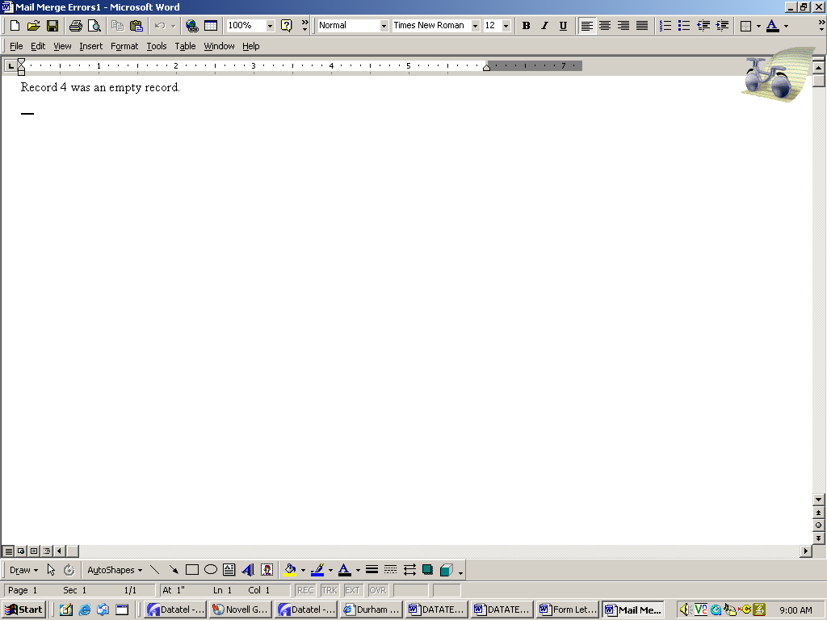
Don’t panic! Your documents aren’t lost. This batch is processing letters to 3 students. Since there isn’t a fourth student, “Record 4” is empty.

Click on the X to exit this page.

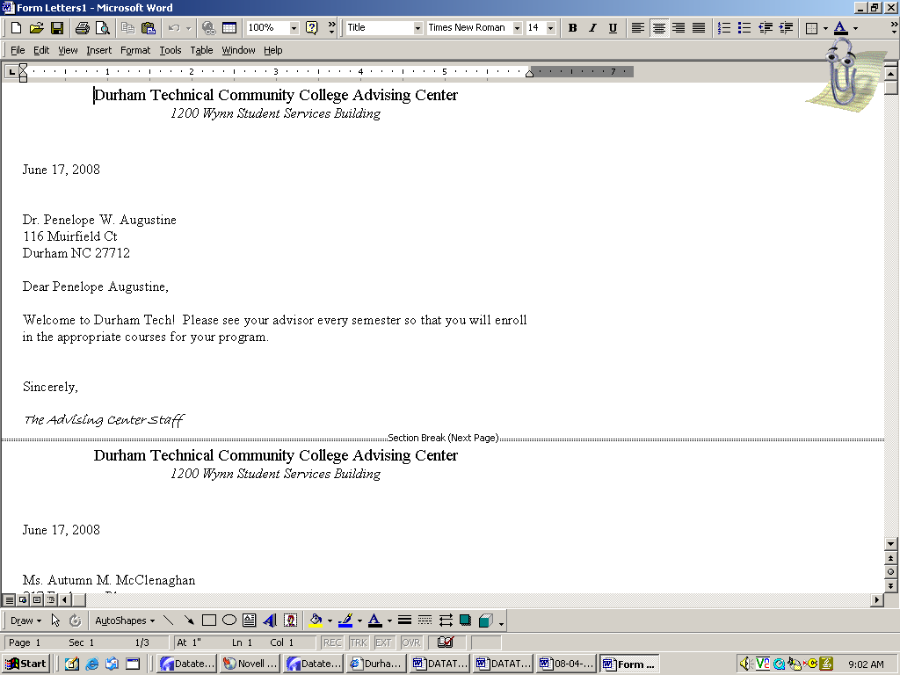
Your letters will now appear on screen. Note that the student’s name and mailing address automatically populates in the letter.

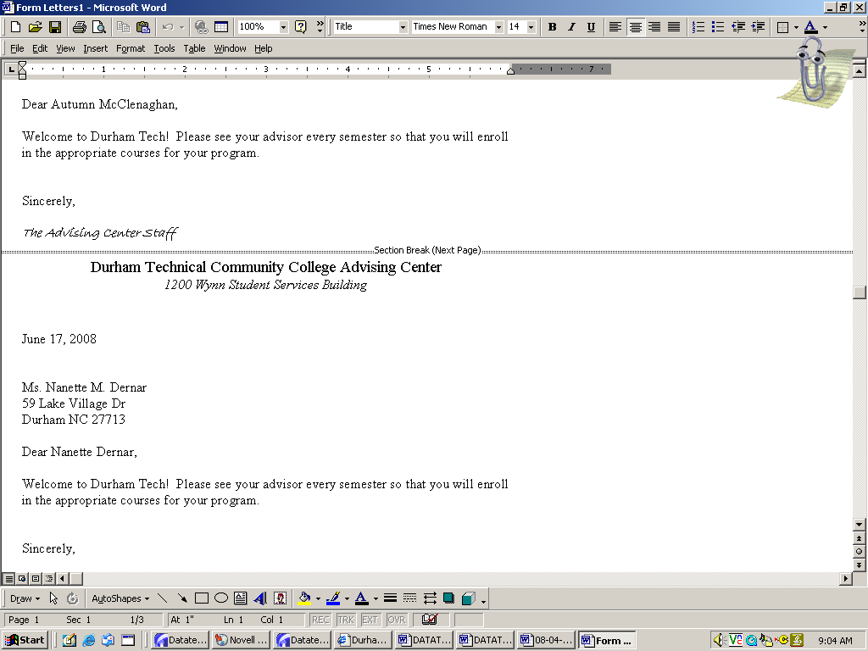
Depending on your Word setup, your letters may be displayed this way (showing page breaks) or they may be displayed as separate pages. Either way, the pages will print as separate letters.

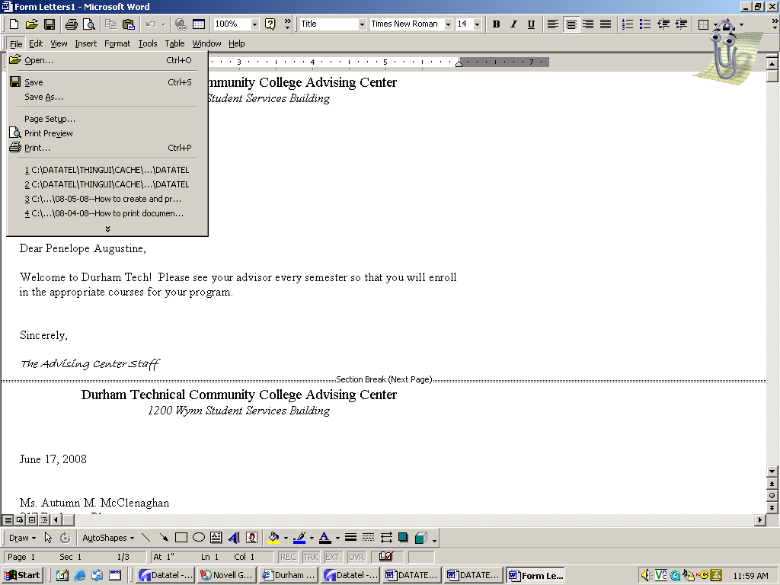
PRINTING: You can now print your documents through Word. Click on print and then OK to print to your selected printer.

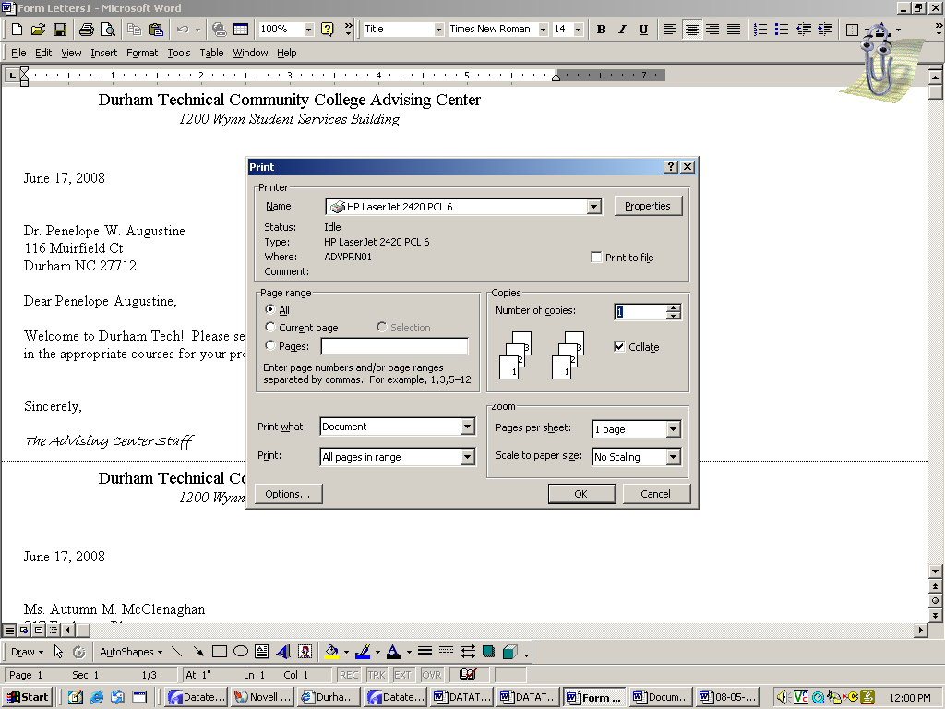
Make sure the correct printer is displayed, then click OK.

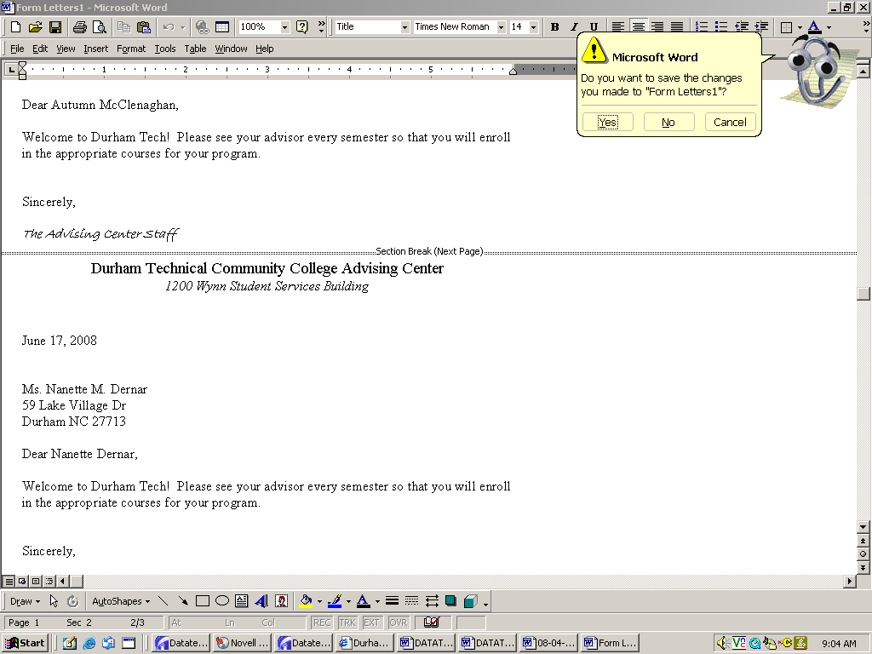
After your documents are printed, click on the X to exit. Colleague gives you the option of saving these letters as a regular Word file.

If you want to save the letters to “My Documents,” click Yes and follow your usual process for saving a file.

If you do not want to save them, click No.

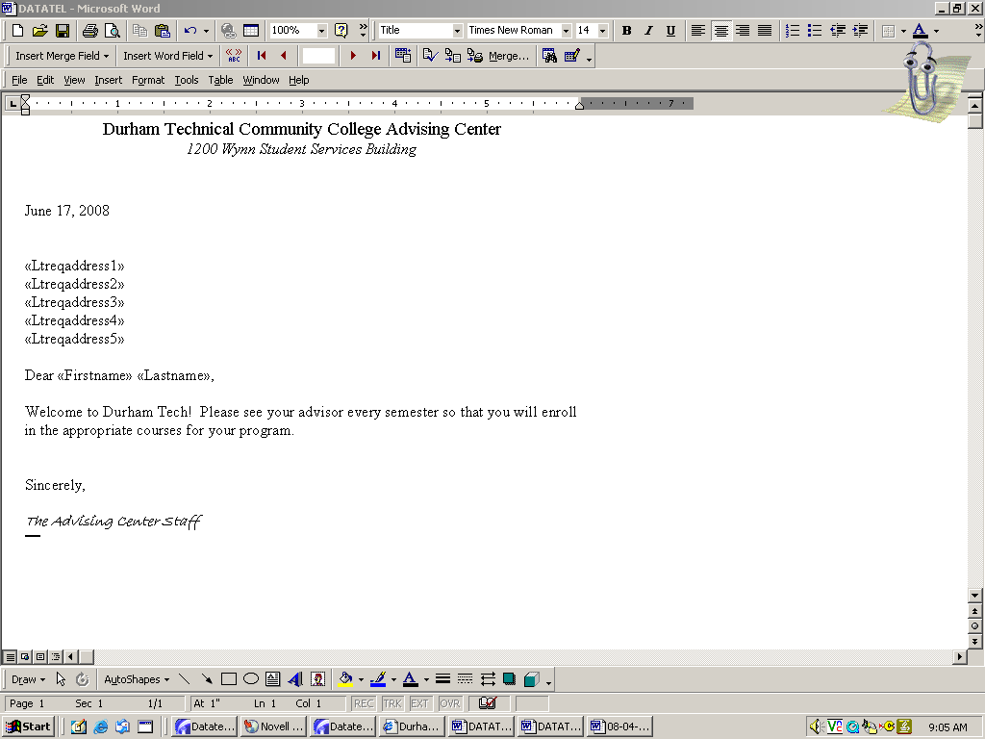
Click the X again to exit the setup screen.

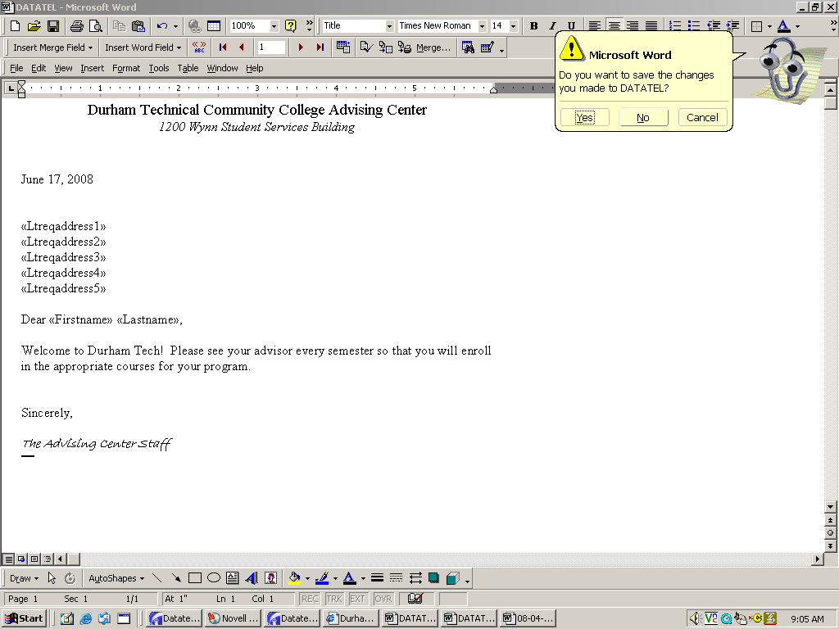
Click on No.

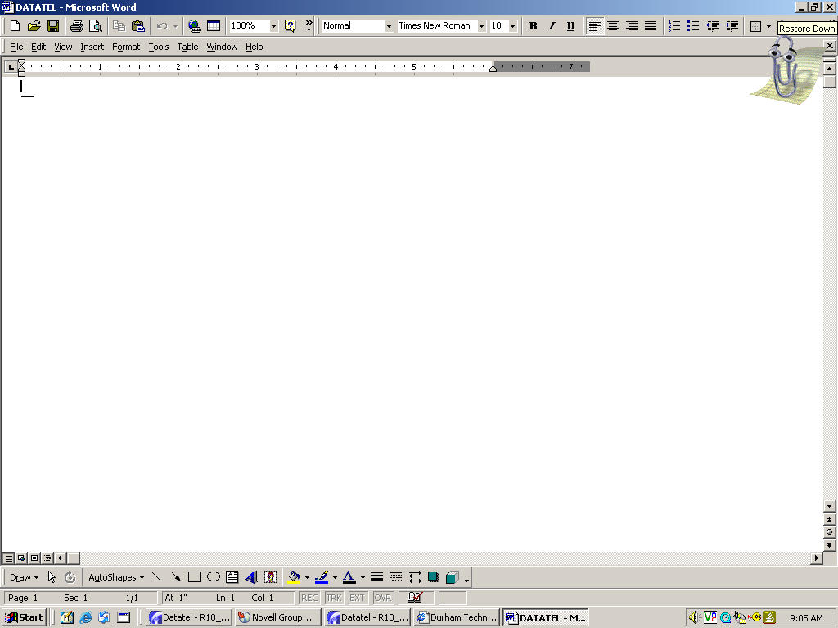
This blank screen may or may not appear as you close out of the batch print process. If it does, just click the X again.

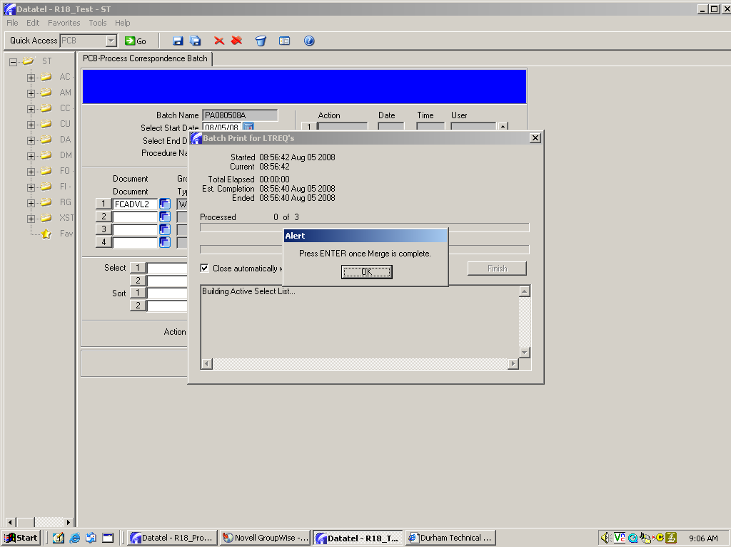
Click OK.

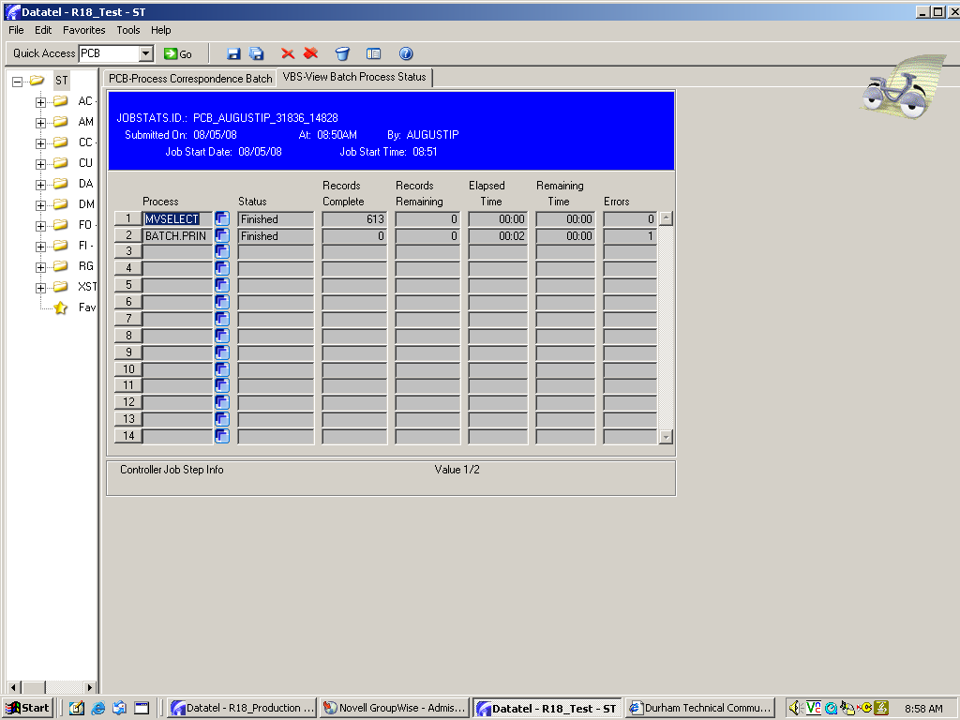
Click on the Save All icon to finish the printing process.

FINAL STEPS: After you finish printing, you will need to “history” and then “delete” this batch. This process will take another minute or two to complete (see below).

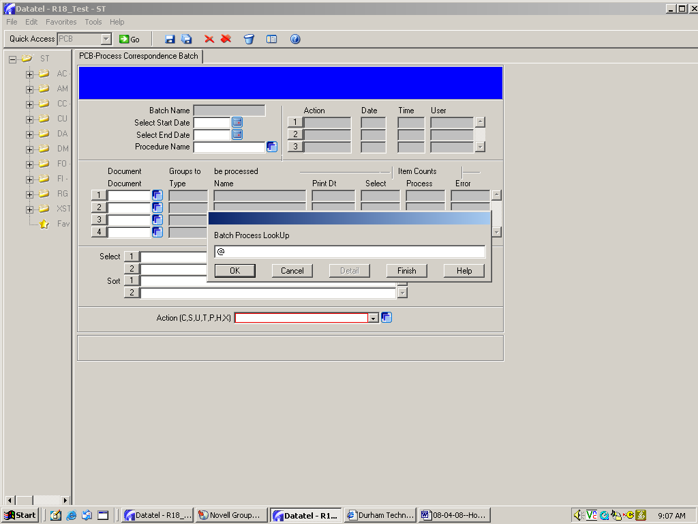
HISTORY: Go back to PCB and enter the @ sign in the lookup box to pull up the batch you just processed, then click OK.

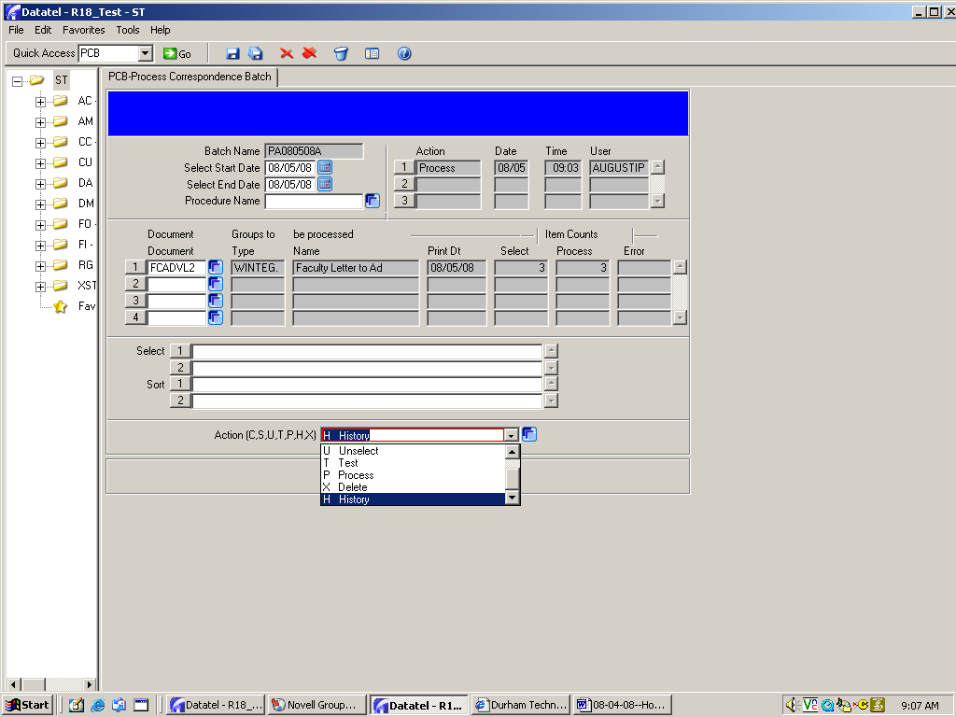
This time, click on H in the Action dropdown box.

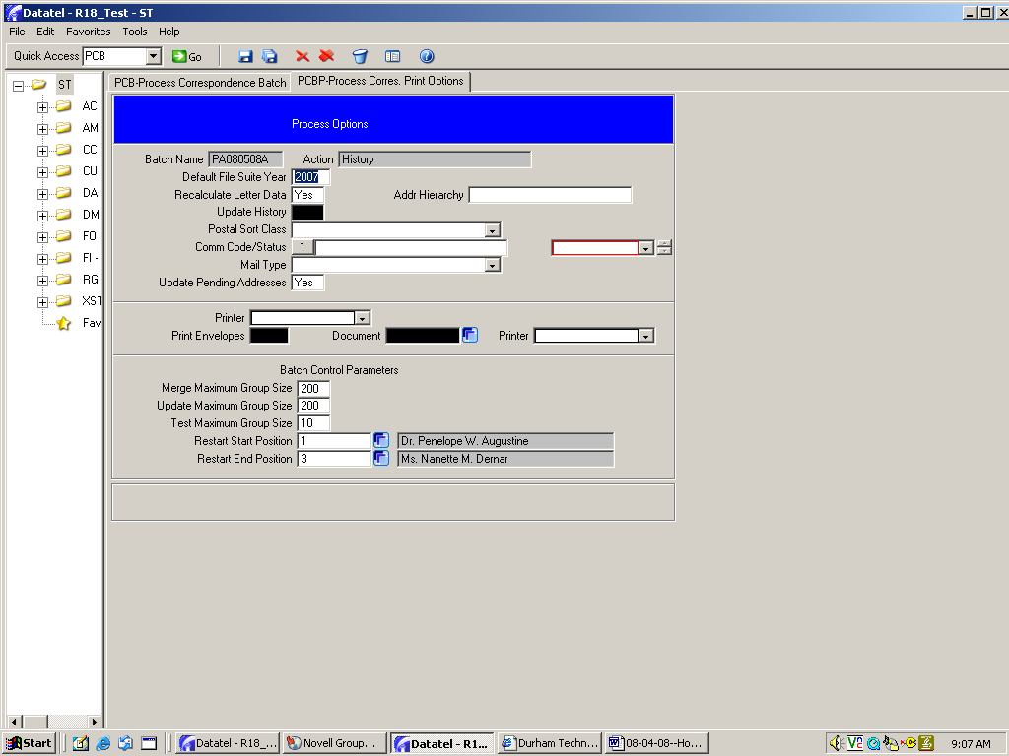
Click on Save All.

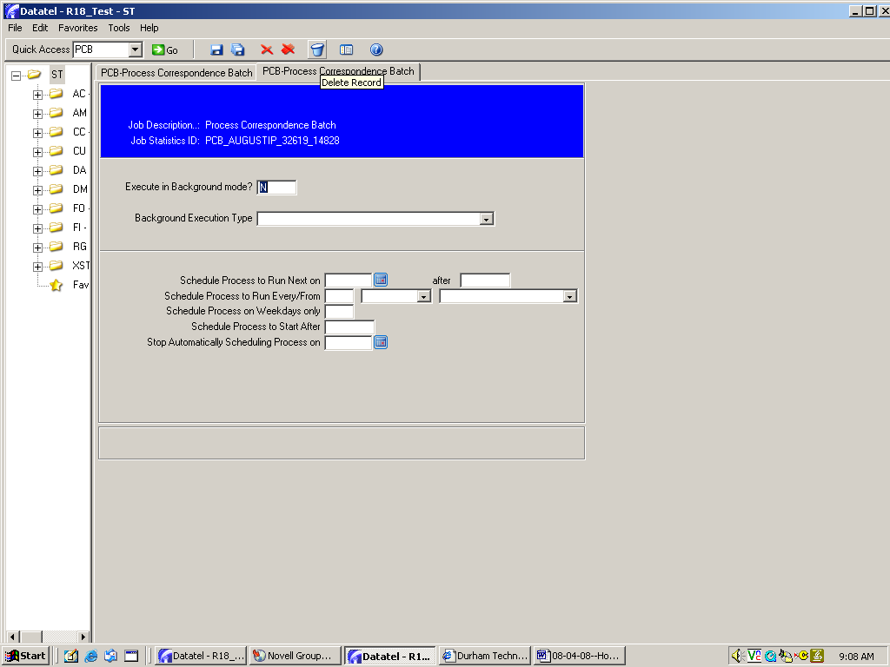
Click on Save All.

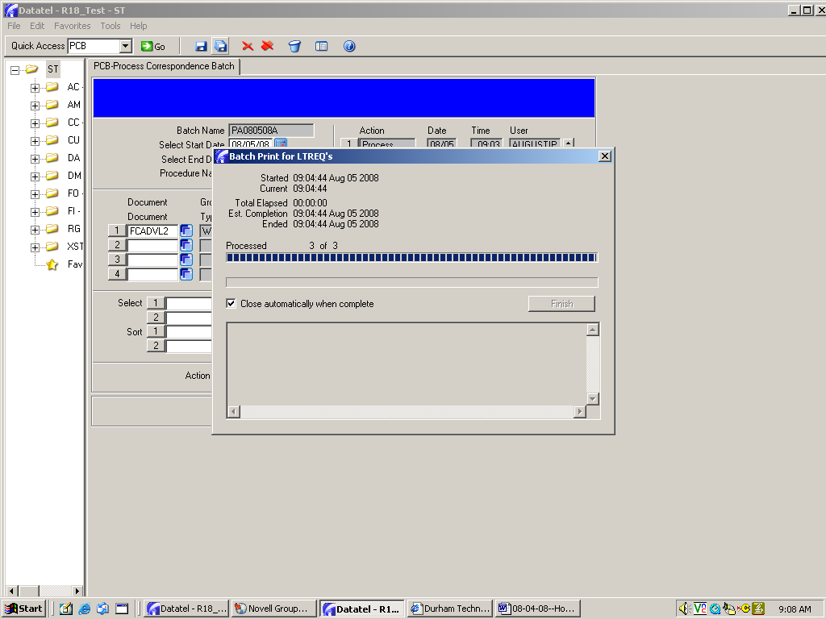
Click on this box to automatically close this screen when the process ends.

Click the Save All icon.

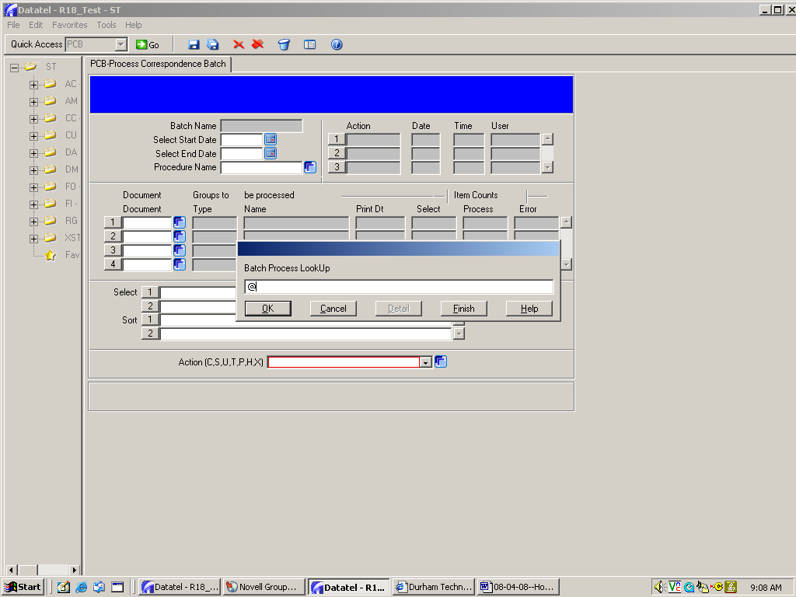
DELETE: Repeat the process one final time to delete the batch.

Enter the @ sign in the lookup box and click OK.

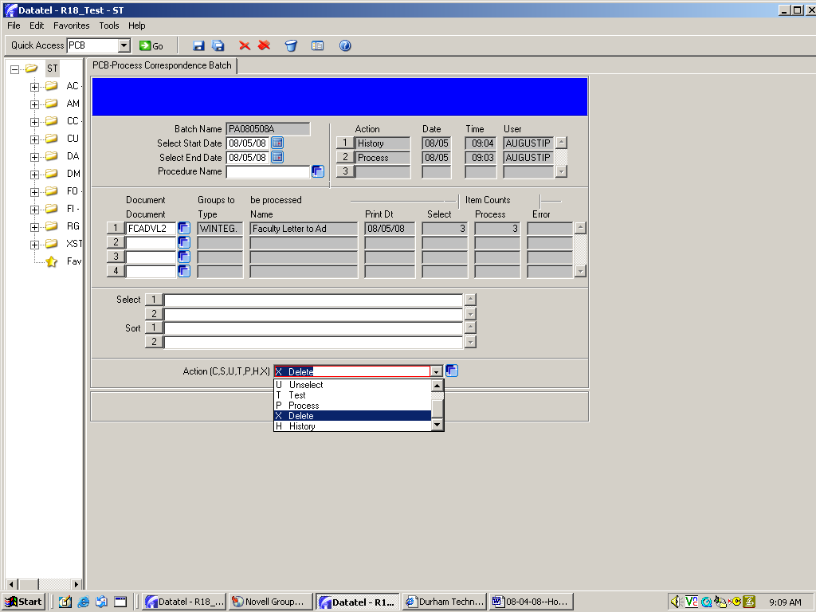
Click on X (delete) in the Action dropdown box.

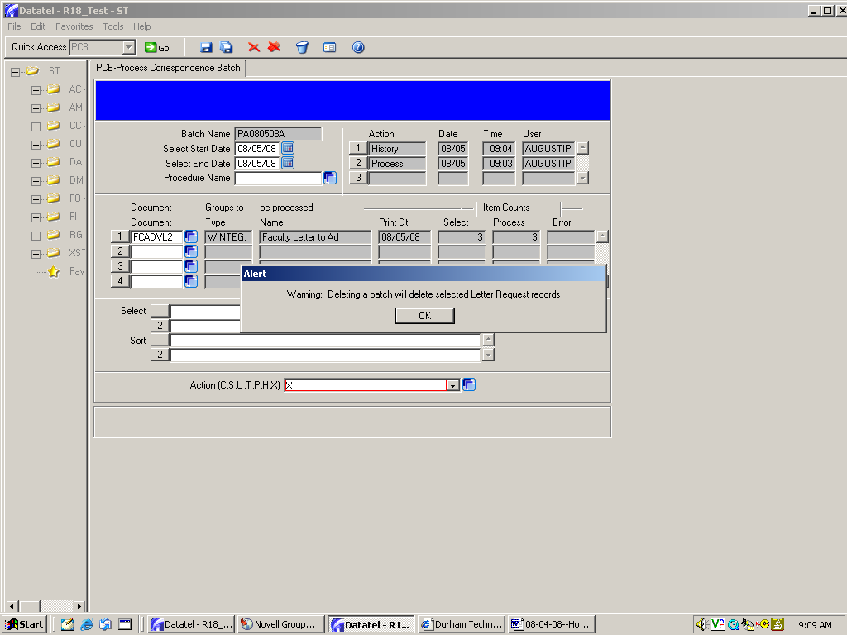
Click OK.

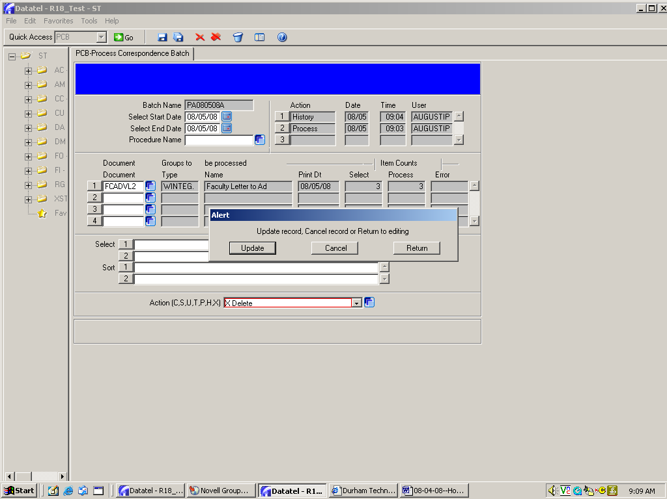
Click Update.

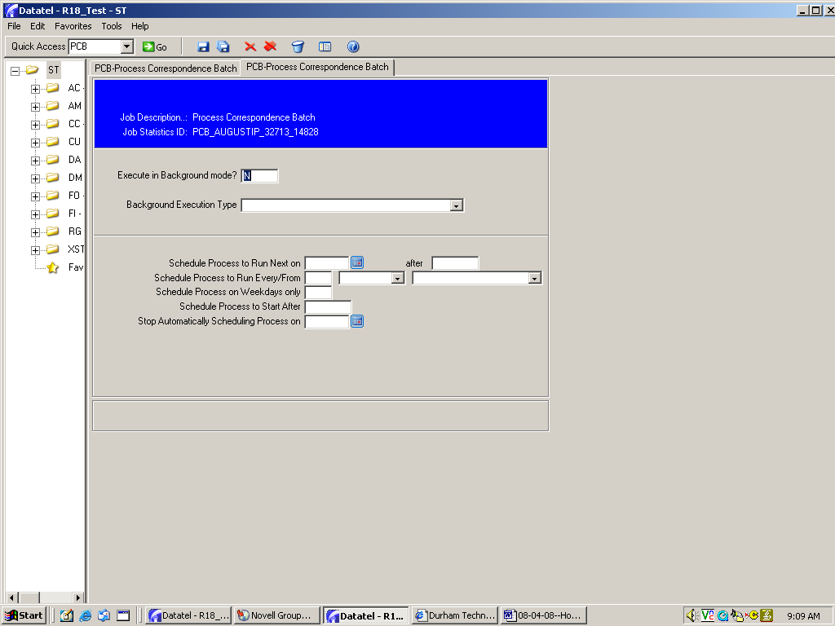
Click Save All.

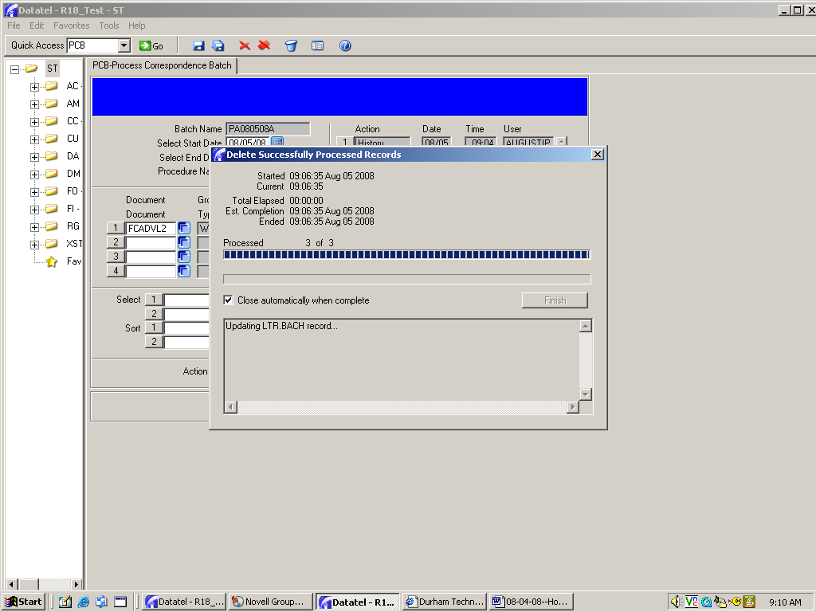
Make sure this has the checkmark.

Click Save All.

Important Information for Batch Processing Documents

Once you finish printing (P to Process), creating a history (H to History) and deleting (X to Delete) a document batch, it will be gone. If you want to reprint the same letters for the same students, you’ll need to reassign the documents to your selected students by going through GTA again (see page 18).

However, you will be able to reprint without going through GTA if you run the process again before you H/History and X/Delete. [I’ve had this happen because the printer jammed or ran out of toner.] To reprint, go back into PCB and enter the @ sign to pull up the same batch. In the Action dropdown box at the bottom of the page, enter U to “Unselect” and finish through all the screens. Then go back to PCB, enter the @ to pull up the same batch, then enter P to “Process” the batch again.

DOC: How to create, assign and print LABELS

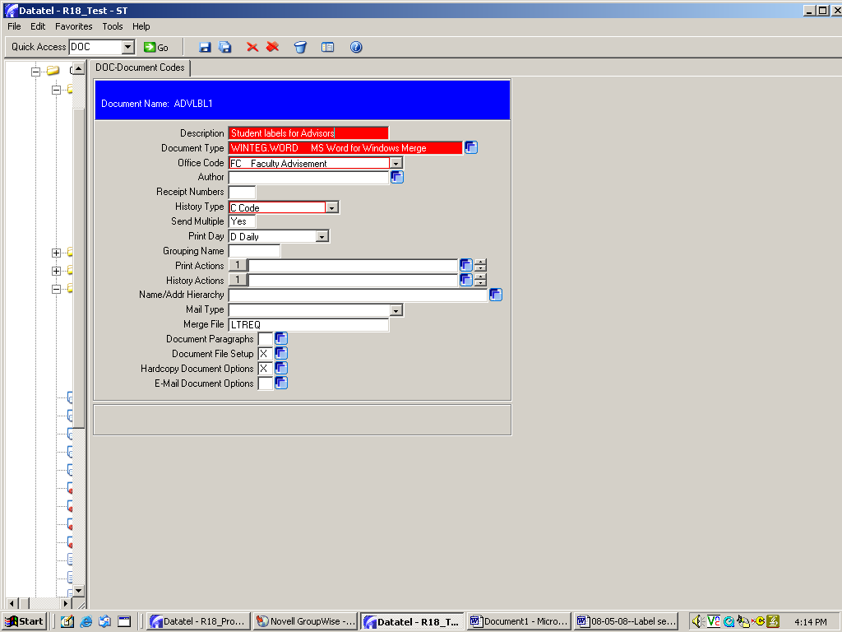
STEP ONE:
Create your label template

Create your label document the same way you create a letter document (see pages 1-3).

Next, click on Document File Setup to select your label fields.

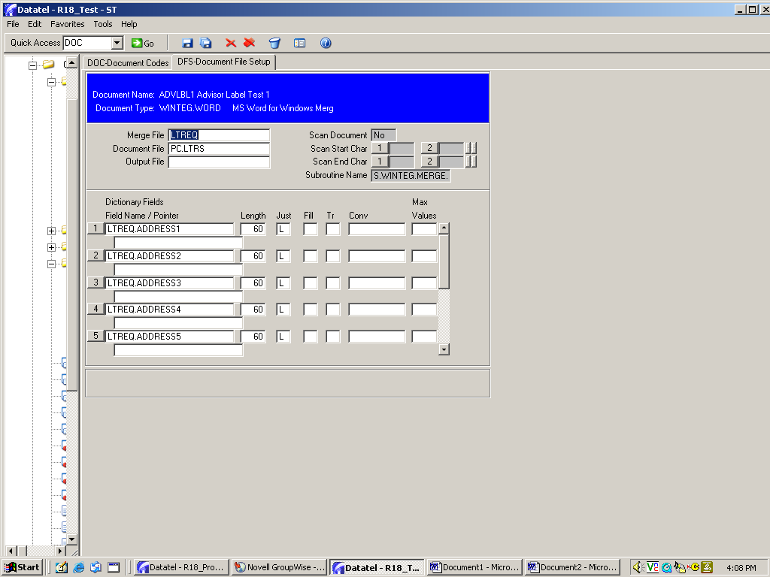
Add the standard five LTREQ address fields for your label. Save and Update to return to the DOC mnemonic.
Click on Hardcopy Document Options to begin creating the label template.

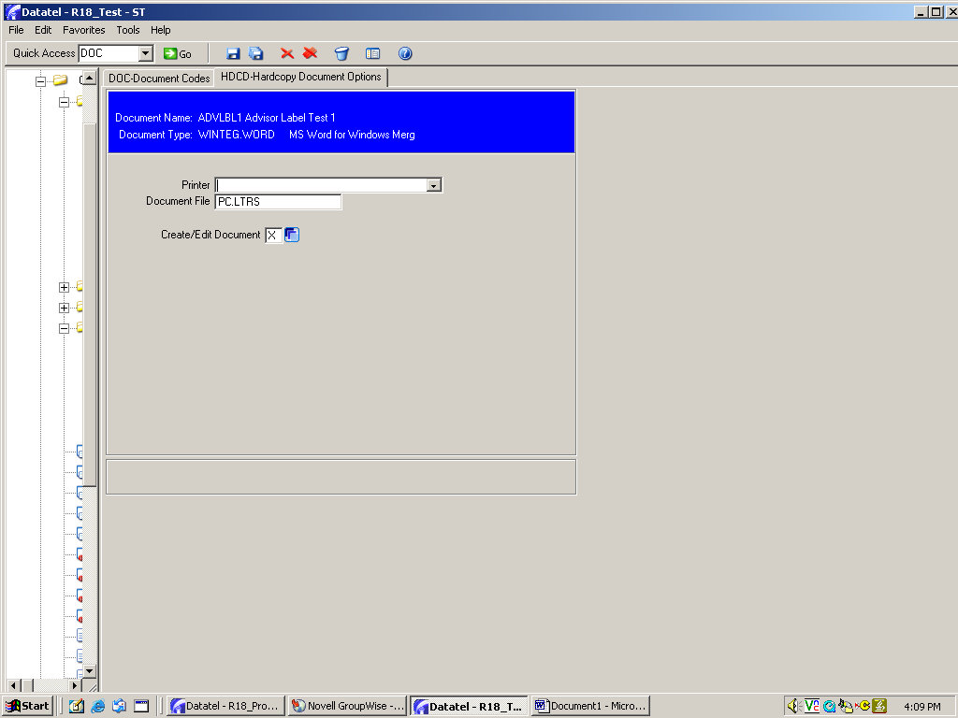
Click on Create/Edit document.

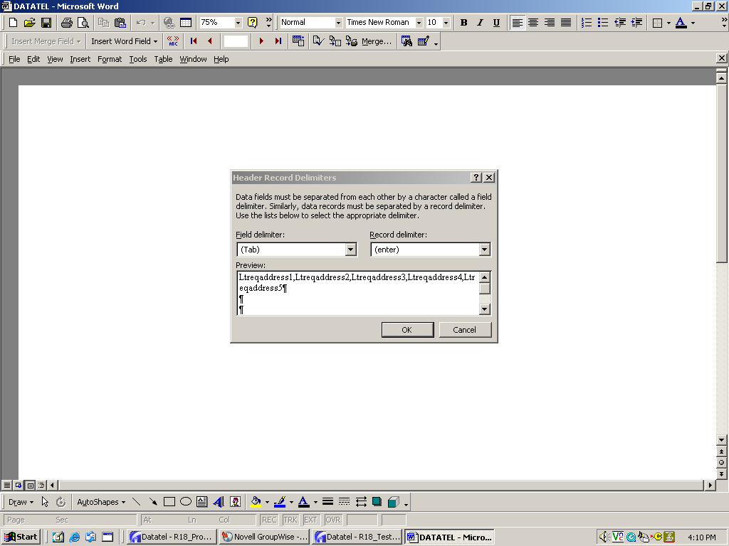
Click OK to insert the field names.

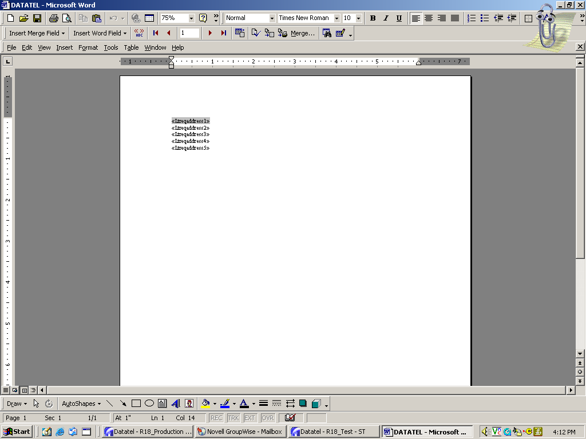
This is your label template.
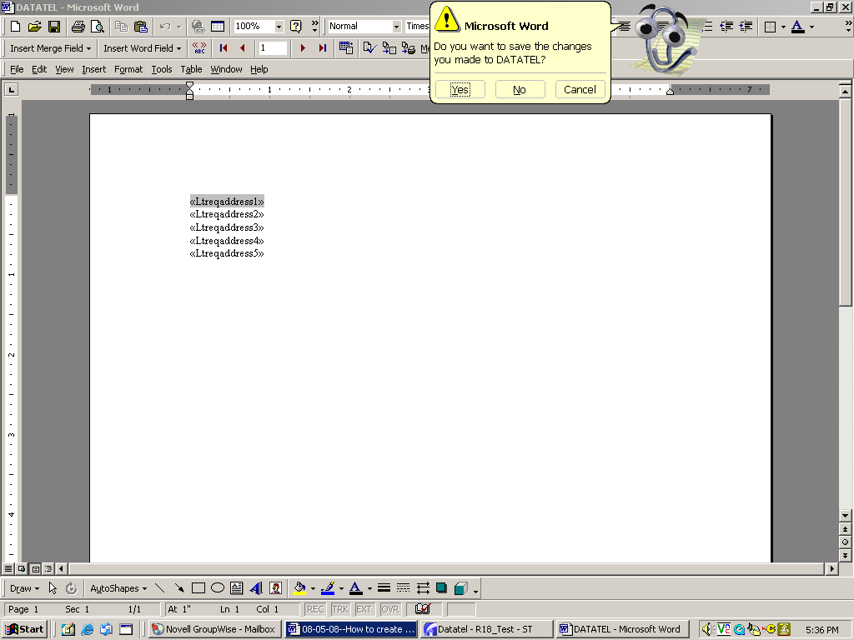
Click on the X to exit, then click on YES to save the template.

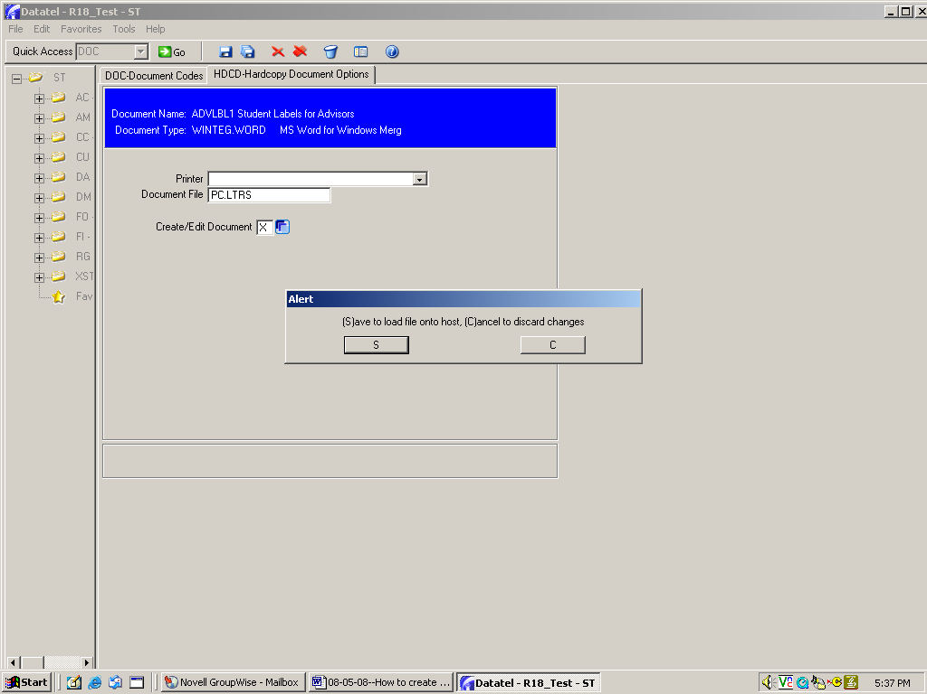
Click S to Save and return to the DOC screen.
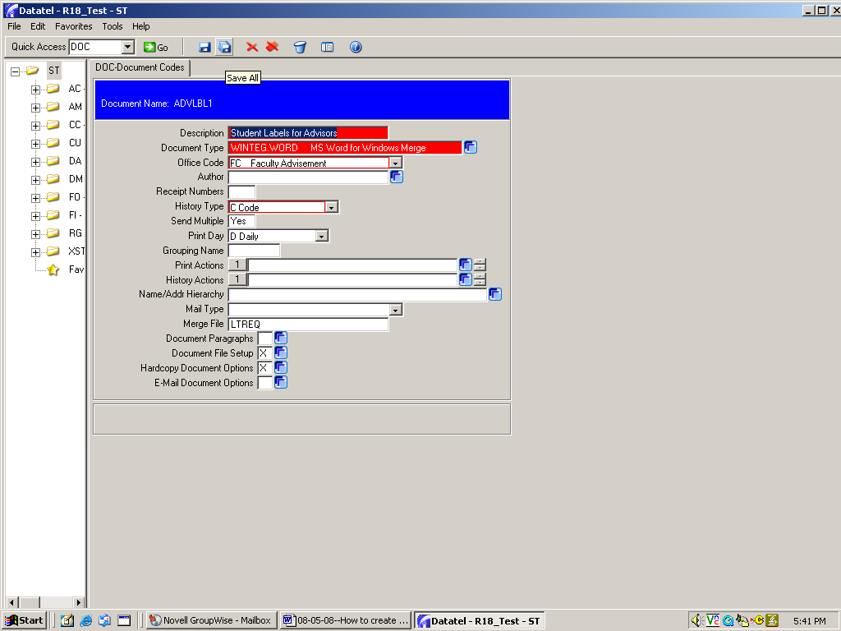
Click Save All to save your label template.

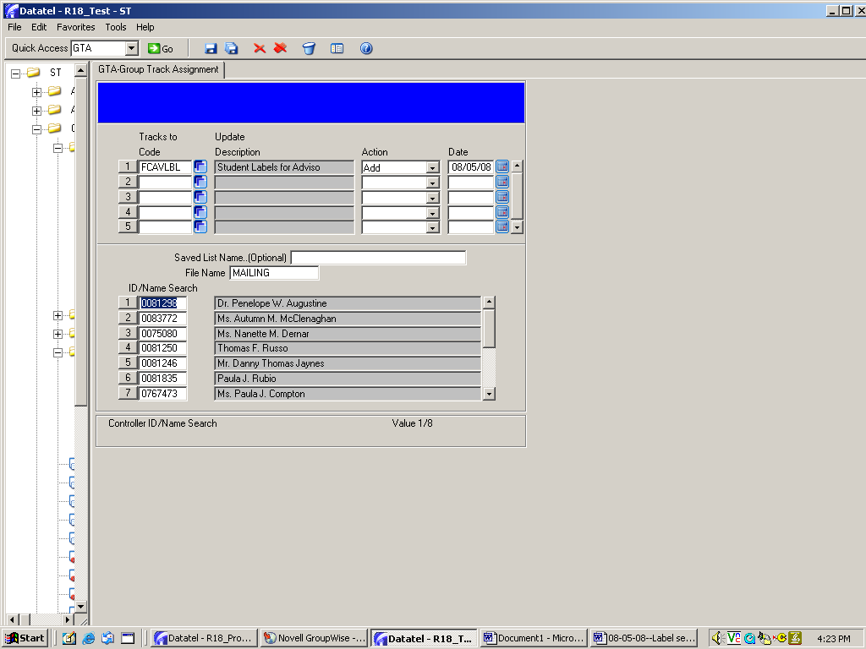
STEP TWO
Create your document track
Once your label template is created in DOC, go to TRC to create a track. Follow the setup instructions on pages 13 – 20 to create you track and assign it to students.

Remember to name this track something that will recognize when you want to print labels for other students at a later time.

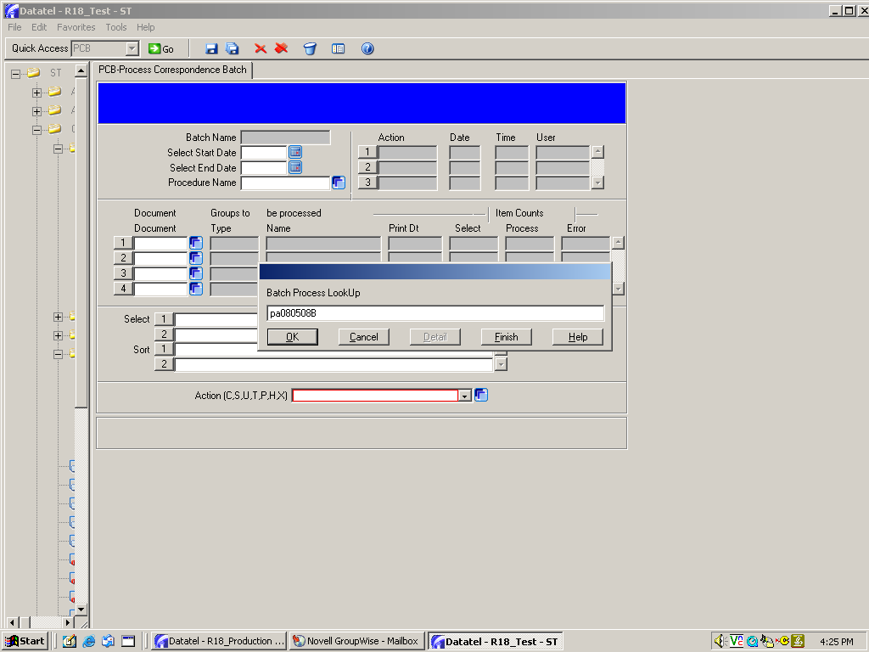
STEP THREE

Print your labels

The process for printing a batch of labels is similar to the process for printing a batch of letters.

Follow the directions on pages 21-25 for instructions on setting up the PCB batch.

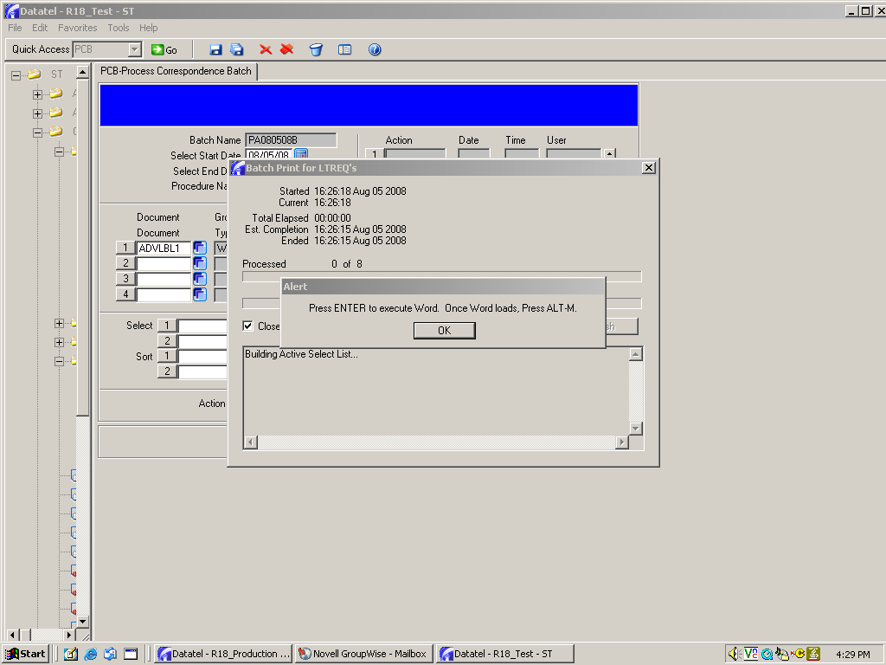
When this screen comes up, click OK or press Enter on your keyboard.

When this blank screen appears, press Alt and M at the same time on your keyboard to go to the next screen.

If you get the “Enable Macros” alert box, click on Enable Macros to continue.

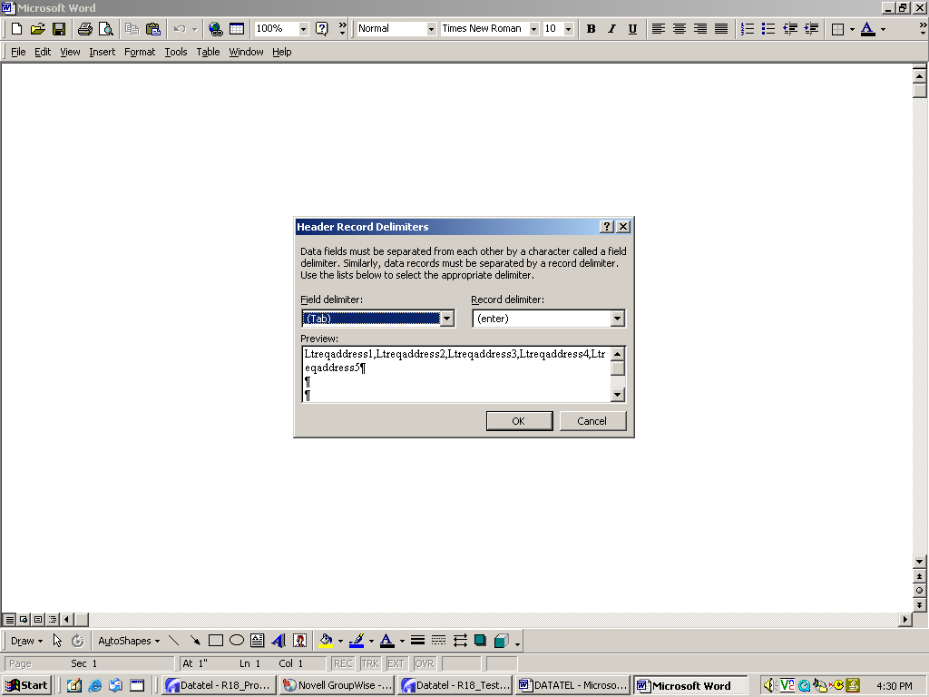
Depending on your Word setup, you may or may not get this screen, If you do get this screen, click on OK to continue.

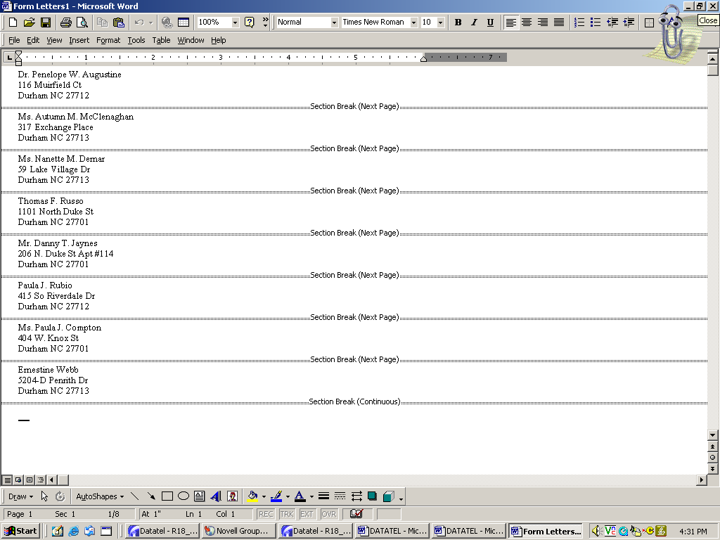
This screen will display the names that will appear on your labels.

This is the tab that I clicked on to bring up the screen shown below.

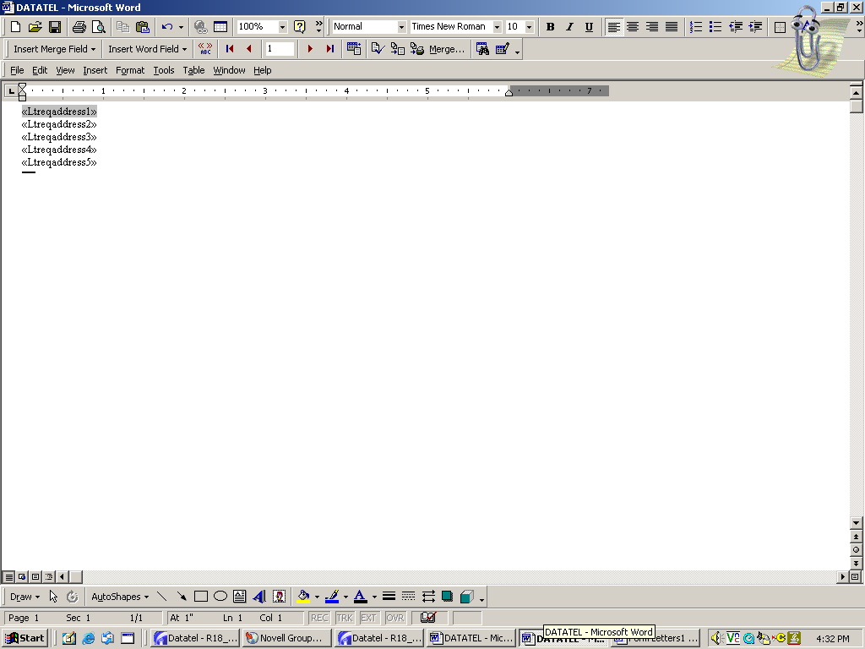
IMPORTANT: Several new tabs will be displayed on the bottom of the screen. One of them will show the setup screen shown below. Click on each tab until this screen displays.

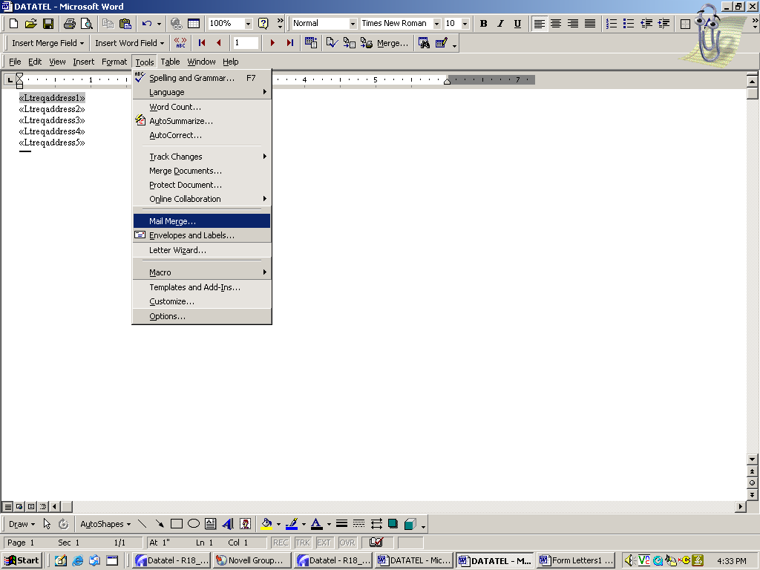

MERGING YOUR DATA

IMPORTANT: The next screen shots will show you how to set up Mail Merge if your version is Office 10. If you use Office 11, your mail merge screens will look different.

For Office 10, click on Tools, then Mail Merge.

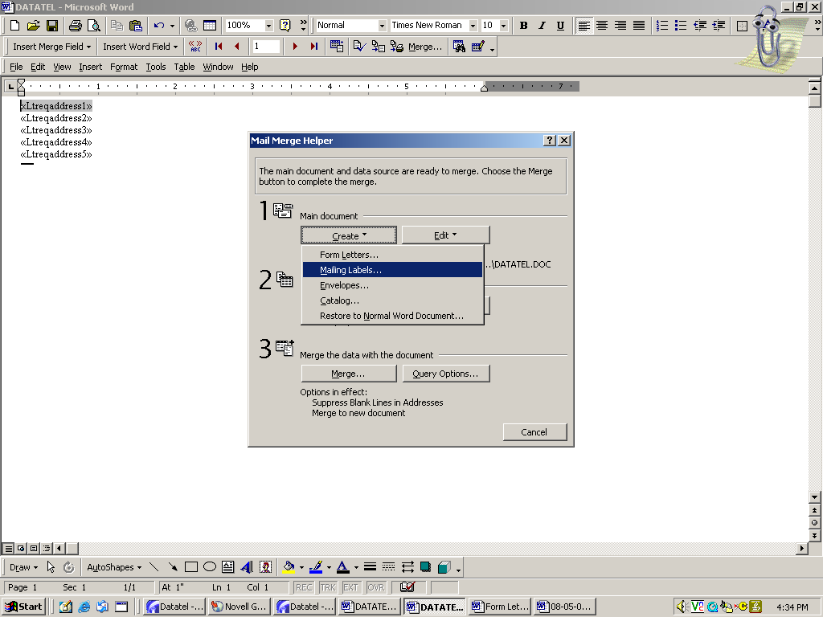
Click on Create, then Mailing Labels.

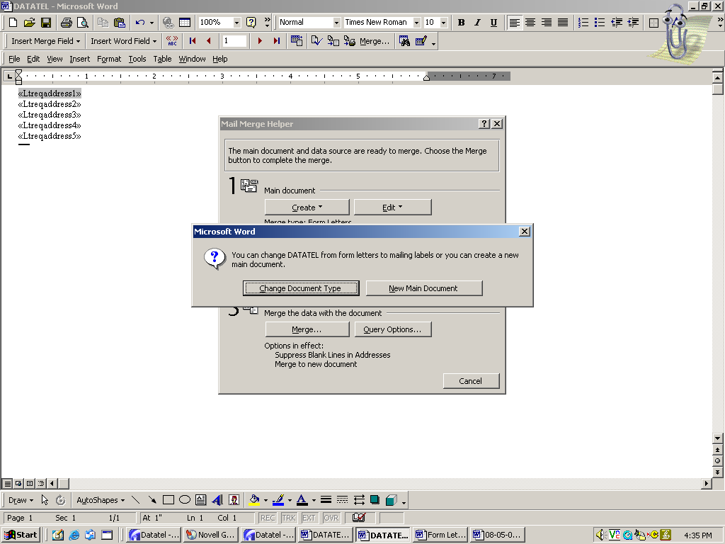
Click on Change Document Type.

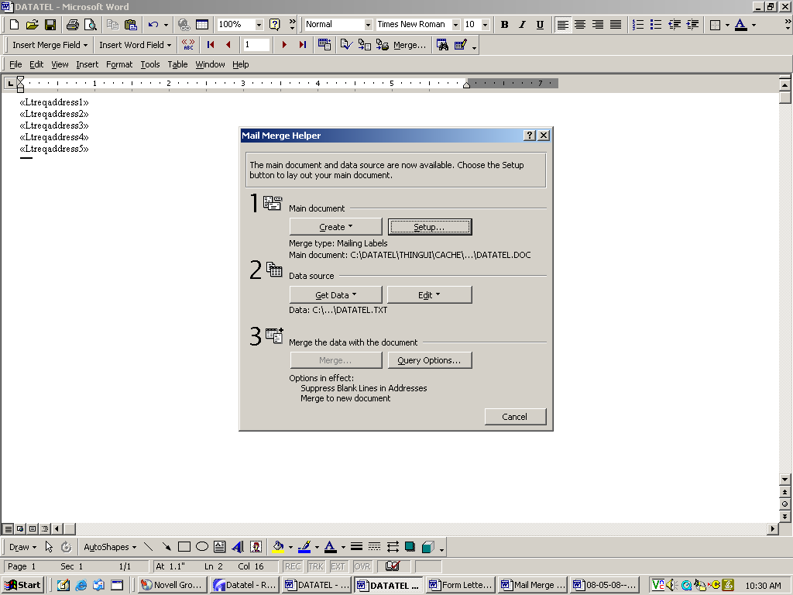
Next, click on Setup
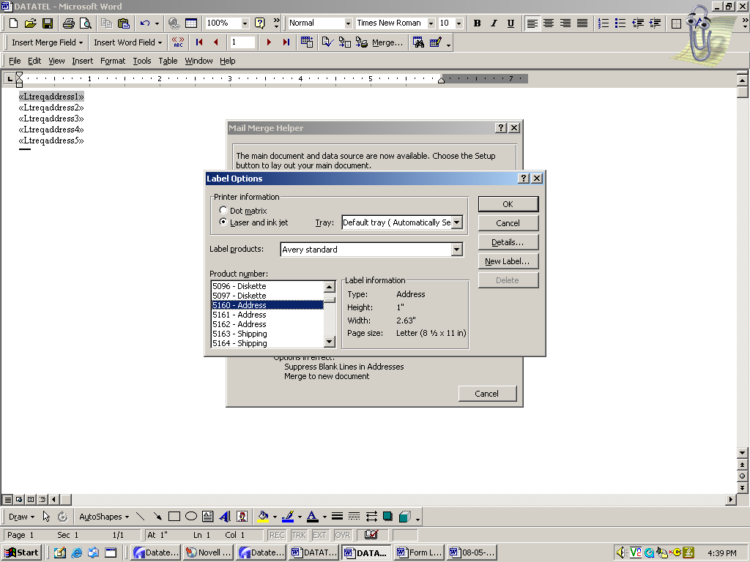
Find and select the correct product number for the blank labels you’re using. This should be displayed as an Avery number on your box of blank labels. (I’m using 3 across by 10 down labels, so I selected 5160-Address.)

Then click OK.

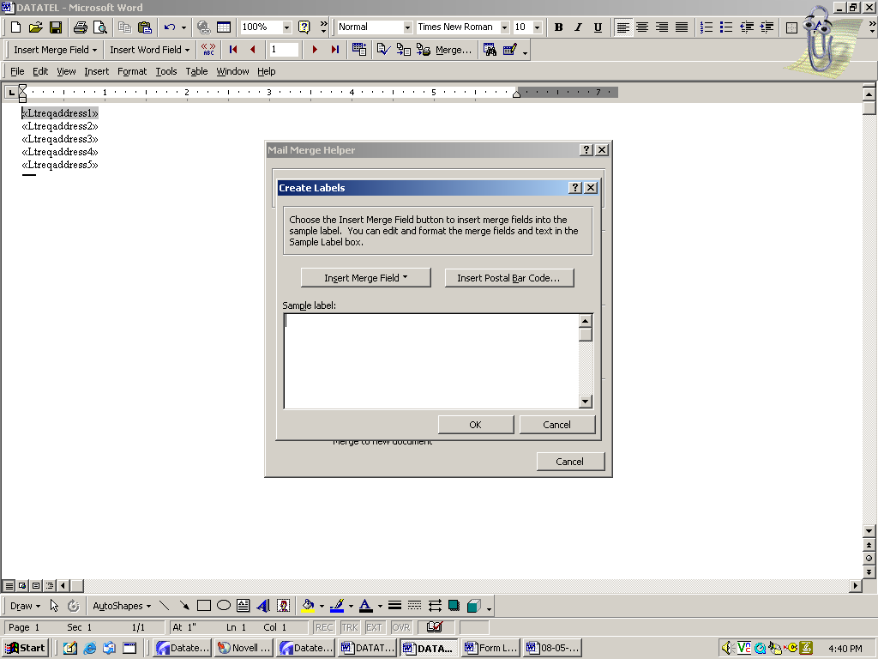
Click on Insert Merge Field.

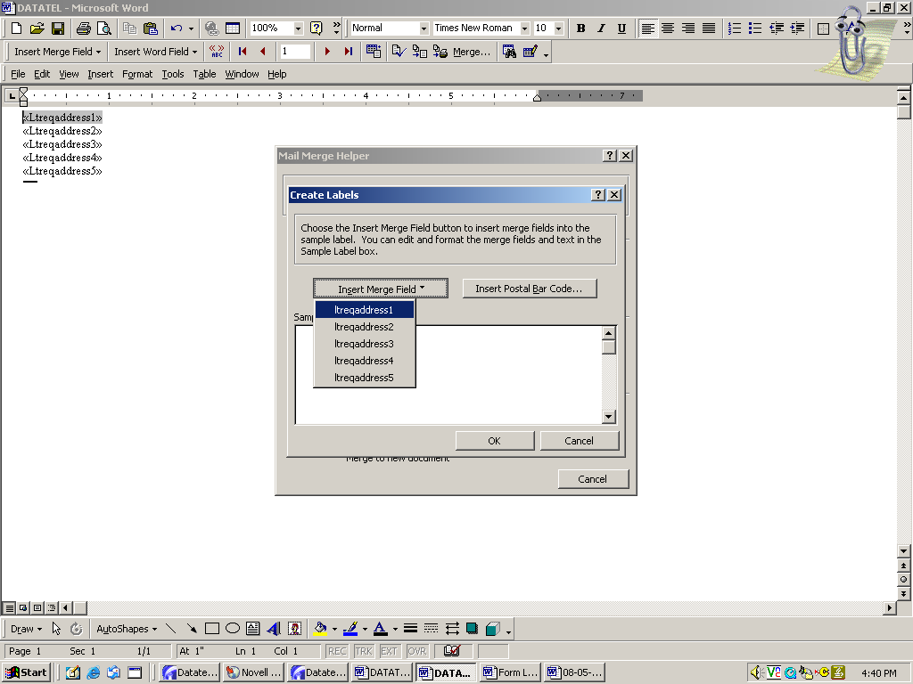
One at a time, click on all five address fields to merge them into the label document. Be sure to click on them in order (ltreq.address1 through ltreq.address5) so that the address will be properly displayed on the label.

IMPORTANT: Press Enter after each is displayed so that the next address field will be inserted on the next line.

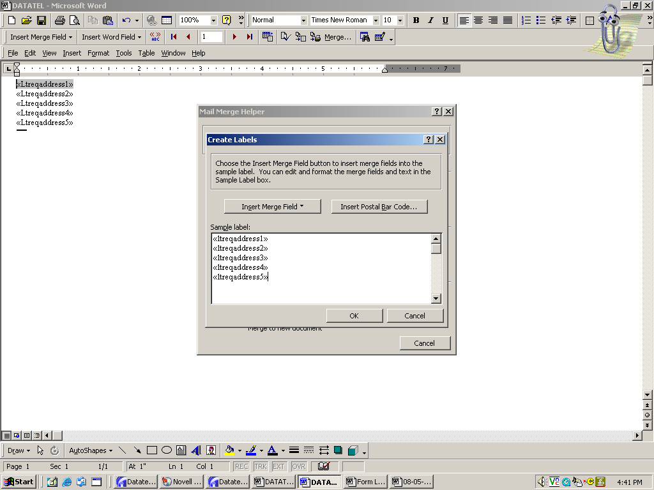
Once all five address fields are displayed as merged, click on OK.

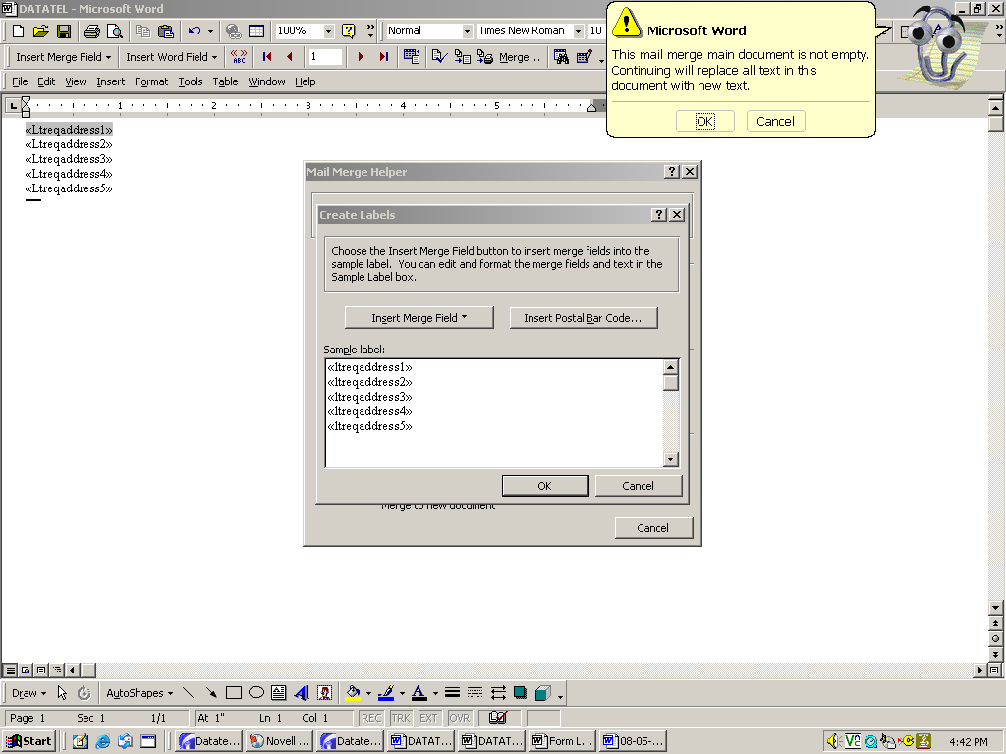
Click on OK.

Note: If your “Office Assistant” is hiding, this alert box will appear in a plain box.

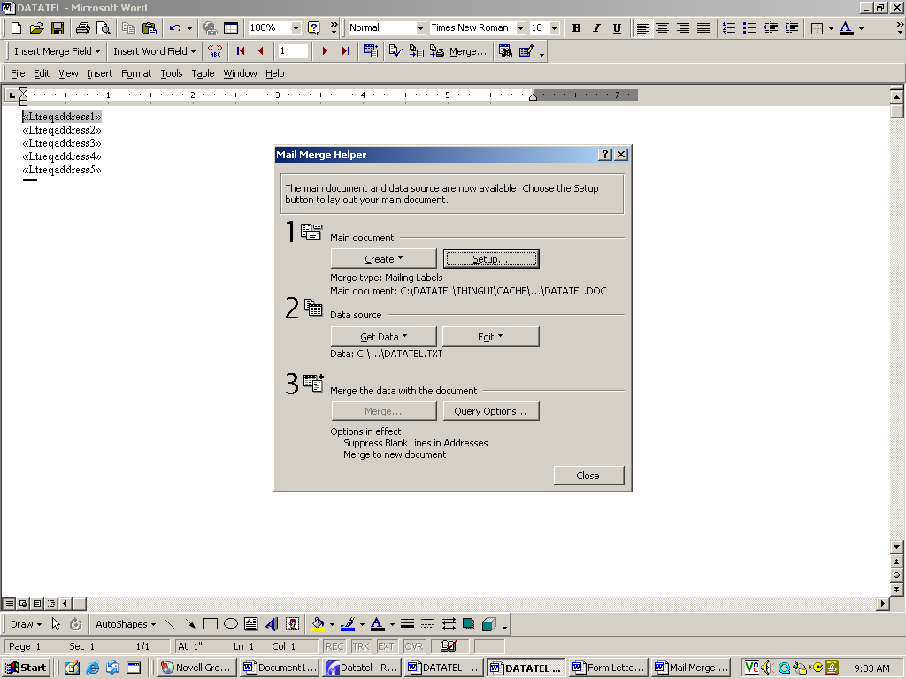
Now click on Get Data Source.

You don’t need to do anything else; clicking selects the data source.

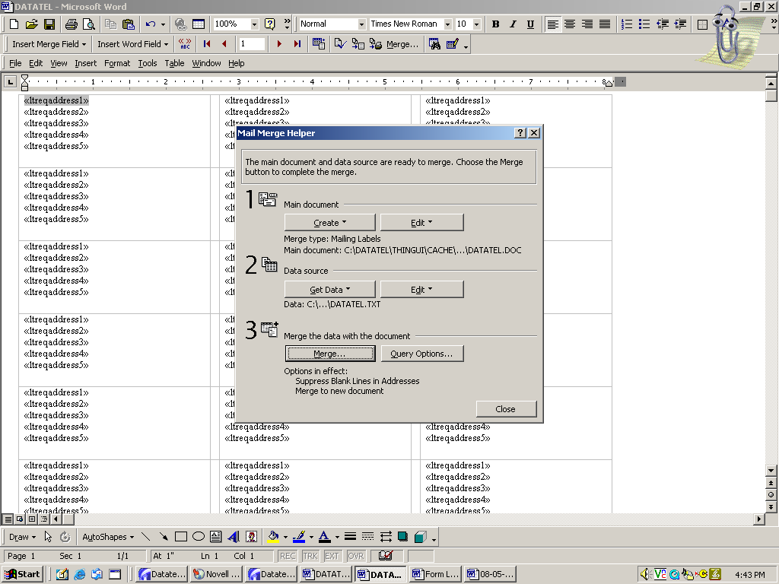
NOTE: If the label template shown here does not show up as the background screen when you get to this point in the process, click on the tabs at the bottom until you find the one that does display this template.
Now click on Merge to bring up the next box.

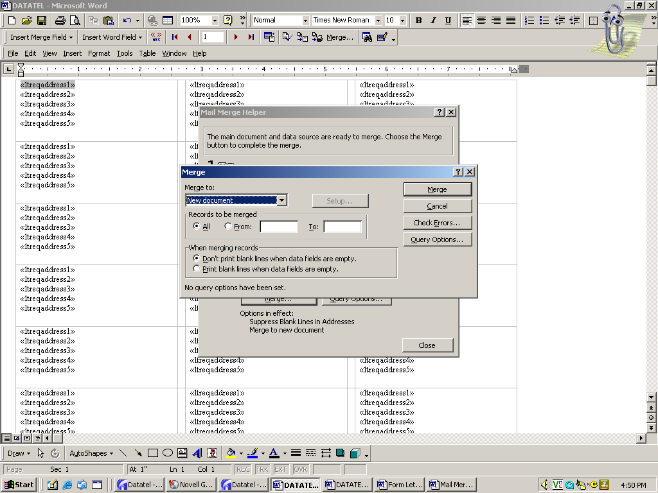
Click on Merge
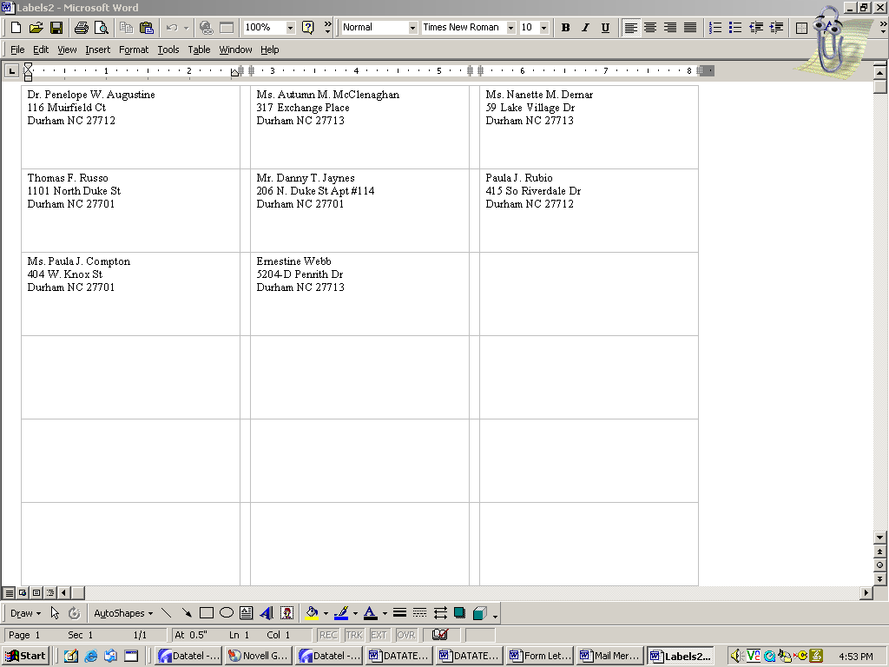
Your address labels will now be displayed…just as they will appear on the actual labels.

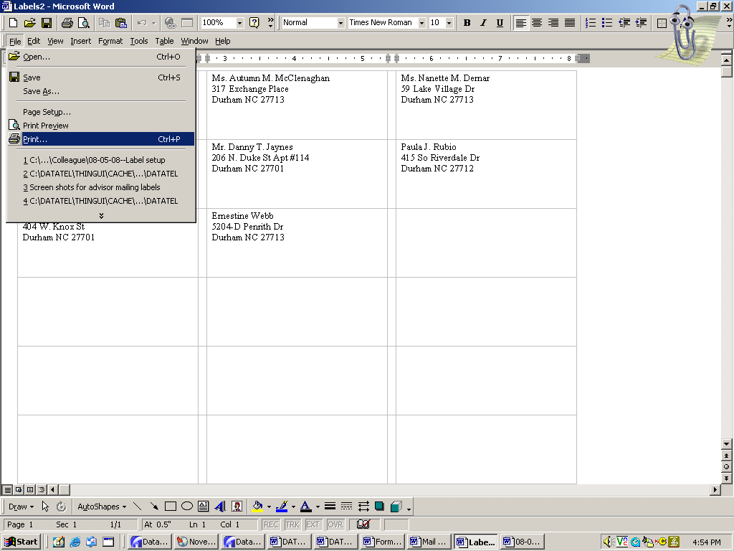
To print, follow your usual process. Click on File, then Print.
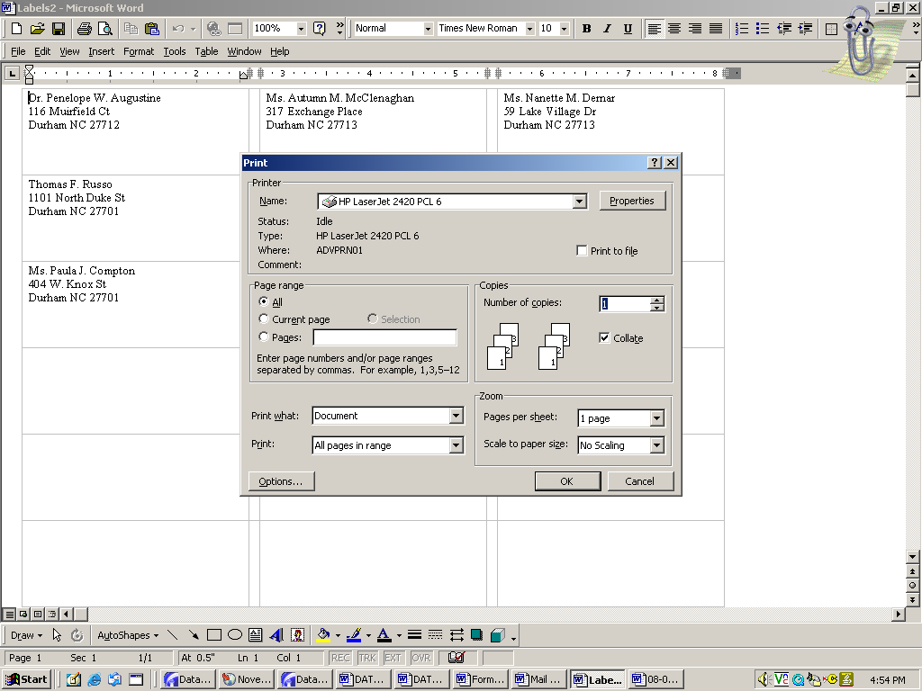
Make sure the proper printer is displayed, then click OK.

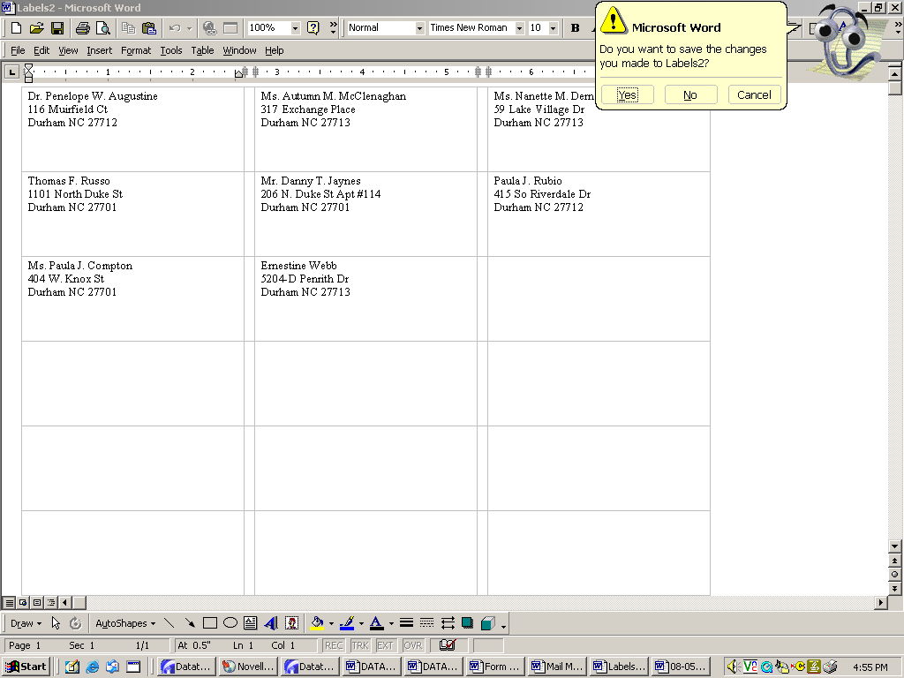
Once printing is completed, click on the X. You will be given the option of saving the labels to your desktop. Click Yes if you want to save them (using your regular process to save a document to “My Documents”) or No to exit without saving.
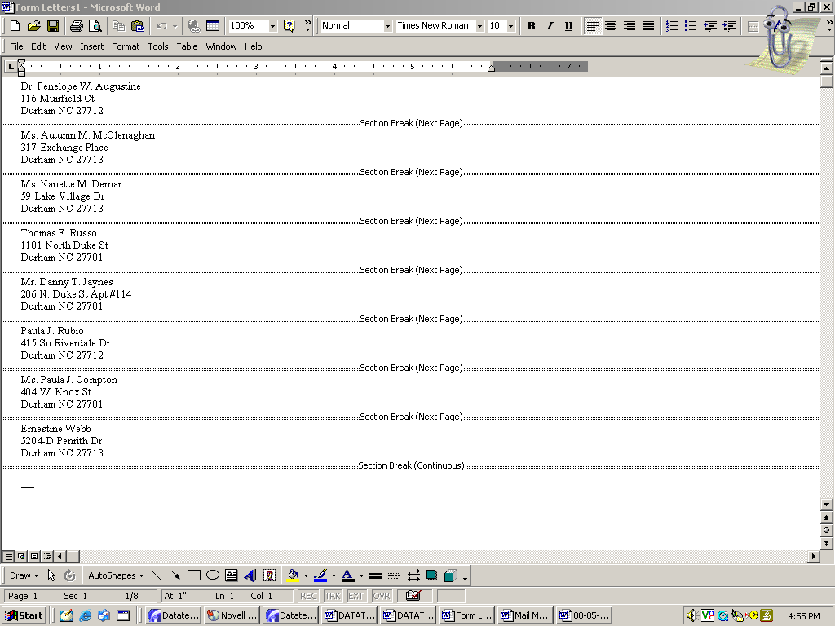
Click on X to exit.

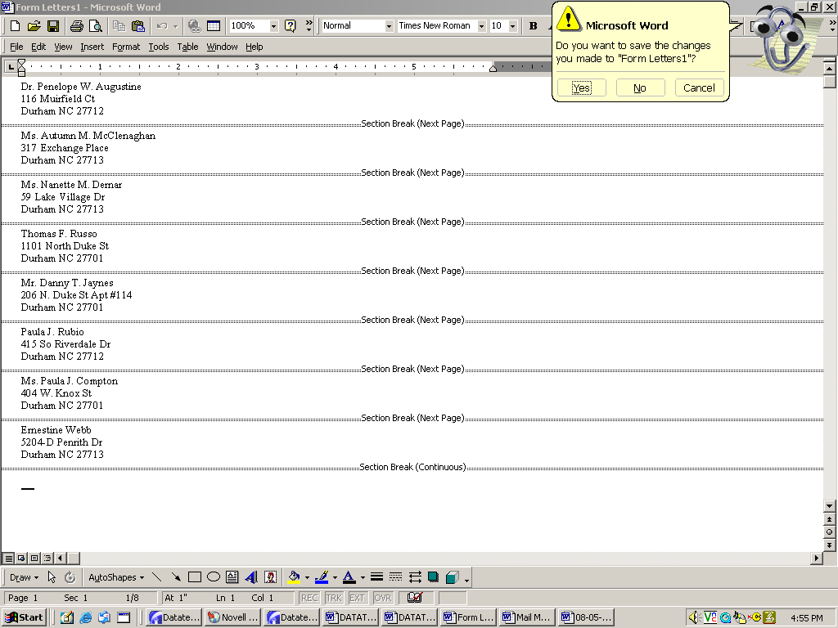
Click on No.
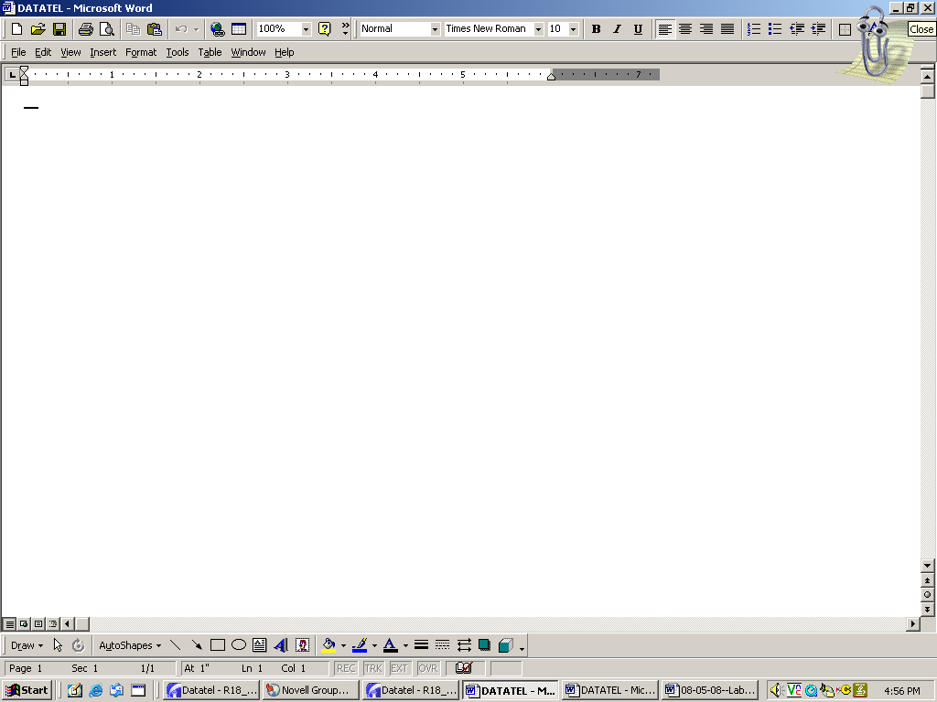
Click on X to exit.

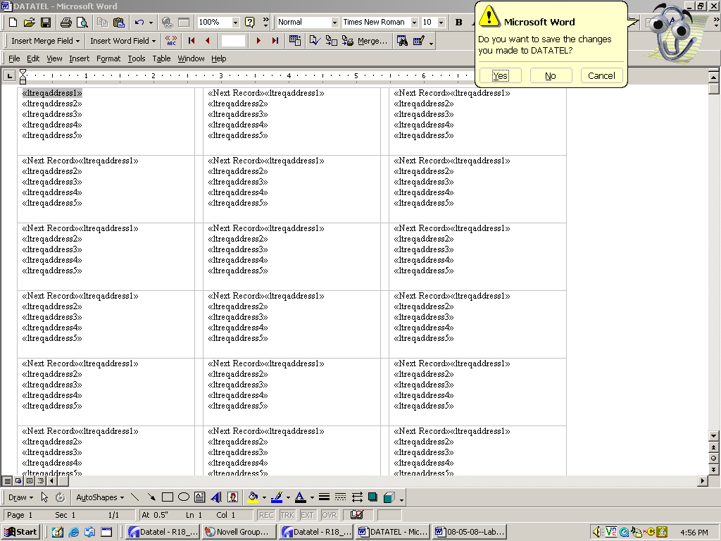
Click on No.
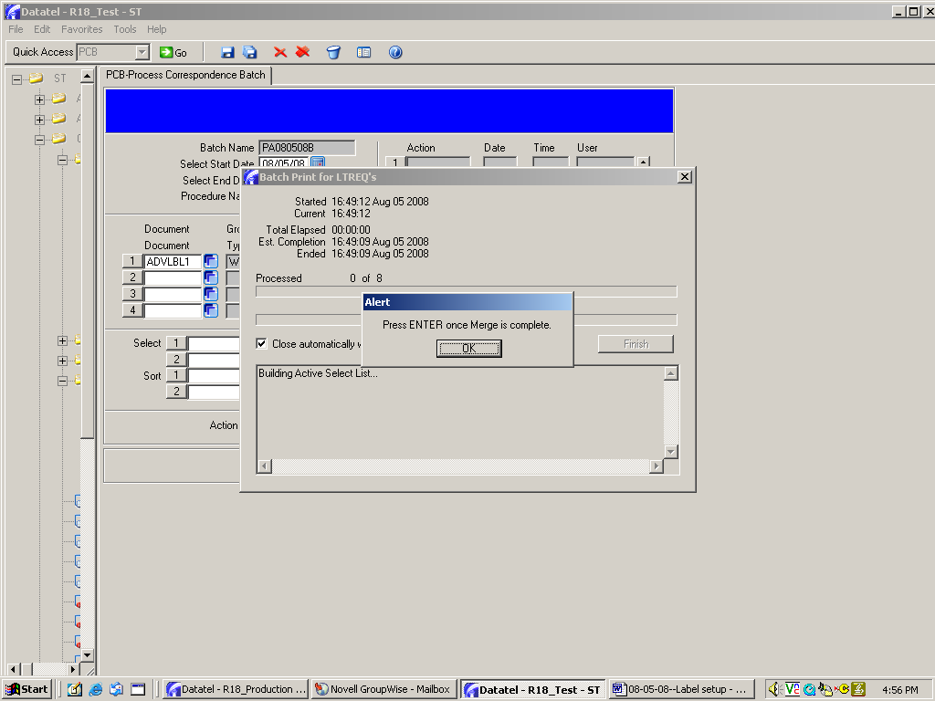
Click on OK

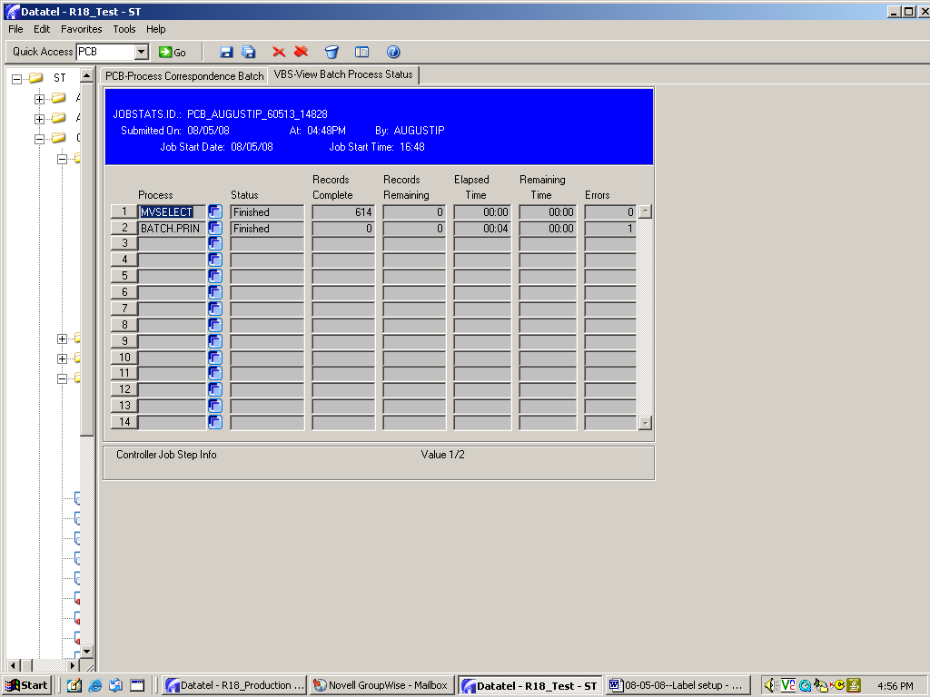
Click on Save All.
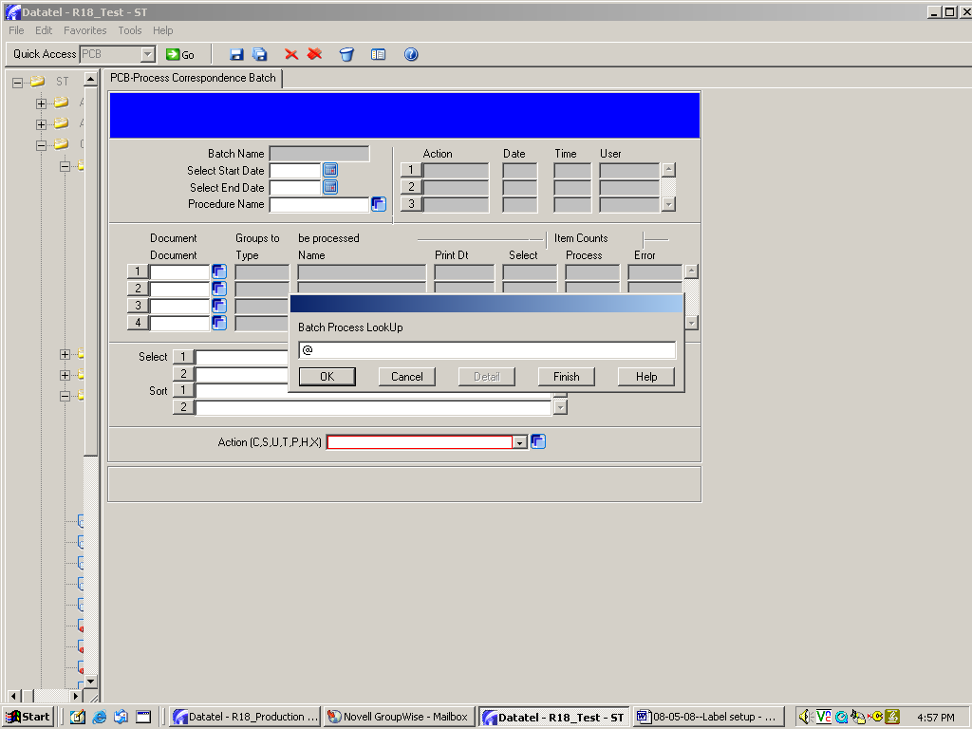
After printing is completed, remember to go through the H to History and X to Delete processes as shown on pages 33 through 39.

Use the @ sign to pull up the batch for each process.

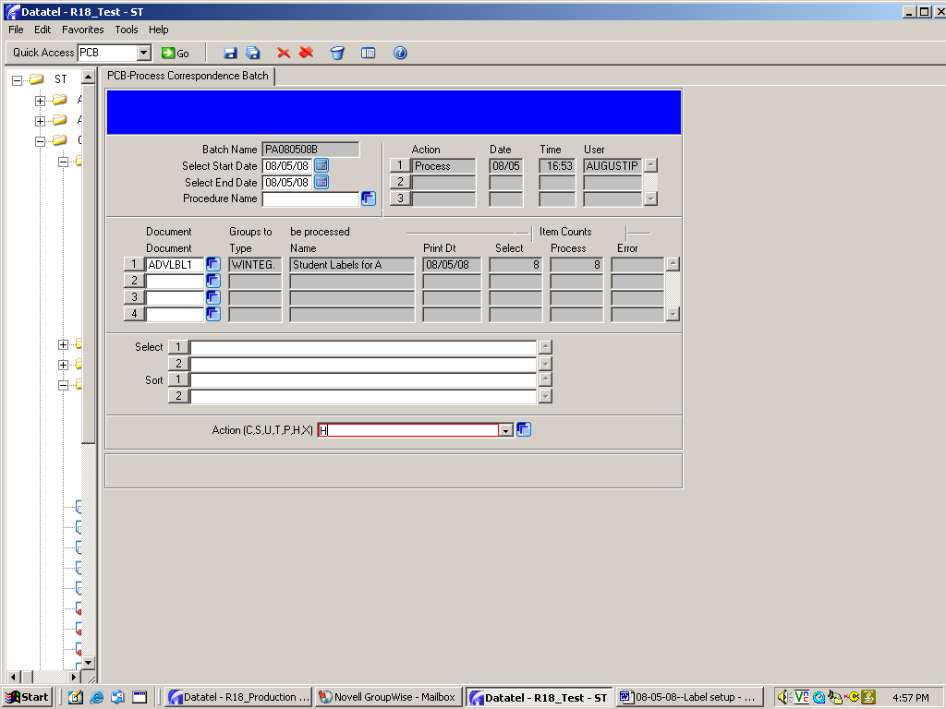
Choose H for History.
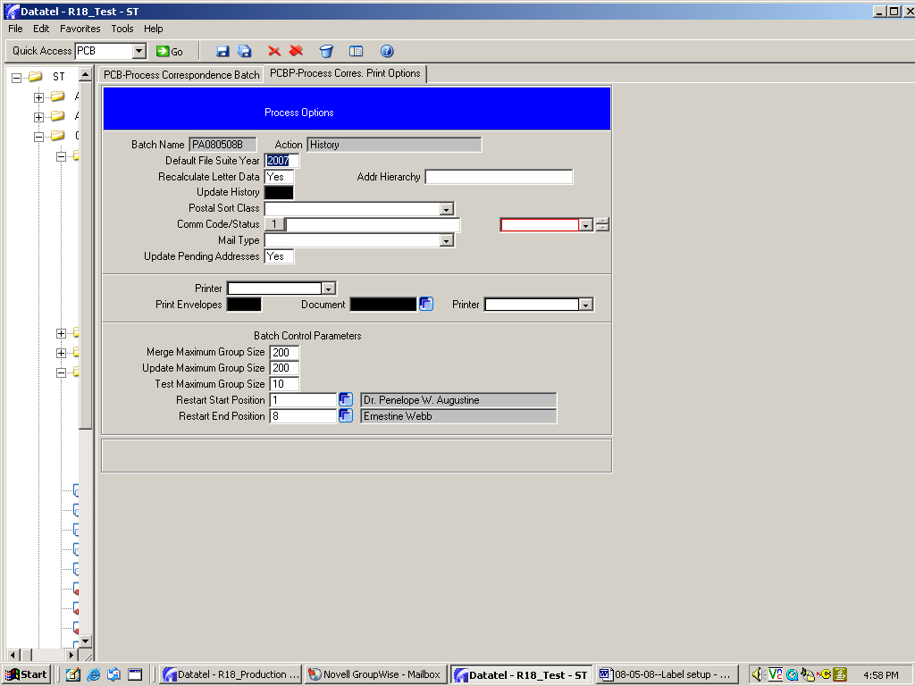
Save All.
After H to History is finished, run the same process for X to delete the batch.

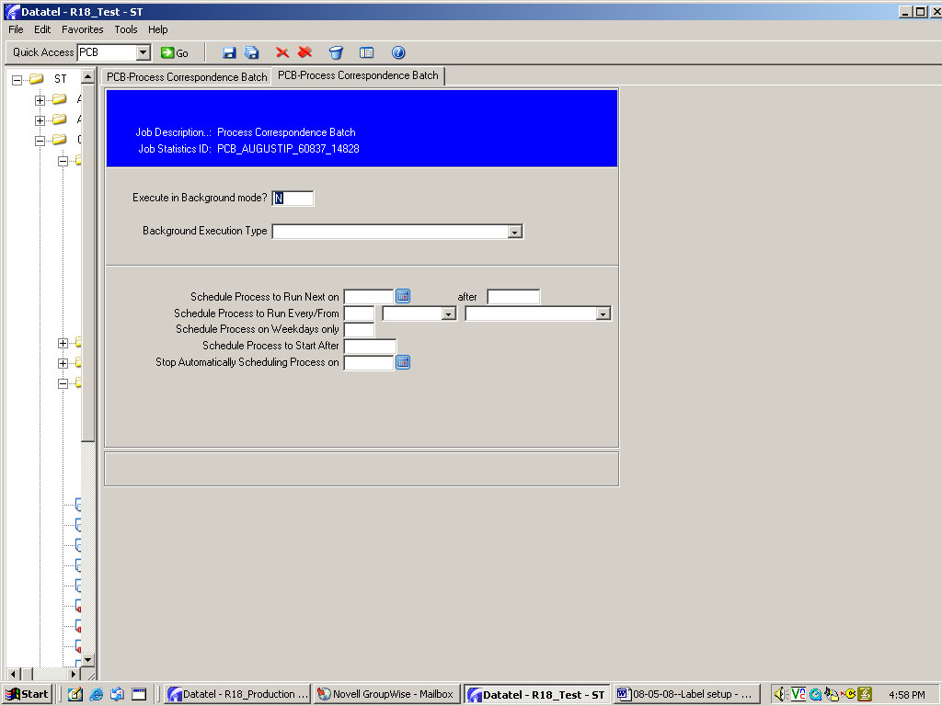
Save All.

Mnemonics required for the processes shown in this manual

Tree Path and Mnemonic | Description
ST>CC | Communications Management
ST>CC>CCS | Support File Setup
ST>CC>CCS>DOC | Document Codes
ST>CC>CCS>DOC>DTSY | Document Type Setup
ST>CC>CCS>DOC>DFS | Document File Setup
ST>CC>CCS>DOC>HDCD | Hardcopy Document Options
ST>CC>CCS>TRC | Tracking Codes
ST>CC>RUL | Rules Menu
ST>CC>RUL>GTA | Group Tracking Assignment
ST>CC>RUL>PCB | Process Correspondence Batch

Other mnemonics associated with Communications Management

If you attend Communications Management or Rules workshops taught by the system office (or Datatel), your training will be much more extensive and will cover many more mnemonics. These are screenshots of the mnemonics covered in the training I attended over the past years.

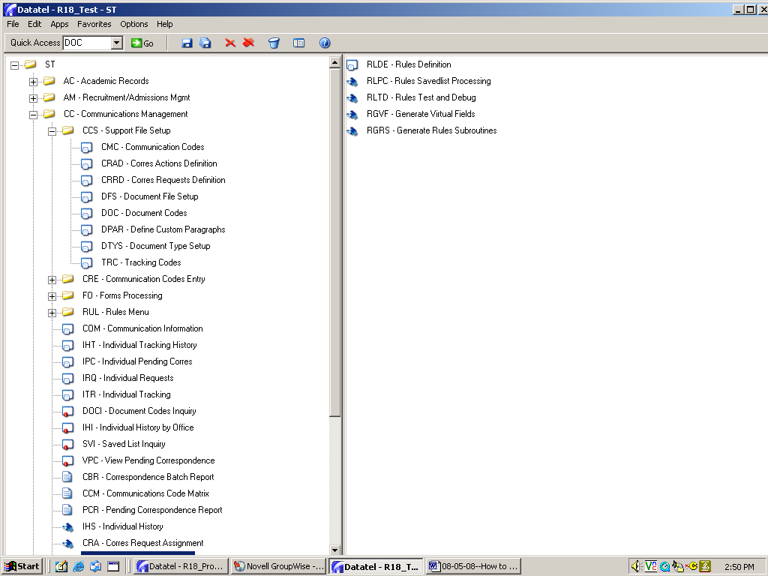
Support File Setup Mnemonics

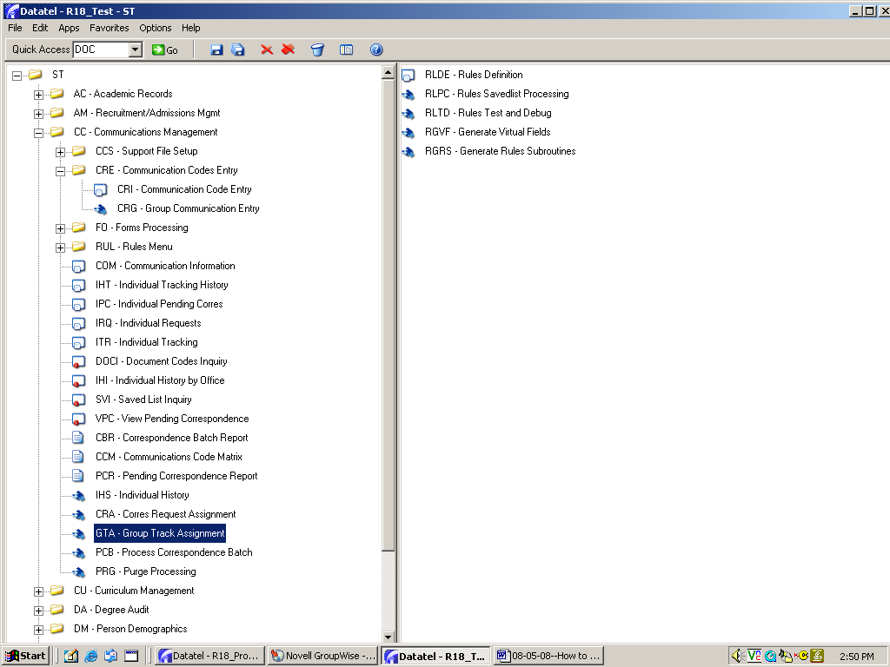
Communication Codes Entry Mnemonics
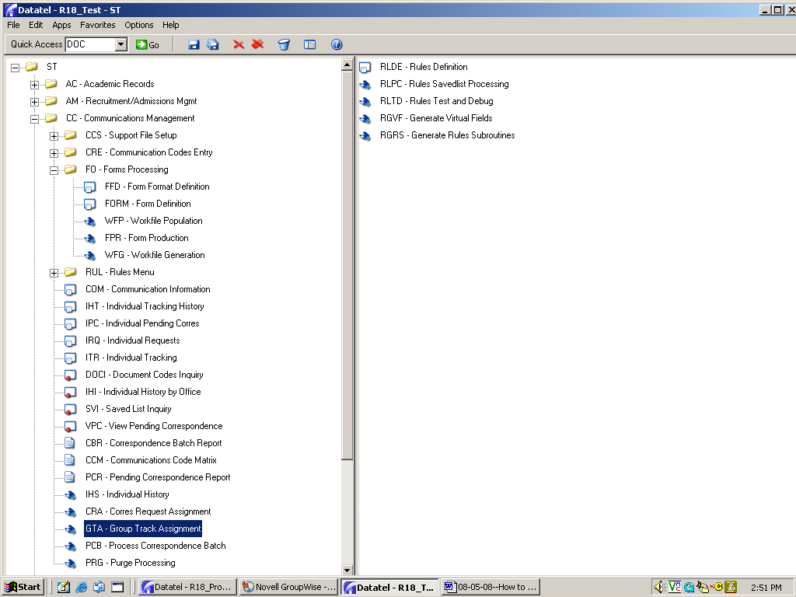
Forms Processing mnemonics

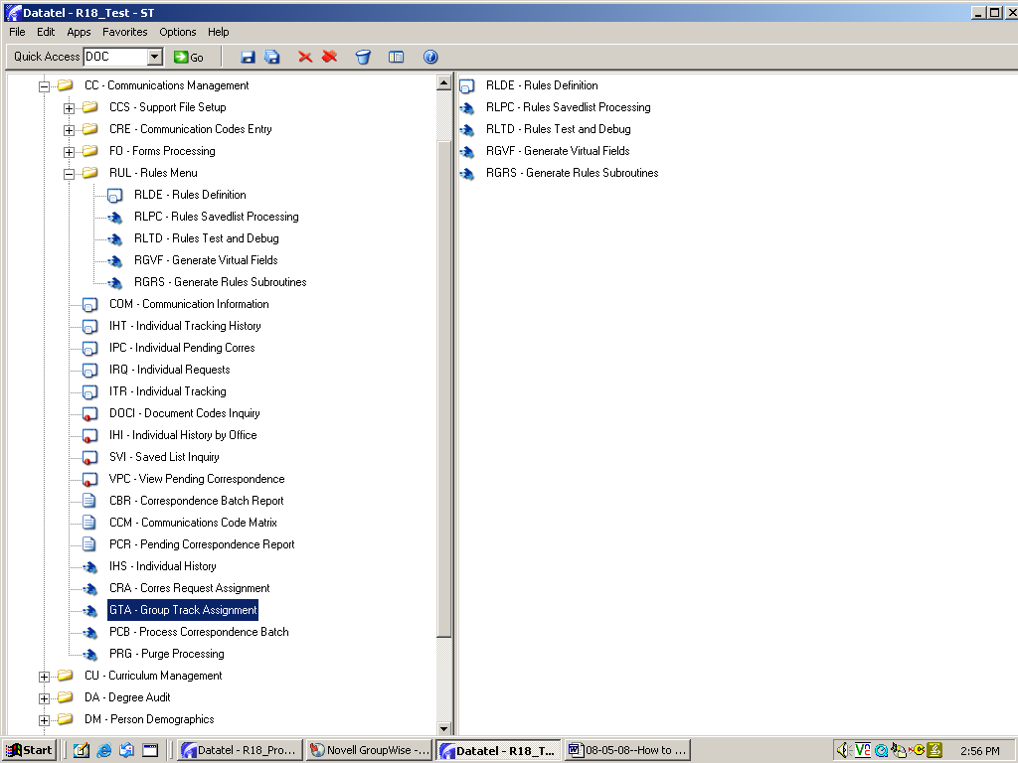
Rules Menu mnemonics

