Creating an Accessible PDF File from a Word Document

Preparing the Word Document

Use Word’s Built-in Features
- Headings – nest properly (like an outline)
- Numbered or Bulleted Lists
- Alt text (and long description, if needed) for images
- Tables
- Headers/footers
- Table of Contents – for longer documents

Create Accessible Tables
- Keep tables simple
  - Avoid merging or splitting cells
  - Avoid nesting tables
- Denote the Header Row
- Provide a title (in Word, this is called a caption)
- Provide a summary of the table in the Alt text. Are there any abbreviations that should be explained? Is there anything that someone who cannot see the table will miss if it’s not in the summary? Note that a long description may be necessary if the table must be complex.
- Avoid blank cells

Check for Accessibility
- Heading Styles are used to create the headings/subheadings
  - Open the Navigation Pane - are the headings descriptive?
- If a table has been used, make sure each of the column headings is descriptive, and there are no merged or split cells.
- To test a table, place the cursor in the first cell and press Tab to make sure the cursor moves to the right, and then automatically down to the next row. If you are unable to place the cursor in the table, the table may be an image (and will require alt text and a long description)
- Use the Accessibility Checker (File tab > Info > Check for Issues > Check for Accessibility)

A Note about Saving the Document
It is suggested that you save your document prior to creating a PDF file.
- .doc – This file type does a better job of properly ordering all of the document tags, including the placement of images in the correct location. Note: The Accessibility Checker will be unavailable.
- .docx – This file type will allow you to use the Accessibility Checker; however, creating a PDF from a .docx causes images to be tagged out of order, and they may be missed all together by an assistive technology user.

Resources for Further Learning
- WebAIM’s PDF Accessibility
http://webaim.org/techniques/acrobat/converting#in_acrobat
- NCDAE’s Accessibility Cheatsheets
http://ncdae.org/resources/cheatsheets/
- Access for All’s Free PDF Accessibility Checker (PAC 2)
http://www.access-for-all.ch/en/pdf-lab/pdf-accessibility-checker-pac.html

To Create a PDF File:
- Save the document as a .doc file extension.
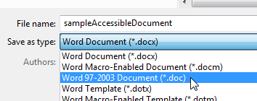
- Then select PDF.
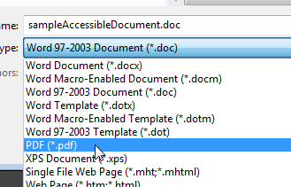
- Click the Options button.
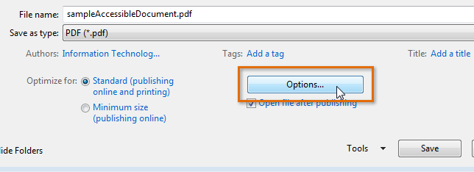
- A dialog box appears. Place a check next to the following options:
- Create bookmarks using – Headings
- Document properties
- Document structure tags for accessibility
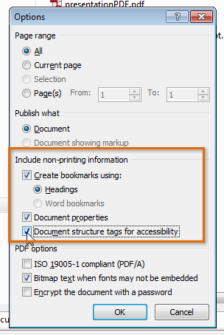
- Click OK and then click Save. The PDF file will be created.

