Extracting a Transcript for a YouTube Video
Extracting the transcript from a captioned YouTube video is an efficient method for creating a video transcript. You will need to copy the transcript provided by YouTube and paste it into a word processor.

To Locate a YouTube Video’s Transcript:
- Locate a YouTube video. To review the video’s captions, click the CC icon.
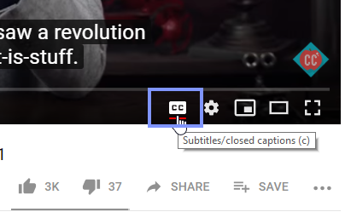
Note: YouTube’s automatically generated captions (auto-captions) may appear by default. Auto-captions should be considered only a draft of the captions because they are usually inaccurate and need corrections by the video’s creator. If the video’s creator has corrected the auto-captions, the corrected version will be available. To select the corrected captions, click the Gear icon, and select Subtitles/CC and then English (or the desired language).
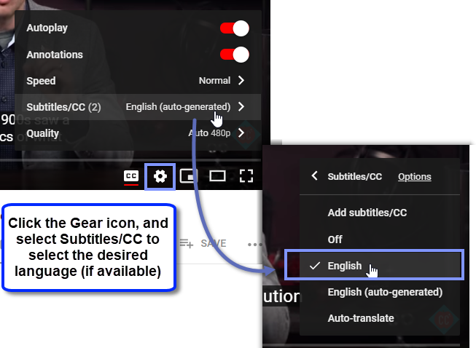
- To open the YouTube transcript, locate and click the three dots (below the video). Select Open transcript.
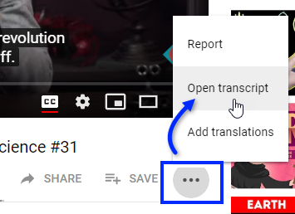
- The YouTube transcript appears in a pane on the right-side of the screen. By default, an automatically generated transcript appears. Auto-transcription should be considered only a draft as it is usually inaccurate and will likely need corrections from the video’s creator. If the video’s creator has corrected the auto-captions, the corrected version will be available. To select the corrected version (if available), click English (auto-generated).
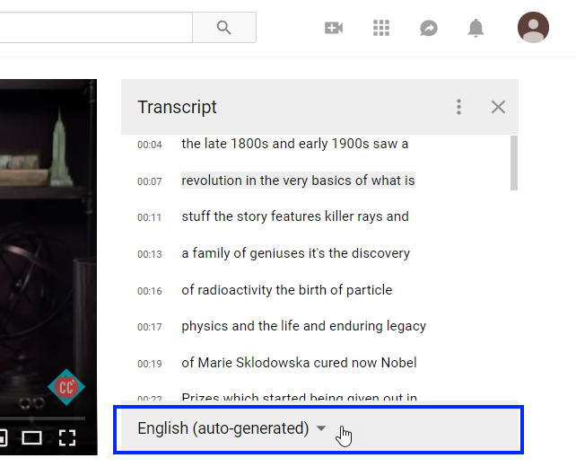
- Select English (or the desired language). (Note: If the desired language is not available, you will likely need to make significant revisions and edits to the transcript in step 8.)
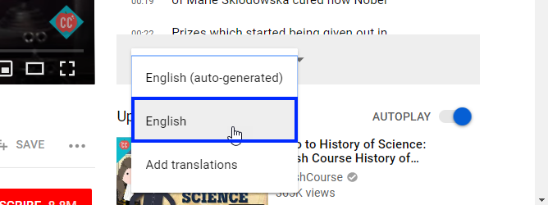
- The transcript will update. To remove the timestamps (for easier reading), locate and click the three dots (above the transcript). Select Toggle timestamps.
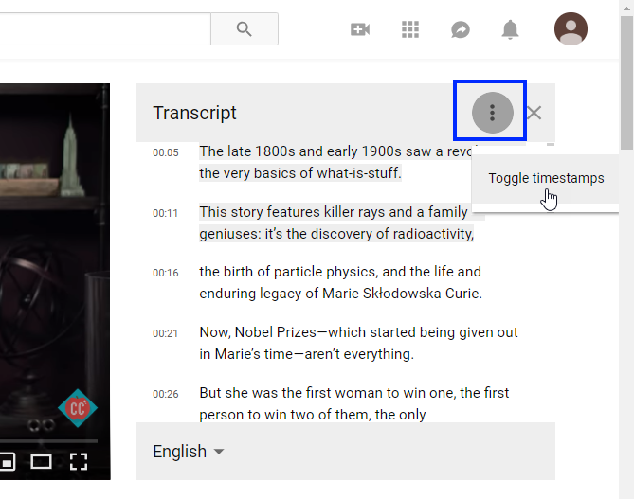
- The timestamps will disappear. Highlight the transcript text, and then right-click and select Copy.
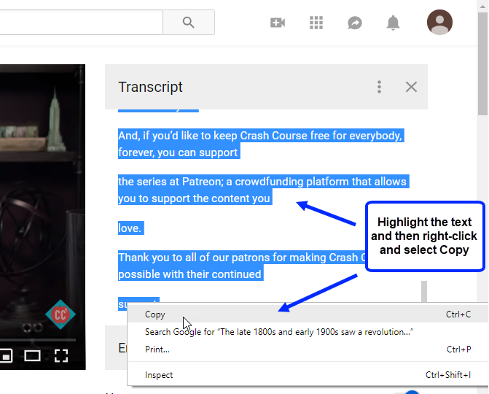
- Open a word processor, such as Microsoft Word, and type a title for the transcript and then paste the copied transcript text. You may edit the text and apply formatting as needed.
- Upload the transcript document to Sakai, and create a link to it under the video.
