The Microsoft Office Accessibility Checker
Microsoft Word and PowerPoint have a built-in Accessibility Checker that can help you verify some of the accessibility considerations required for digital accessibility compliance. The Accessibility Checker scans the file and looks for potential barriers or issues for people with disabilities.

To Activate the Accessibility Checker:
You’ll access the Accessibility Checker the same way in both Word and PowerPoint.
- Select the Review tab, and then click Check Accessibility.
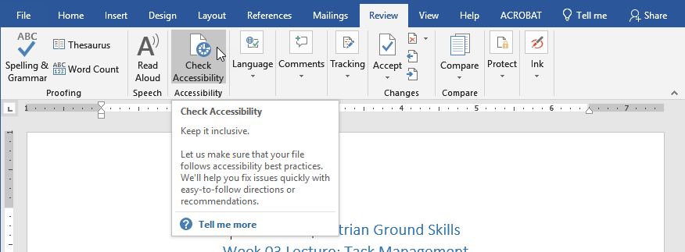
- On the right side of the screen, the Accessibility Checker’s pane appears. It displays Inspection Results.
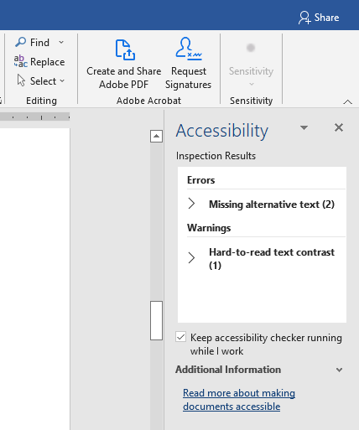

Troubleshooting Tip
If the Accessibility Checker is unable to check the document/presentation, a message will appear in the pane prompting you to convert the file to a modern format.
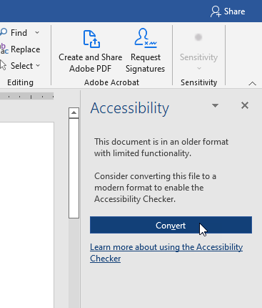
This message means the file was created with an older version of Word or PowerPoint. Try saving the file with the newer Word Document (*.docx) or PowerPoint Presentation (*.pptx) file type (see Figure 1 and Figure 2 below), and then reactivate the Accessibility Checker.

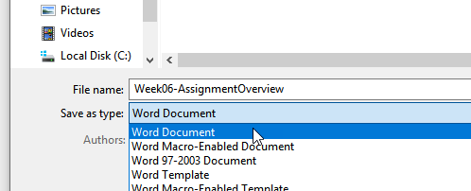
Figure 1: Saving in the Word Document format
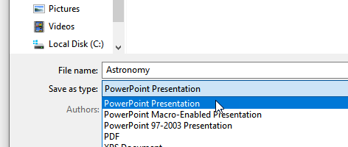
Figure 2: Saving in the PowerPoint Presentation format

Addressing Accessibility Issues
When the Accessibility Checker detects one or more accessibility issues, a list of Errors, Warnings, or Tips appears in its Inspection Results.
- Content tagged with an Error may be impossible for people with disabilities to understand (for example, an image without an alternative text or slides that do not have titles).
- Content tagged with a Warning may be difficult for people with disabilities to understand (for example, insufficient contrast).
- Tips help improve the user experience for people with disabilities.

To Display Information about How to Fix an Accessibility Issue:
In addition to displaying potential barriers, the Accessibility Checker also provides information on how to fix each of the accessibility issues it detects.
- Select an issue from the Accessibility Checker's pane. The inaccessible content becomes highlighted in the document (or presentation).
- Review the information about how to fix the issue in the Additional Information area at the bottom of the pane.
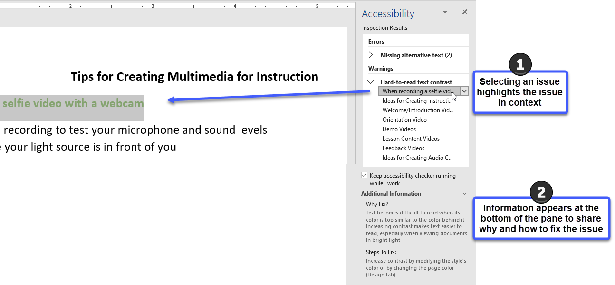
NOTE: A few editing options are available from within the Accessibility Checker’s pane. Often, a drop-down arrow is offered with each Error; Warning; or Tip, allowing the correction to be made (or accessed) quickly from within the pane itself.
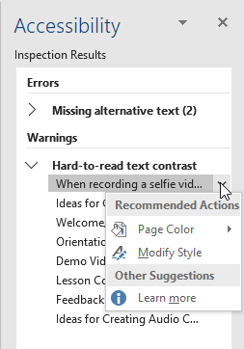
To learn more about Office’s Accessibility Checker, visit Microsoft’s Rules for the Accessibility Checker.

