Creating Presentation Structure in PowerPoint
When you’re ready to add content to a slide, PowerPoint has a number of built-in slide layout templates, many of which contain placeholders for entering text, images, tables, and more. Using slide layout templates will structure the content of your presentation, making it easier for your students to understand the information, as well as make it accessible to assistive technology.

Types of Slide Layout Templates
Table 1: Types of Slide Layout Templates
Layout Template Name | Description | Recommended
Title Slide | When you open a new presentation, the Title Slide appears by default. Using this template, you can add a title for your presentation and if needed, a subtitle. | YES
Title and Content | This template has a title placeholder at the top of the slide and then a large content placeholder. The Title and Content placeholder is useful for creating a single list or adding a single image (or table) to your slide. | YES
Section Header | If your presentation requires multiple sections, this template is useful for introducing a new section. It contains a placeholder for the section's title and an additional text placeholder for a subtitle or other information. By default, the title of the section will be capitalized. | YES
Two Content | This template contains a title placeholder at the top of the slide and then two identical content placeholders that have been positioned side-by-side. This layout is useful for displaying two images, a list and an image, or two lists. | YES
Comparison | Similar to the Two Content template, the Comparison template contains a title placeholder at the top of the slide and two identical content placeholders that have been positioned side-by-side. Above each of the content placeholders is a subtitle placeholder, useful for labeling the content in the content placeholders. | YES
Title Only | This placeholder is similar to the Title Slide template except it does not have a subtitle placeholder and instead of centered on the slide, the Title placeholder is located at the top of the screen. | YES
Blank | The Blank slide layout template is a blank slide. It contains no placeholders. Using this layout is not recommended because it could be mistaken for the end of the presentation. A student using a screen reader and expecting to hear content may be confused because there is no indication that the slide is blank. | NO
Content with Caption | The Content with Caption layout provides a small title and a text box along with a larger placeholder. This layout is good for displaying images or tables and provides an area for a caption, long description, or additional information. | YES
Picture with Caption | This layout provides a large placeholder for images, a text box for a caption, and a title placeholder. | YES

To Create a New Slide:
- From the Home tab, click New Slide, and then select a layout template.
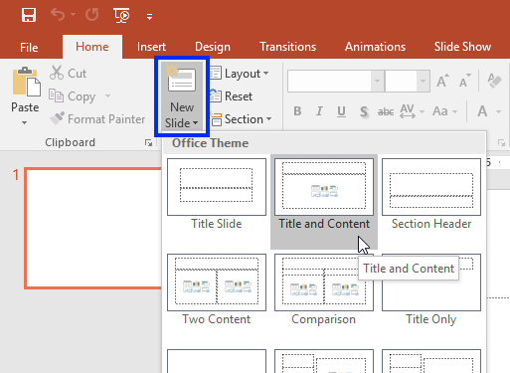
- The new slide appears.
- Click a placeholder to add your content.
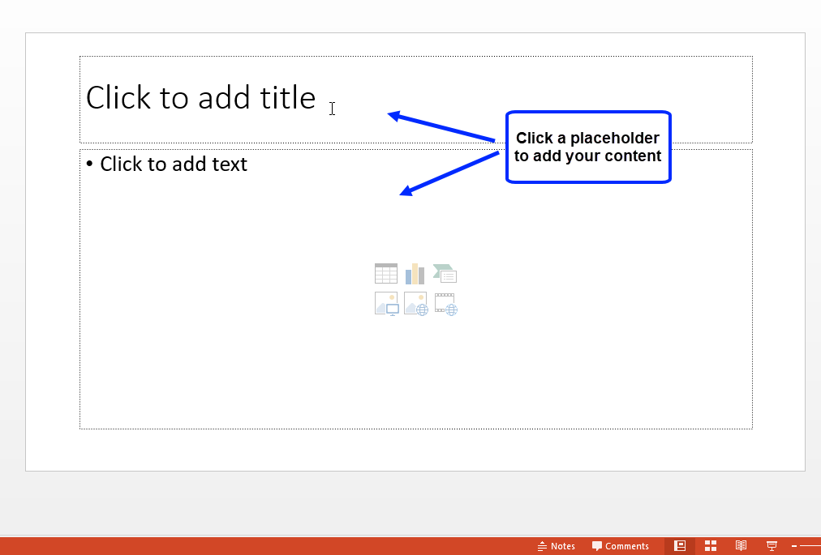

To Modify the Layout of an Existing Slide:
- Select the slide you wish to change.
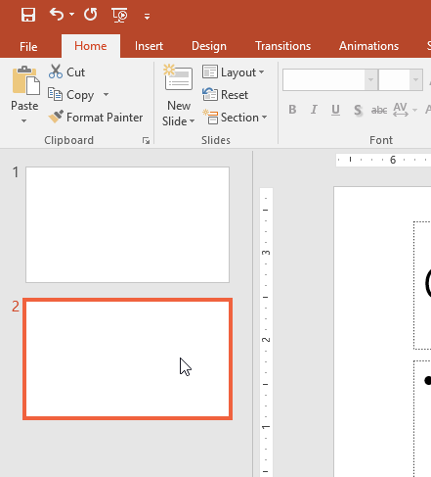
- From the Home tab, click Layout and select a layout template.
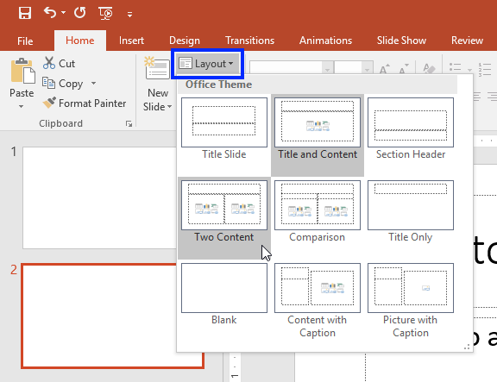
- The new template appears on the slide.
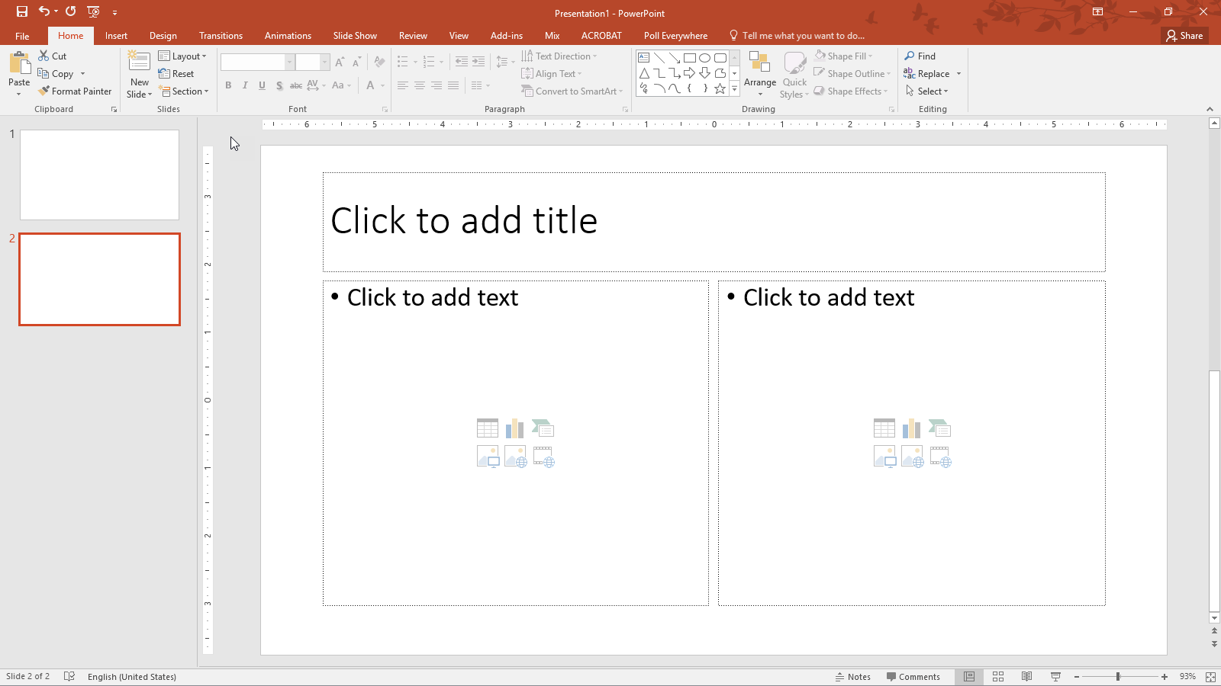

Bulleted and Numbered Lists in PowerPoint
When developing text content, avoid writing paragraphs or long passages in the content placeholders. Instead, use PowerPoint's bulleted and numbered list commands to help structure the text on your slide. Using lists will make the content more manageable for students to digest, and screen reading software will announce when it has arrived at a list, informing the user to expect a series of items.
By default, as soon as you start to type in a placeholder, many of them create a bulleted list; however, you can also create a numbered list.

To Create a Bulleted List:
- Make sure you have selected a template that contains at least one content placeholder. Click the content placeholder and type the first list item. By default, the content placeholder will format the text as a bulleted list.
- Press Enter to move the cursor to the next line.
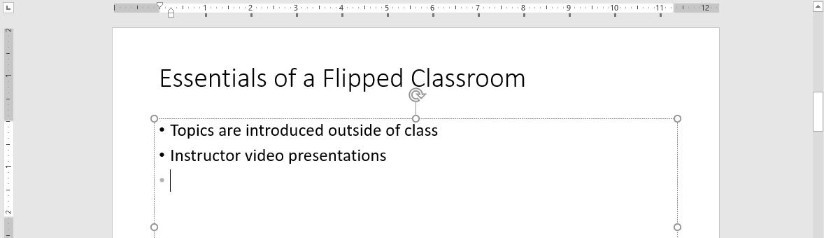

To Create a Numbered List:
- Highlight the list items you want to number.
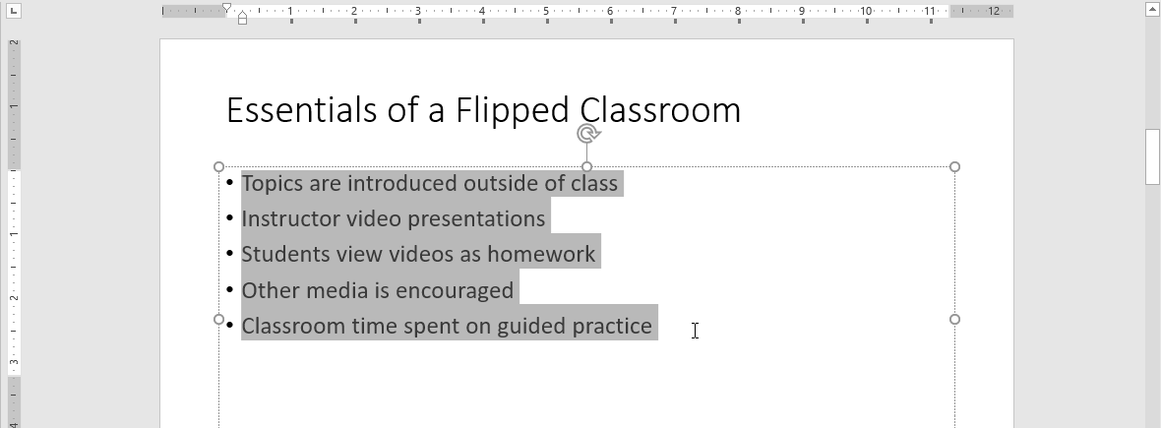
- Locate the Paragraph group on the Home tab, and click the Numbering option.
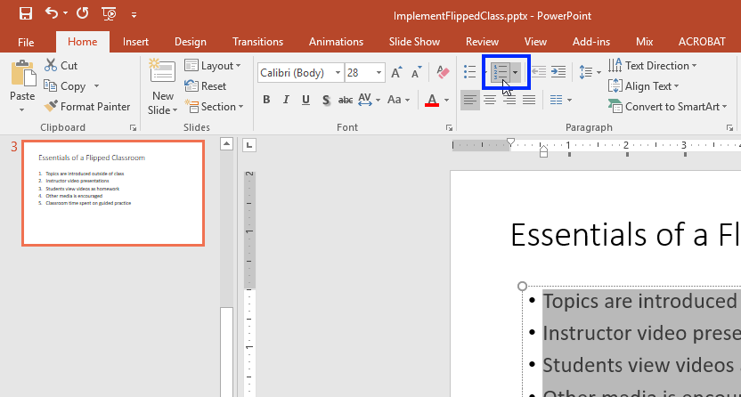
- The list becomes numbered.
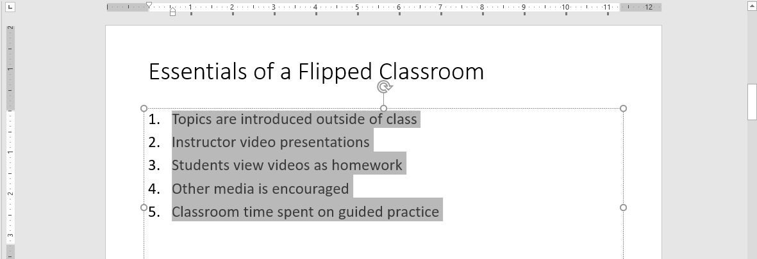

Viewing a Presentation in Outline View
Beyond accessibility, one of the benefits of utilizing PowerPoint's placeholders is the ability to view an outline of the presentation to verify structure. Outline View, located on the View tab, displays all of the text content that has been added to each slide's title and content placeholder(s). It provides an easy way to make sure all of your slide titles are unique and all of your text content is available to screen reader users.
Once you've created some content, you can then verify the presentation's structure in Outline View.
- Click the View tab, and select Outline View.
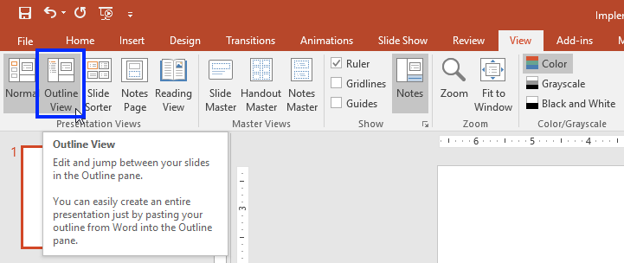
- The Outline pane appears on the left side of the screen. Check to make sure each slide has a unique title and that all of the slide text is appearing. (Note that each slide title appears as bold text.)
