Making Images Accessible
Images can perform a variety of useful roles, such as supplementing your lecture content or providing thoughtful imagery for discussion. To make images available to students unable to see them, they need text representation, called alternative text. This handout provides instructions on adding alternative text to an image in Word and PowerPoint, as well as to an image in Sakai.

Adding Alternative Text to an Image in Word and PowerPoint
- After inserting an image, right-click the image and select Edit Alt Text from the menu that appears.
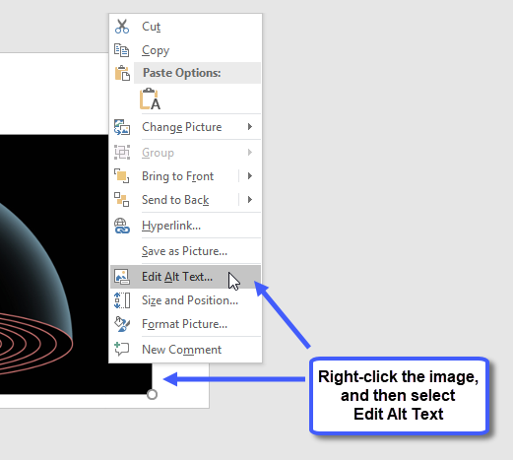
- The Alt Text pane appears on the right. Type the image’s text representation in the text box.
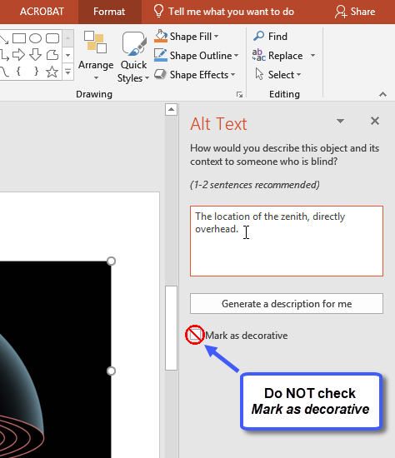
- Close the Alt Text pane by clicking the X in the upper-right corner.
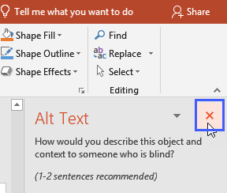

Two Important Notes about Options Available in the Alt Text Pane
- Mark an Image as Decorative (NOT recommended for use)
Unfortunately, the Mark as decorative option is not yet working properly, and selecting it is NOT recommended. What was intended with this option was for assistive technology to skip over and ignore the decorative image altogether; however, with this option the technology currently notices the image and reads the image’s dimensions. Knowing the dimensions of an image is not very helpful to a student unable to see the picture, as the student will readily know there’s an image present but will be unable to access the information provided in the image.
When using a decorative image, the recommendation is to always write a brief alternative text.

- Generate a description for me (NOT recommended for use)
The Generate a description for me option uses artificial intelligence to generate an alternative text for the image. The technology is in its infancy and is not very accurate (at this time, this option is good for a good chuckle…for example, a picture of a cartoon cat may be identified as a clock). Selecting this option is NOT recommended.
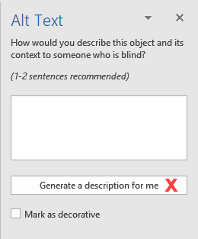

Adding Alternative Text to an Image in Sakai
In Sakai, there are two methods in which an instructor can insert an image. Below are instructions for adding alternate text for each method.

Method 1: Embedded Image in Lessons
- From within Lessons, click Add Content and select Embed content on page.
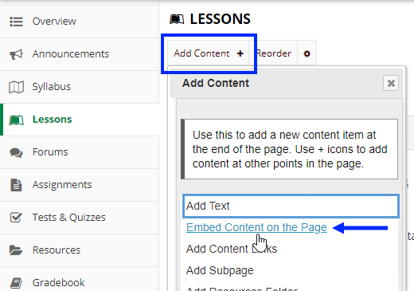
- A dialog box appears. Click Choose Files, or click Or select existing files from Resources.
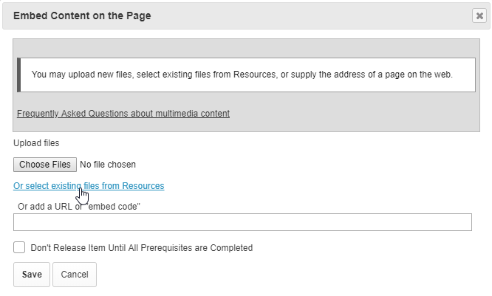
- Locate and select the file you wish to embed.
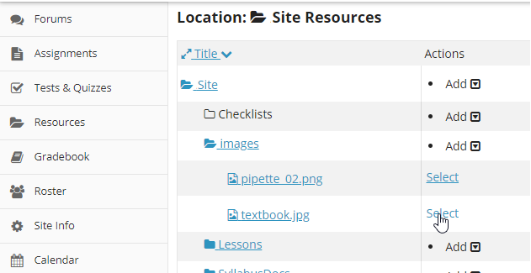
- The image appears in Sakai. To access the image’s alternative text field, click Edit content item.
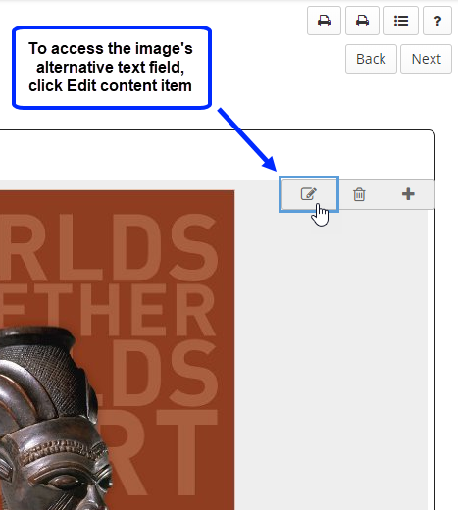
- In the Alt Text field, type the image’s text representation. Click Save.
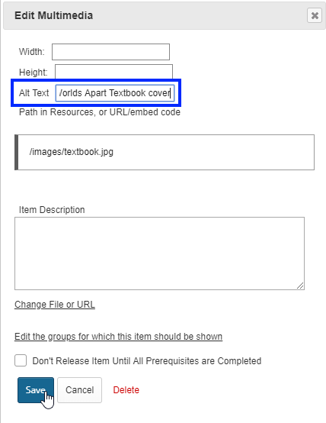

Method 2: Using the Text Editor Toolbar
- From the text editor’s tool bar, click the Image icon.
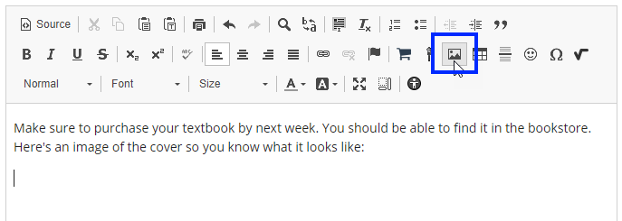
- A dialog box appears. Click Browse Server to locate and select the image.
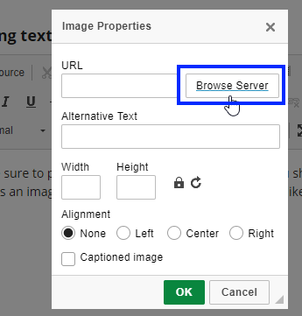
- In the Alternative Text field, type the image’s text representation. Click OK.
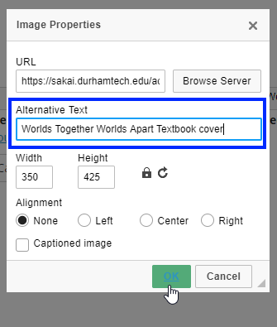

Determining When to Use a Long Description
Often, a long description will be required for more complex, educational graphics. When the information portrayed in an image requires more text representation than what can be provided in a succinct alternative text, providing a long description allows you to further describe the image. All students can benefit from having access to a long description, as they will have access to the information about the image that you have decided is important for them to know.

Adding a Long Description in Word
Type the long description near the image. For example, as a paragraph after the image. Then type the location of the long description in the image’s alt text so the student using assistive technology will know where to find it
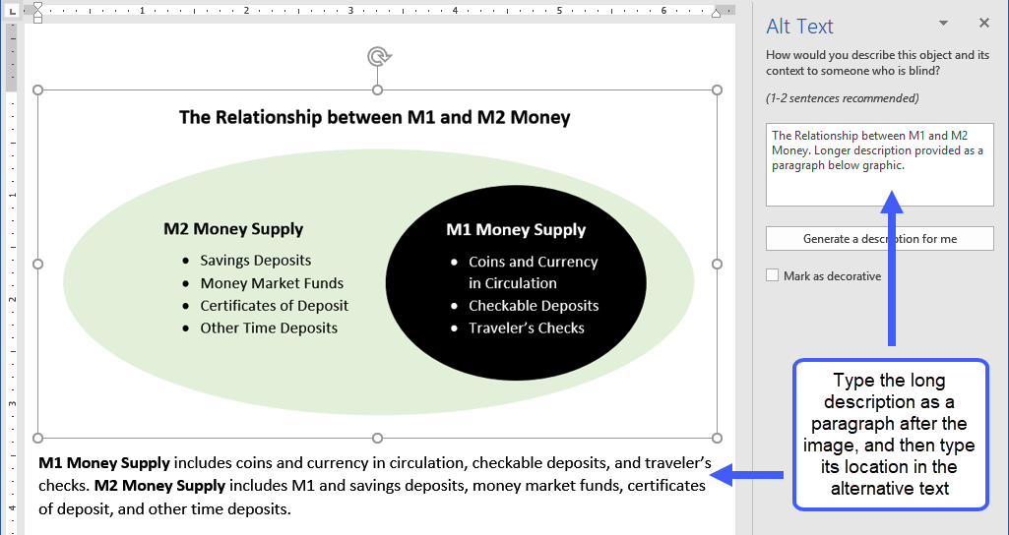

Adding a Long Description in PowerPoint
Depending on the amount of text needed for the long description, it can be typed in the Notes area of a slide or included as a list on the slide itself. (If a paragraph is needed, it’s best to type the long description in the Notes area.)
Then type the location of the long description in the image’s alt text field (the Description field) so the student using a screen reader will know where to find it.
(Example on next page)
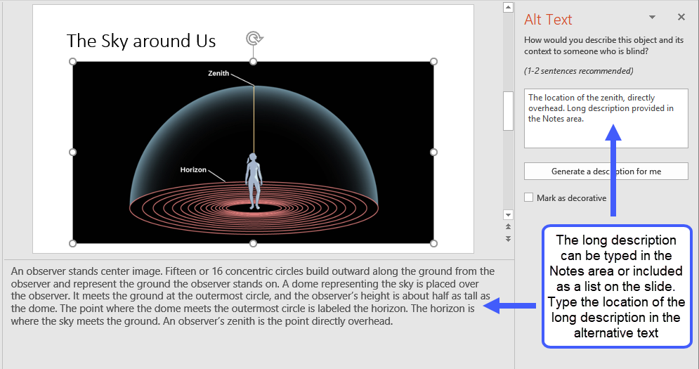

Adding a Long Description in Sakai

Method 1: Embedded Image in Lessons
In Lessons, click Edit content item and type the long description in the Item Description field. The long description will appear as sentences under the image.
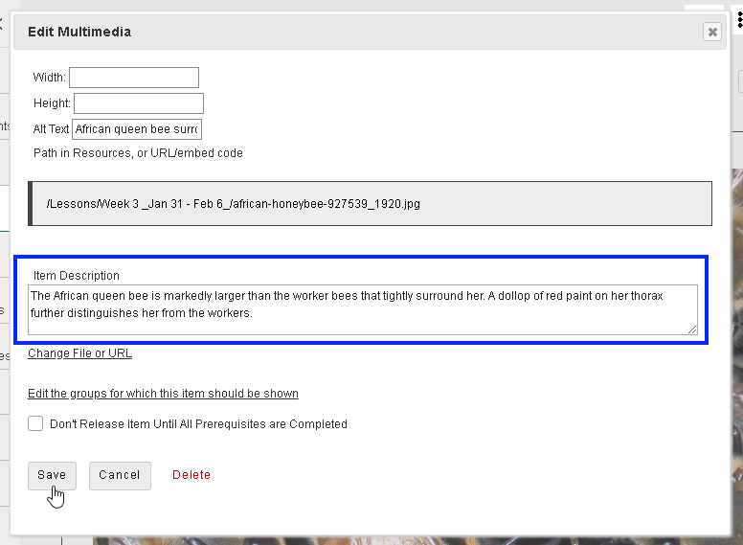

Method 2: Using the Text Editor toolbar
Type the long description after the image (or hyperlink to a document that contains the long description). Then type the location of the long description in the image’s Alternative Text field so the student using a screen reader will know where to find it.
